**Project on**

**House Rental System**



**Rupesh Dhakal**

**00172917**

**Computing Project**

**Level 5 Diploma in Computing**

**Softwarica college of IT and E-Commerce**

**Kathmandu, Nepal**

**2019-01-04**

# Abstract

HajurKo Property is a booking system which allows booking the property that are listed in this web application. The primary goal of this application is to reduce the time people spend on finding suitable property for them. Closing down the old ways of searching property is also the main moto of this application. The properties that are listed in this website are authentic which are verified by an active admin member.

HajruKo Property also allows user to register and post their advertisement once they are logged in to the system. Keeps your account safe by hissing the password that you have saved. This website was created using PHP and LARAVEL as a framework. User will also have facility to book the property and contact the owner as their information is provided aside of the very property. Only performing the intended function is not enough. This website has astonishing UI design that pleasures human eye. With easy to understand interface you will love and appreciate the effort that I have given to develop this web application. It is not just the website that was created to make revenue but it is the website that truly understand the emotions of people and try to solve real world problems of searching the property.

# Acknowledgement

I would like to express my humble thanks to my module teacher Mr. Kiran Rana sir for providing me a golden opportunity to make this project happen at the first place. He is a very inspirational teacher I have ever seen. I would also like to thank my colleagues who believed in me and my idea for developing this web application. All the teacher who have gave me necessary knowledge for completing this project.

I would also like to thanks all the teachers who had always supported me since day one I joined this very college. Mr. Sujit sir who taught me how to design good dynamic website and one of the humble people I have seen. I would also like to thank Mr. Sudip Lal Bajimaya sir who taught me better way of developing software. Mr. Achyut Timsina and Pratik Bhushal sir for providing me detail knowledge about MVC pattern that I have used in this very project.

Lastly, I would like to thank my family and friend who always supported me in all the situation I had. I would have stressed out completely without their support.

**Table of content**

# Chapter 1: Introduction

HajurKo property is the web application which allows all the people to keep direct relationship between owners and buyers. In this application you can find all the listed house and rooms that is for rent or sale along with best deals. This web application is an ingenious solution to the problem for searching property. Any person that uses this application will have the privilege of listing their own property as along with booking the property they desire. Old ways of searching house, rooms or flat will be minimized with the help of this application. In Short it is an unlimited resource for property and intelligent solution to find suitable home, office and any other property for you.

### Problem background to the system

Problem statement determines the problem that the project can solve after the project is ready. This project can minimize the old ways of searching houses and room for work places or resident. Way of visiting every home and asking for room are bit old trends that are time consuming and frustrating this in my notion this project will definitely overcome that problem.

My main moto is to develop the web application that will have variety of houses and rooms that can be choose. Spending relatively less time compared to the old ways if we can get better result then why not adapt the new trends.

## Justification

**Background to the system**

The main purpose of this project is to provide the facility of buying and selling of houses and rooms to the people.

Tension, frustration evolves in human if they have to search for an apartment/ rooms or a house. It is difficult to find the suitable property in reasonable price and in desired location. People tends to satay with bad owner then finding the new place to stay all because it’s hard to find place to stay until now. This is the reason behind developing a web application that provide the facility of buying and selling of houses and rooms just in one click. You can access the web application anytime, anywhere. People will have free access to all of our services without any noise and stress which can also be said as voice like your own. I tend to see that many people their personal real estate agent to get property for them which costs more and you might not get property according to your choice and test. Our application eliminated you to heir the external agent to get the property.

## Aims

The overall goals that will be fulfilled via this application are:

* **Guidance:**

This web application will provide proper guidance to get the desired property. The main moto behind this is to provide user facility to choose their property without any hustle.

* **Flexibility:**

providing flexible service that will make user feel application butter smooth. Allowing user to use the application freely and without any errors. Allows user to perform multiple function without any difficulty.

* **Security:**

Security is the key to make any application success. HajurKo property provides extra layer of security to user’s data. Also, to the advertisement process.

* **Time and Efficiency:**

Storing any new data to the application is rocket fast, without any lag and flaws. Same goes to retrieving and removing the data. User can invest their expensive time to other work rather than finding suitable property. Frustration regarding the property will be carried by hajurKo property.

## Objectives:

Objectives are the things that helps to meet the aims we expect to be fulfilled. Some individual stage that leads to achieve those overall goal is listed below:

* Basically, hajurko Property is simple to understand hence providing guidance is mandatory nut in case if needed people can contact admin by clicking on support listed in footer area of website.
* By make older process of searching property automated I can save time and make the property searching process more efficient.
* Security and verification are also quite strong regarding it is the first-generation product. You will have to get verified by admin to post any kinds of property information which will make sure that the property is genuine.
* You require login to access to your panel which will restrict other user accessing your information. Plus, point is that your password is hashed which can not be easily hacked by the hackers.
* Look and feel regarding the interface is detailly studied keeping in mind that user may get bored with outdated and ugly design.

## Overview of the project design

The main need of the project is to minimize the human effort, time that goes for searching the property. In the current scenario of the society it’s very hard to find the desired homes and property. Even if the property is found there are lots of negotiation and scarification because of different factors and due to lack of choices.

This web application can minimize this problem to some extent by letting you to choose from wide ranges and varieties of properties. All kinds of properties are listed in this application where you can get information of the owner and contact them Realtime. Keep things simple is the main motto behind developing this application where user can understand the application easily.

I am very fortunate to provide such service to the people which makes their daily life lot easier.

# Chapter 2: Analysis

## Introduction to analysis

Analysis is an examination and evaluation of the information is called analysis. Analysis of any project can be done by breaking down it into various parts which helps us to understand the project more clearly. We can also identify the relationship of different topics and we can also identify how they fit together by analyzing. Without analysis we might not get what is the main purpose of the project. It is also the second stage of SDLC

### Needs for analysis

* It is important to identify the opinion of person that uses the final product hence analysis is needed. Eg: things like design of an application is acceptable by the end-user or not?
* Analysis is necessary to identify the best ways to design and built the frame work for successful product at the end.
* It is also important because it allows us to identify the core problems that to be solved after product is built.
* It is basically the first step of the software development.

### Object oriented analysis

**Object-oriented analysis** is a popular technical approach for analyzing and designing an application, system, or business by applying OOP. (Point, 2019)

By implementing object-oriented analysis, we can minimize the complexity of the product because we divide project according to their modularity. As the system is divided into different models it is easier for us to upgrade from small system to larger in future as project might not get completed at the first phase it also helps during updating the project. Modifying the application in certain module will not affect the other parts as they are modularized according to their functions.

### Pitfalls and merits of the project

**Merits:** This project can definitely solve many problems some of which are listed below:

* Consists of different small feature which eventually help to make great experience.
* Easy and interactive design
* Project have met the basic requirements that make project worthful.

**Pitfalls:** even though project have met all necessary requirements and can solve various problems it still lack perfections and have some pitfalls like:

* Lacks facilities like online payments.
* There is less accessibility features.
* Only consists of diversification as a security factor before posting which is not sufficient for security purpose

## Requirement

Gathering requirement is the crucial phase of any software development as this is the phase where we will know the purpose of the application. How application final output should be and other. If requirement is not clear it might create problem during implementation phase. As I am following waterfall model it’s very important to clarify the requirement as it is hard to reverse the process once it is done in case of waterfall model. In this phase I will also prioritize the requirements that I have identified. I will be creating different Diagrams which have their own purpose of making development work run smoothly.

### Functional and non- functional requirements

**Functional requirement** specifies the behaviors or function. Any requirements that specifies something the system should do is functional requirements. (ReqTest, 2019) For example: user should be able to update their profile without any errors.

Typical example of functional requirement is:

* Business rules
* Transaction corrections
* Administrative Functions
* Authentication
* Certification etc.

**Non-Functional requirement** specifies the criteria that judge the operation of the oystercatcher that the specific behaviors. It specifies how the system should behave. For example: the database value of the user should be updated in just a mater of a second. Here, performance, efficiency matters.

Typical example of non-functional requirement is:

* Performance
* Availability
* Scalability
* Recoverability
* Reliability
* Maintainability etc.

### Requirement prioritization

Requirement prioritization is done to identify which requirement is more precious and should be completed first in order to achieve the minimum goals (requirements) gathered from the user or clients. We should also prioritize the requirement to minimize the risk that may arise during the development i.e. Highly risky requirements can be implemented at first.

I have prioritized my requirements to understand its importance on the project. For prioritizing the task, I have used MoSCoW prioritization.

**M – Must have**

**S – Should have**

**C – Could have**

**W – Won’t have**

**Functional prioritization:**

|  |  |  |  |  |
| --- | --- | --- | --- | --- |
| **S/N** | **Functional Requirement** | **MoSCoW Prioritization** | **Justification** | **Dependency** |
|  | Registration | M | Allows user to register to the system. |  |
|  | Login | M | Login grants access to the user to use facility of an application. | 1 |
|  | Post(add) advertisement | M | Allows user to post advertisement about the property | 2 |
|  | Book property | M | Buyer can book the property and contact owner later to buy the property | 2,3 |
|  | Search property | M | Desired property can be searched. Property can be searched according to location and own customization. | 3 |
|  | Add to Wishlist | C | Property that is liked by a user can be added to Wishlist so they can check it later. | 3 |
|  | View detail | M | Detail of the property can be viewed. | 3 |
|  | Filter property | S | Filtering the search of property according to the wish. | 3 |
|  | Comment | S | Comment can be provided so owner can get feedback regarding the price and other. | 3 |
|  | Update property | M | Added property can be updated. | 2,3 |
|  | Delete property | M | If we are not interested on posting an advertisement then we can delete it. | 2,3 |
|  | View property | M | Basically, we can view the property. |  |
|  | Edit profile | S | Profile of the user can be updated. | 2 |
|  | Chat | C | Buyer can directly chat with the owner if they are online. | 2 |
|  | Cost calculation | M | Cost of the product can be calculated by including the tax. |  |
|  | Online payment | W | This feature might no be available in the final product but it basically helps to pay for property online. | 2 |
|  | Bid property | W | Bidding for the price where owner starts the bit from low possible price. | 2,3 |

**Non-Functional prioritization**

|  |  |  |  |
| --- | --- | --- | --- |
| **S/N** | **Non-Functional Requirement** | **MoSCoW Prioritization** | **Justification** |
|  | Scalability | M | Application should be able to run in different environment. |
|  | Efficiency | M | Application should be effective regarding time, cost and other. |
|  | Verification | M | Verification of the user should be done to know their identity (Via login). |
|  | Reliability | M | Application should be trustworthy (should be able to generate correct result ). |
|  | Usability | M | Should be easily useable. |
|  | Interoperability | S | Exchange of the information. |
|  | Maintainability | M | Application can be easily maintainable. |

## Natural Language Analysis (NLA)

**Natural language analysis** helps to get the list of candidate class for any project. Relationships among the classes and their attributes can also be identified.

Before drawing class diagram, it is necessary to identify the possible classes, attributes and relation between different classes. NLA is the analysis process which helps to identify Nouns, Verb and adjective in the form of the descriptive text.

* **Nouns are the candidate class**
* **Verb are the are the potential functions of the class**
* **Adjectives are the potential attributes.**

Steps of constructing class diagram:

* Identify all the possible nouns and verbs
* Filtration is necessary as I am required to identify the genuine classes among all the classes.

For filtration following task was performed:

* Got rid of duplicate
* Complex words were removed
* Removing Irrelevancies candidate class (out of scope)
* Synonymous word was removed example: Meeting and Gathering
* Technical word was removed since they should be mention in the future example: keep a database.

Similar filtration process is also performed to identify the verbs. All the above filtration process was done to identify the suitable class for the project.

## Initial class diagram

It is not a final class diagram but it helps to provide small overview and structure of system in term of classes. Relation between the classes can also be identified (Inheritance, Association etc.). Initial class diagram is shown below.

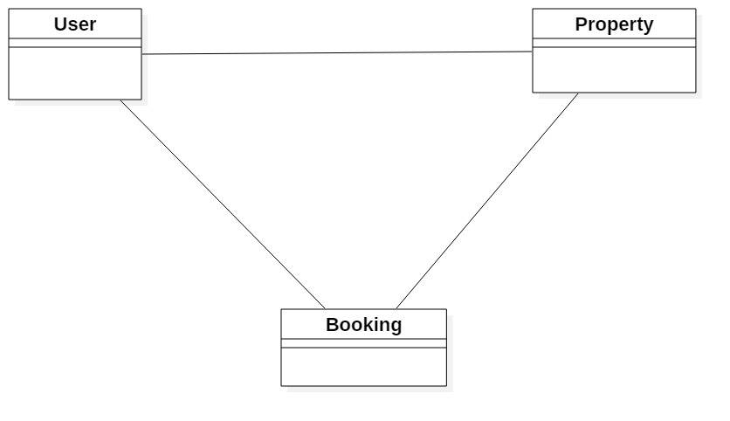

Fig 1 Initial Class Diagram

## Use case Diagram

Use case diagram helps to represent the action that will be performed by different **actors**. Action performed by the actor is shown is **use cases.** Actor can be user, customers etc. it is based on the requirement of the system.

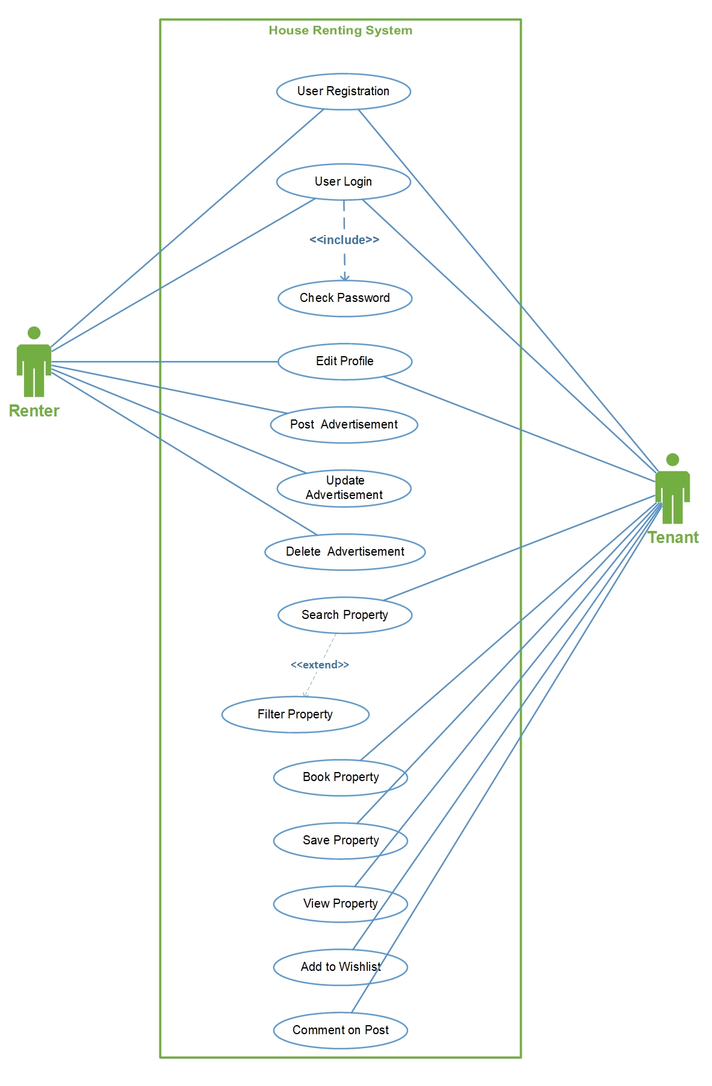

Fig 2 Use case diagram

* **Stickman** Figs represents the **actor** of the system.
* **Oval shape** represents the different **use case** that is performed by the actors.
* **Line** helps to represent the **relationship** of the actor (in above Fig relationship is association).
* **Boundary** around the use case helps to represent the system boundary.

Some of the advantage of use case diagram are:

* Helps to understand who is directly related with the system.
* Helps to identify the different tasks that can be performed by the system.
* It also can help to identify the functional requirement of the system.

Use case diagram was created using Microsoft **VISIO.**

## System Architecture

I am going to use 3-tier Architecture. 3-tier architecture is a hierarchical software architecture which is divided into three layers: A presentation layer, An application layer and A data layer. Reasons for using this architecture are:

* **Increase in efficiency:** Work is divided into several system as each tier has their own function which will help to increase efficiency.
* **Increase in security:** Since RDBMS provides single point access and governs who is retrieving the data and how it is updated.
* **Increase in scalability:** Since System can run in different hardware and OS. The technological stack (OS or related utilities) can be updated without impacting other areas of application.

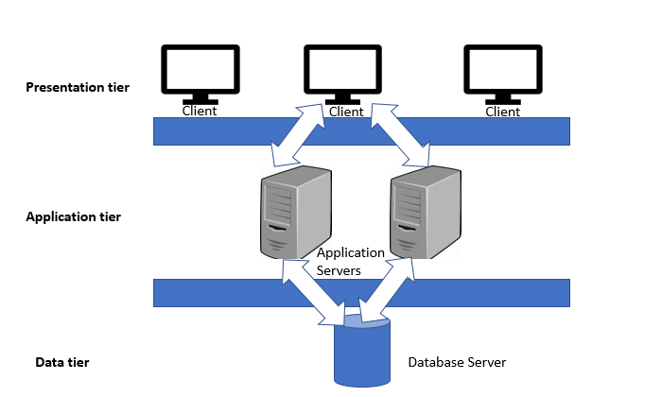

Fig 3 Three tier architecture

**Presentation tier:** Presentation tire is the frontend layer primarily consists of user interface. Interface is commonly available in graphical form from which user interacts with the application.

**Application tier:** Application tier contains the business logics which drives the application which may be written in different programming languages example: C#, PHP, JAVA etc.

**Data tier:** Consists the database/ data storage system Example: MySQL, Oracle I have used **MySQL** database and **XAMPP** 3.2 application to commutate with the database.

# Chapter 3: Design

## Justification

Design just doesn’t represent the UI Design of the application but it also represents methods, functions, objects and overall interaction and structure of the code. Design phase is one of the most important phase of software design because in this phase we decide how we are going to build our project from the very beginning i.e. its framework. Division of the classes also takes place according to what data will a class carry and according to the main function performed by the particular class. Similarly, UI modeling is also an important aspect of the design because it determines how user is going to react to it. Example: software that performs task well but has bad interface might not impress the user but software with good design can flow positive vibes to the user. All the diagram was created using **Star UML** whichis great tool for creating UML diagrams.

## Dynamic modelling

Dynamic modeling is used to define behavior of the system. Dynamic modeling is also used to represent interaction, workflow of the system.

### Activity Diagram

Activity diagram is a dynamic diagram which helps to represent logical process of a system in diagrammatic format. It represents dynamic aspect of a system. Basically, it is a flow chart that shows flow of one activity to other activity. (TutorialPoints, 2019) Activity diagram also help to show detail process of different use cases that is identified in use case diagram. They also show how system work flow are constructed i.e. how they start and end.

These are the notations I have used in my activity diagrams:

* Swim-Lane: All of the classes are divided into different swim-lane to make it easy to understand.
* Initial node: Initial node represents the starting point of the activity.
* Activity: Rectangular boxes that represent the actions.
* Decision: Diamond shape that shows different choices and conditions.
* Flow: they are the arrow which guides towards the end of the diagram.
* Final node: This represent the end of activity.

The activity diagram is shown below:

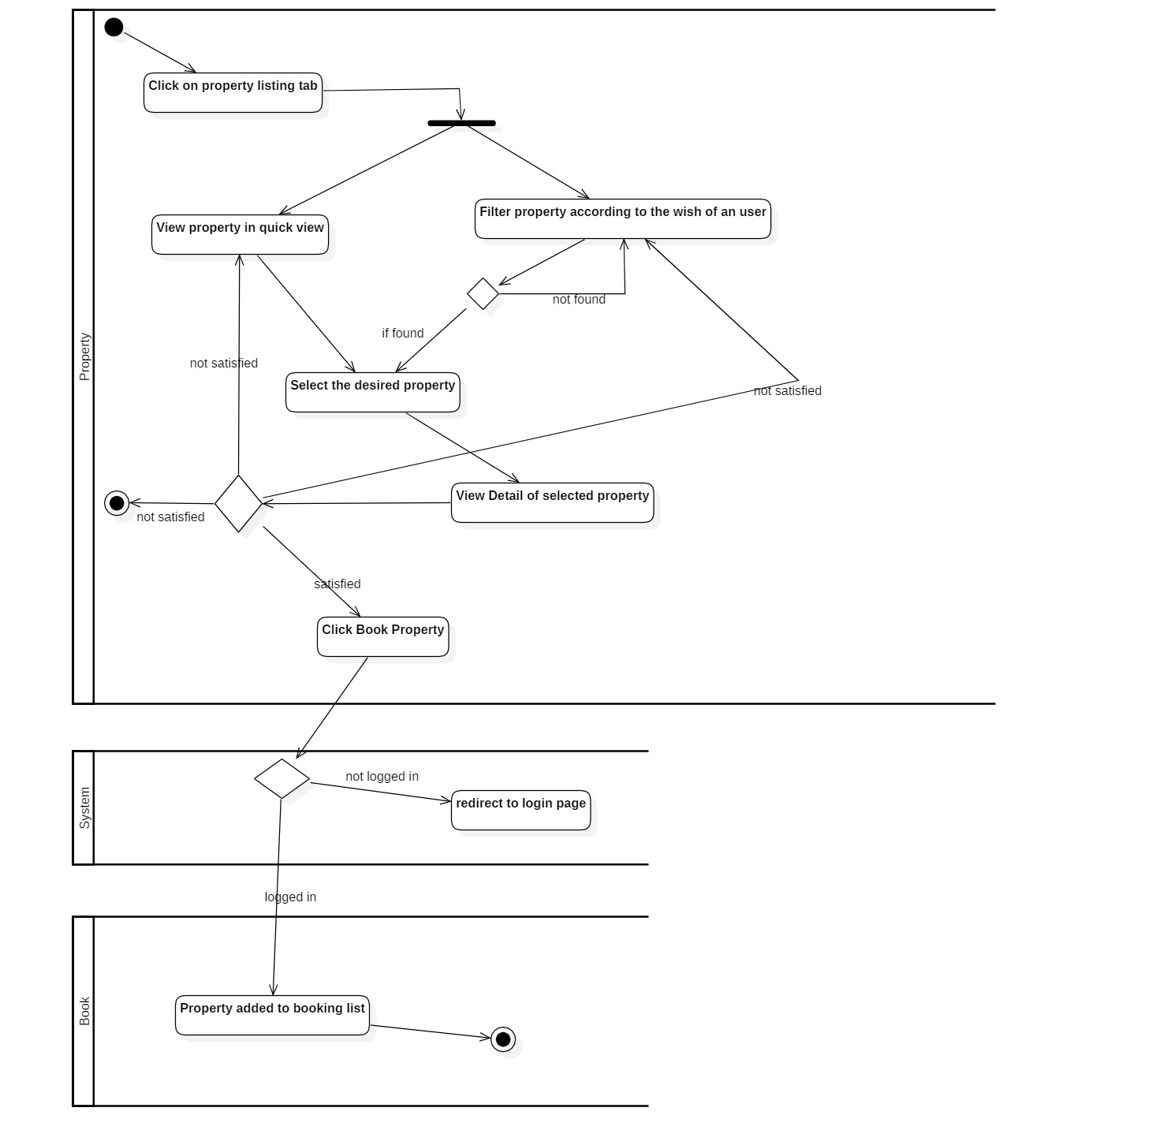

Fig 4 activity diagram showing property booking

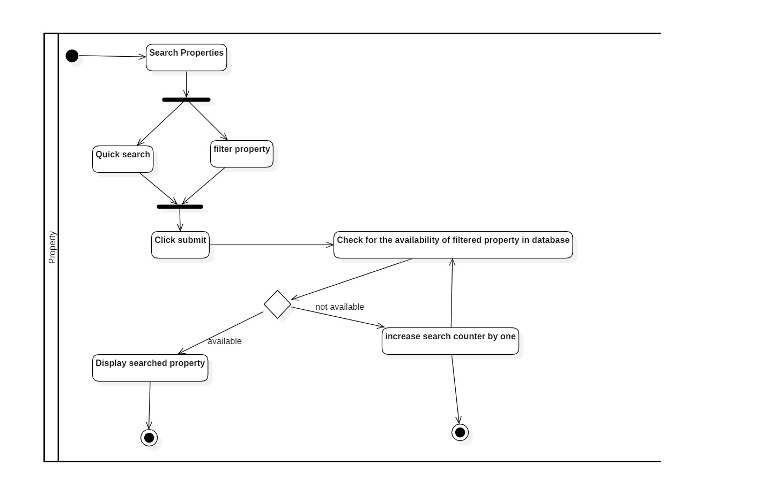

Fig 5 Activity diagram - search property

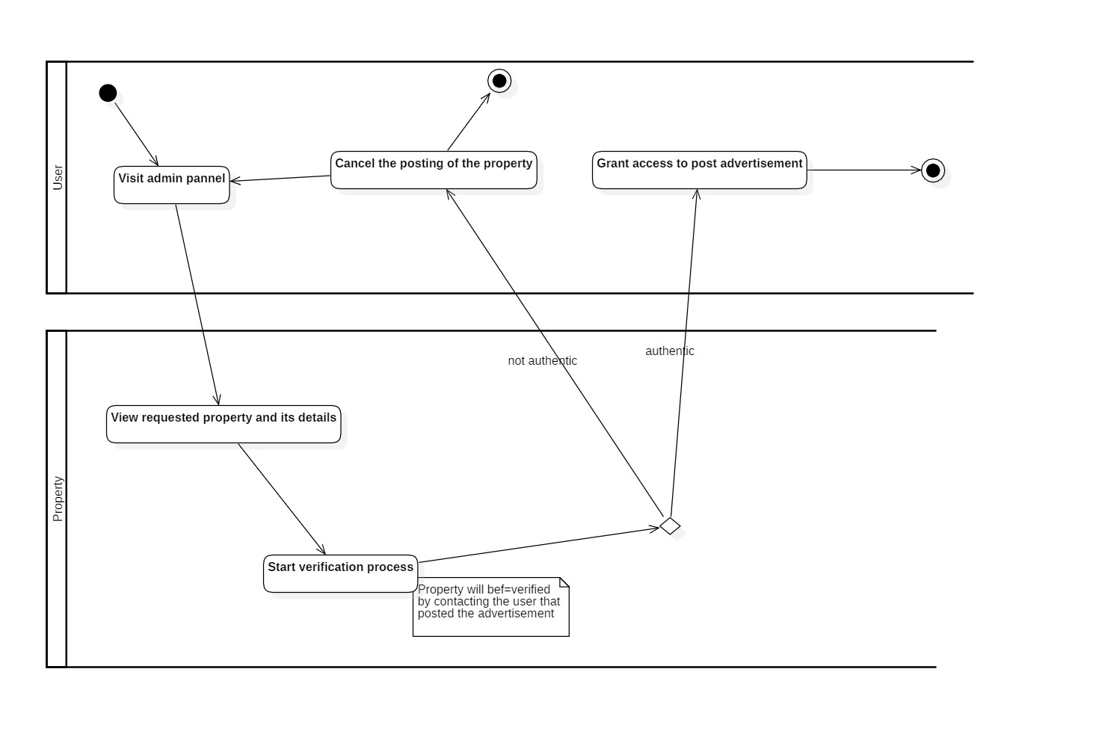

Fig 6 Activity Diagram - Admin verification

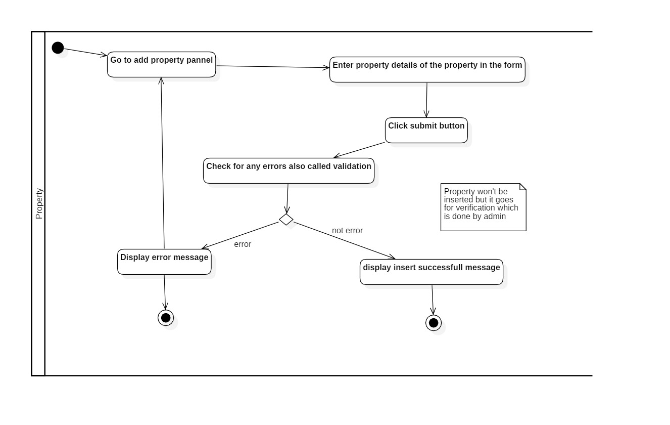

Fig 7 Activity Diagram - Add property

### Sequence Diagram

Sequence diagram is a dynamic diagram which helps to show logical process of the system in sequential way which looks much cleaner as compared it to activity diagram. How the user interact with the system and internal functionality of the system is also shown.

Sequence diagram consists of different notations like:

* Actor: which is denoted by stickman Fig but in this diagram, it is represented by cross square box.
* Lifeline: the dotted horizontal line.
* Call and Return Message: call message is denoted by dotted arrow and return by clean straight-line arrow.

Sequence diagram also consists of different operators which helps to denotes various operations is being performed. Like: alt (alternative choices), loop (indicates iteration).

**Note: There are many other notations and operators which might not be covered in this documentation.**

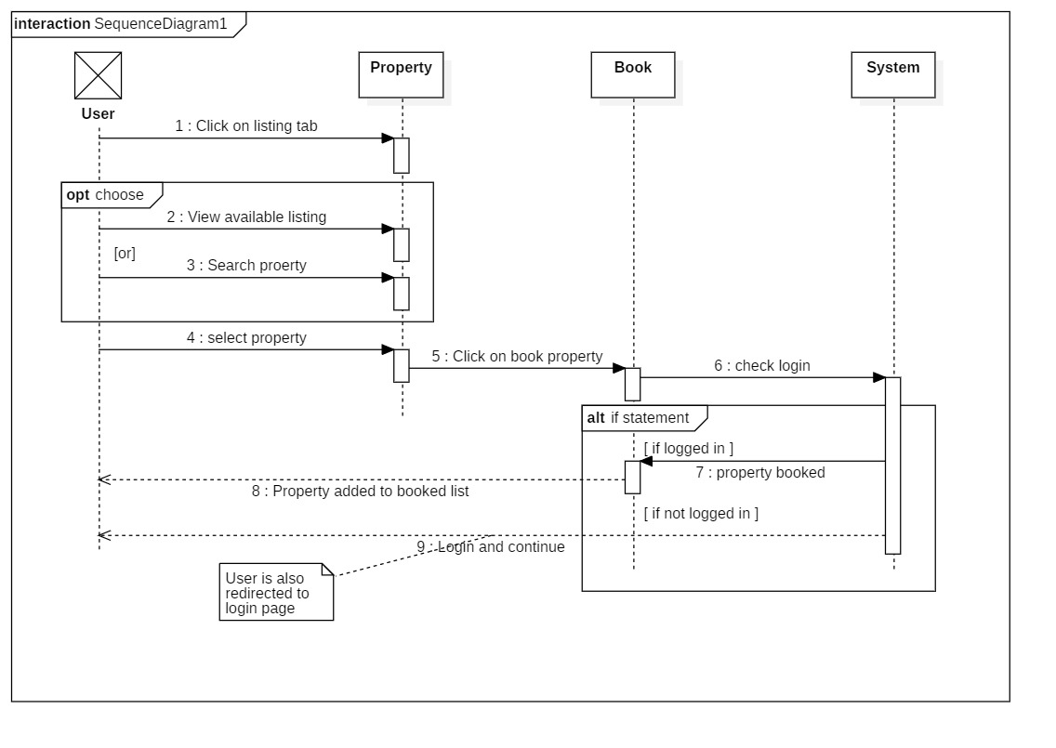

Fig 8 Sequence Diagram - Book property

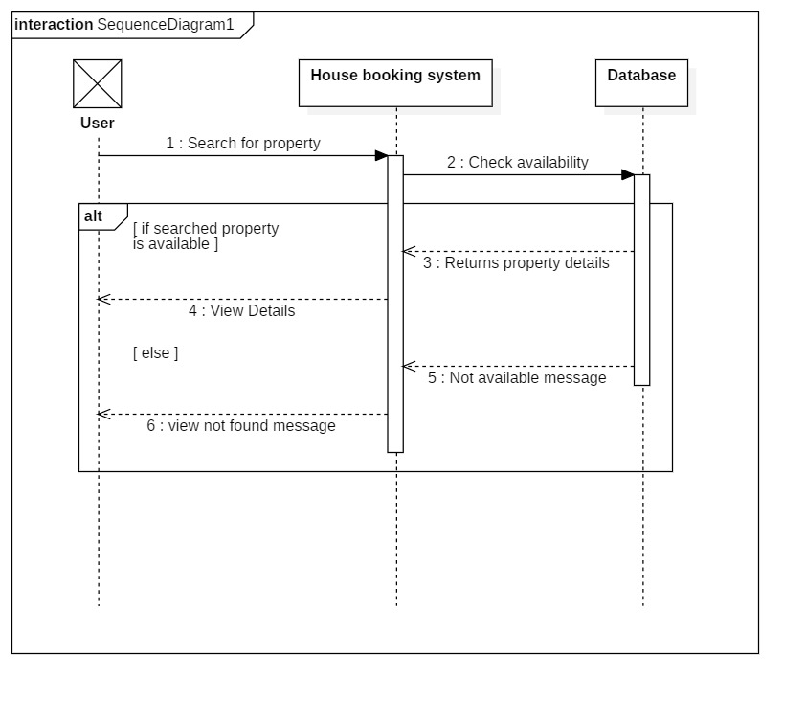

Fig 9 Sequence Diagram - Search

## Structural modelling

Structural modeling is UML modeling which shows fixed structure of a system. It shows the static structure of the system along with the relationship between different objects, attributes, operations etc. Some of the structural diagrams are: class diagram, DFD (Data Flow Diagram).

### Architecture level class diagram

It is an UML diagram which shows classes, attributes, operations and relation between them of any system. Class diagram helps to model the overall system. Class shows different methods, attributes. Attributes help to describe the class and class consists of different relationship like: inheritance, association, Aggregation etc.

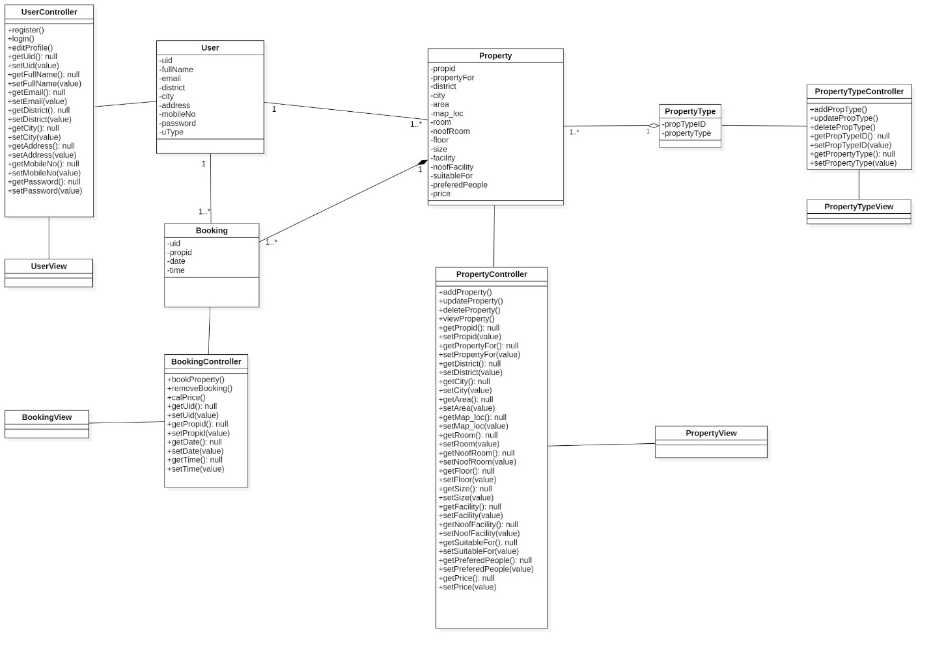

Fig 10 Architecture level class diagram

### DFD (Data Flow Diagram)

DFD is a structural diagram that shows flow of an information for any process carried out in the system. How the flow of data is being started and ended. Main building block of data flow diagram are:

* Processes: Transformation of the data takes place in this activity.
* External Entity: They helps to show from where data are coming or where data is sent to.
* Data Stores: Place where data is stored temporarily (t) or permanently (p)
* Data Flows: shows the movement of the data itself.

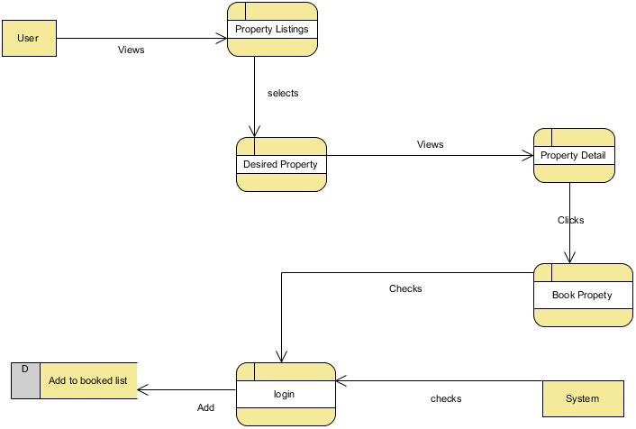

Fig Data-Flow-Diagram : Booking

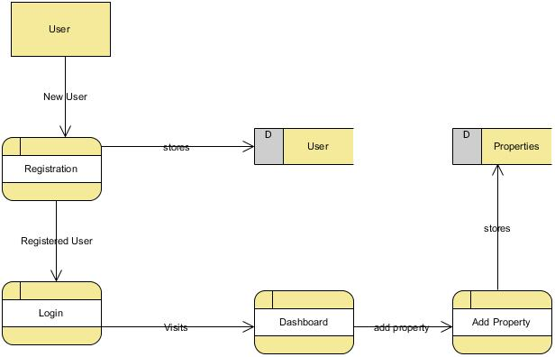

Fig 12 DFD - Add property

## Database Modeling

Process of creating the data model by implementing certain technique is called database modeling.

### ER-Diagram

Entity relationship diagram (ERD) shows the relation of the entities. Entity is anything that distinct existence. It is created by normalizing the existing table. ERD helps to identify logical structure of database. It is a structural diagram used in database design. It contains different notation which helps to identify the relation. The notation that I have used crows-feet notation in my ER-Diagram.

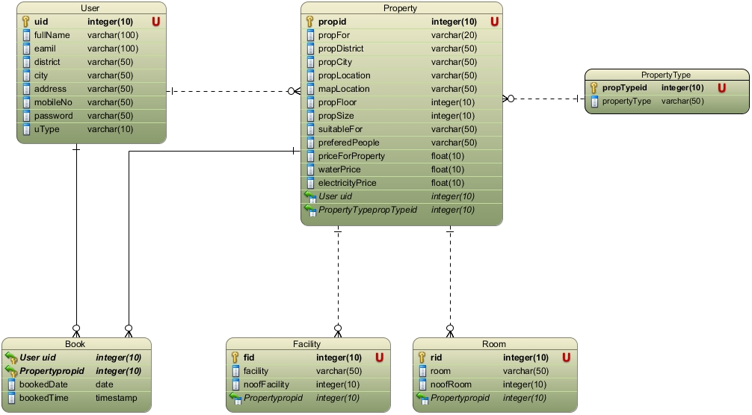

Fig 13 HRS- ER-Diagram

### Data Dictionary

Data dictionary is simply the collection of metadata. It is used to manage large amount of data. Data dictionary contains datatype of the data along with its length, nullable, key and constraint. It also helps to find the errors in the created table of data. Data dictionary helps to show the description of the data.

Screenshot of data dictionary of my database table are shown below.

**User Table**

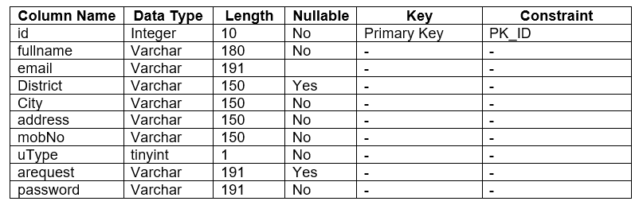

Fig 14 Data Dictionary - User Table

**Properties Table**

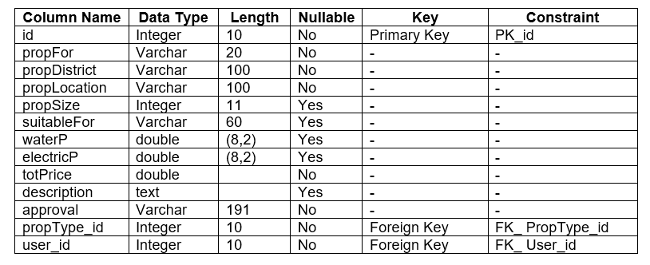

Fig 15 Data Dictionary - Properties Table

**Booking Table**

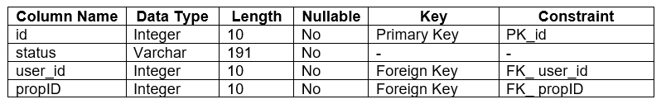

Fig 16 Data Dictionary - Booking Table

**Facilities Table**

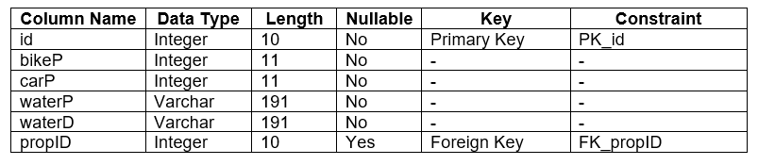

Fig 17 Data Dictionary - Facilities Table

**Rooms Table**

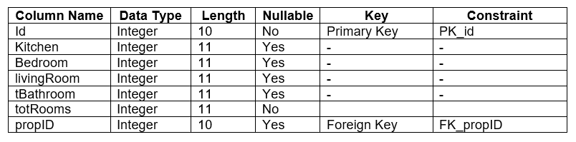

Fig 18 Data Dictionary - Rooms Table

### UI-Modelling (Prototyping)

Prototyping is an early sample of any final UI. Before developing the final user interface its important to create prototype because it let’s us to identify how the final product is going to look. Error that might occur during the development might get eliminated by making prototype at the first place.

Some of the prototype that I have created for my project are:

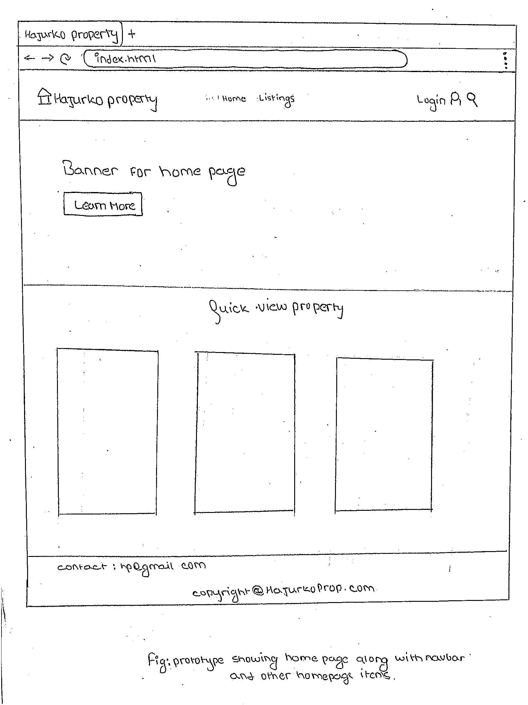

Fig Home Page

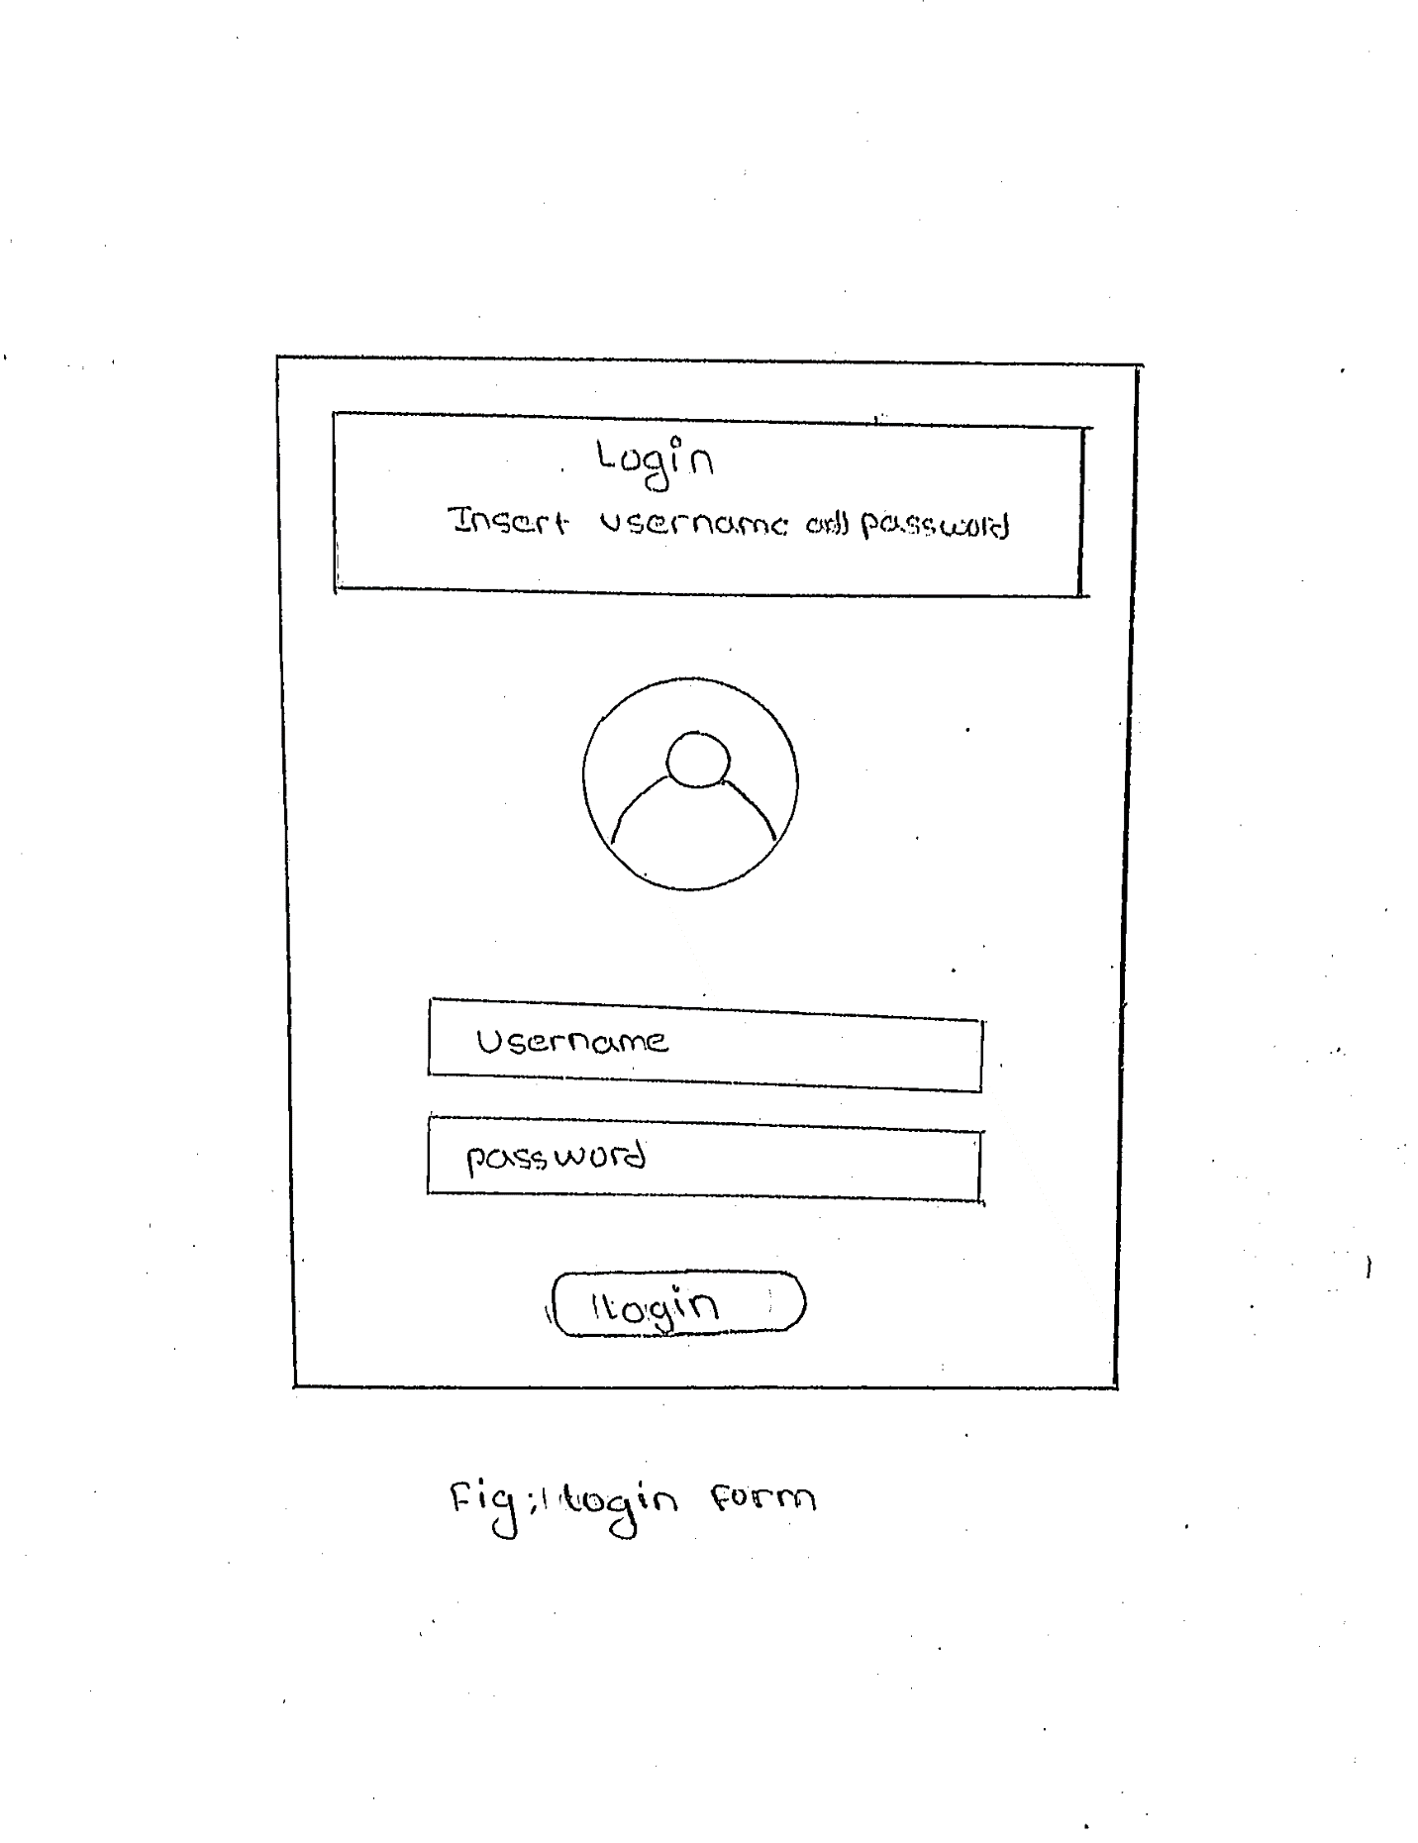

Fig Login

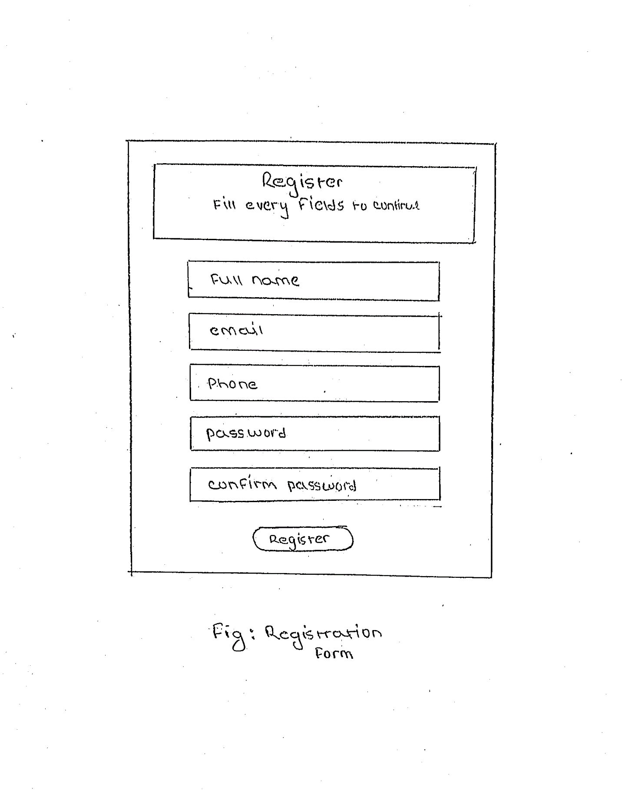

Fig Register

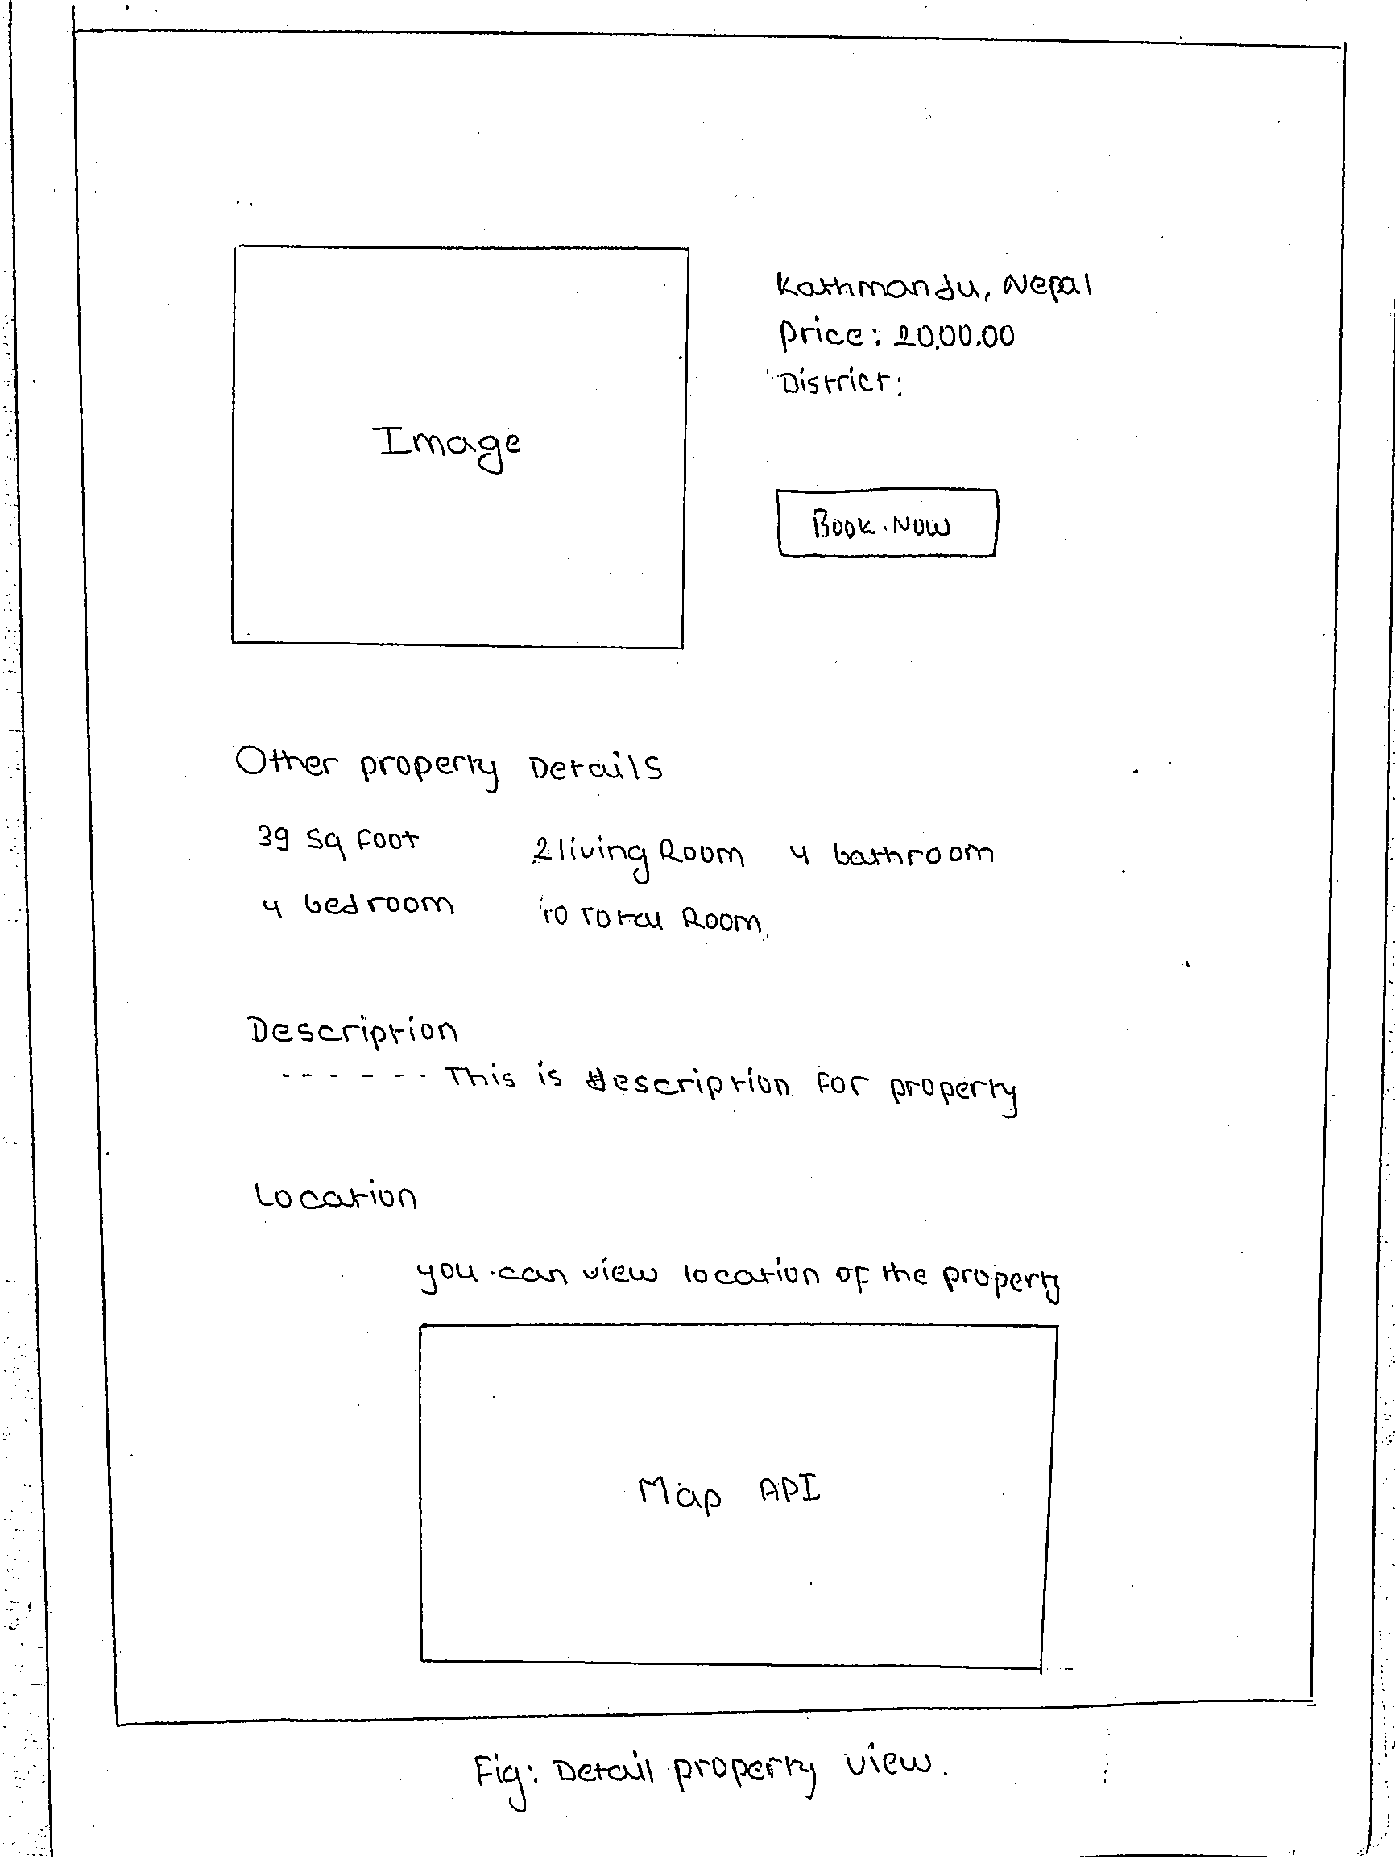

Fig Detail Property View

## Chapter 4: Implementation

Implementation is the fourth stage of SDLC where actual coding of the program takes place. stage like analysis we analyzed the information and in design I created different diagrams and, I have converted those diagrams in to working code in this phase of software development.

### Programing language and framework

Choosing right programing language is crucial. I have chosen **PHP** as a main programming language and I have also used **JavaScript** and bit of a **jQuery** to perform multiple functions and to provide some cool feature and animations to the interface. Since I have built my application in web form this is the main reason for choosing PHP as my main programming language for **framework,** I have used **Laravel** framework because it is simply the best PHP framework available. It supports MVC pattern which is probably the best pattern to write the program on and it also increases performance of the system. MVC eliminates the problem of code management. It has multiple built-in functionality which comes in handy during development of an application. Laravel consists of object-oriented libraries which provides amazing features like security and patches. Laravel Artisan command is used to execute any king of services.

MVC pattern in Laravel looks like this:

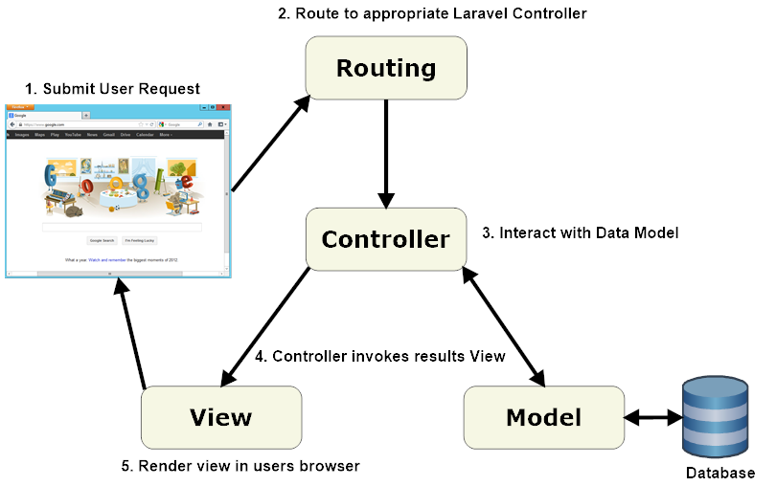

Fig 23 Implementation - Laravel MVC Architecture

Fig link: (ValueCoders, 2019)

### Design pattern

I have used MVC design pattern. Here M - Model, V - View and C – Controller. The reasons for using MVC pattern are: (Solution, 2019)

* Since Model deals with the logical implementation, View deals with the interface (UI) and controller handles user interaction MVC helps to categorize the responsibility of each fields.
* Modification: If we are requiring to make any sort of modification in the code then it will be easier as code are well managed. If modification is done in one class then it will not affect other classes since functionality are divided into individual classes.
* High Cohesion and Low coupling

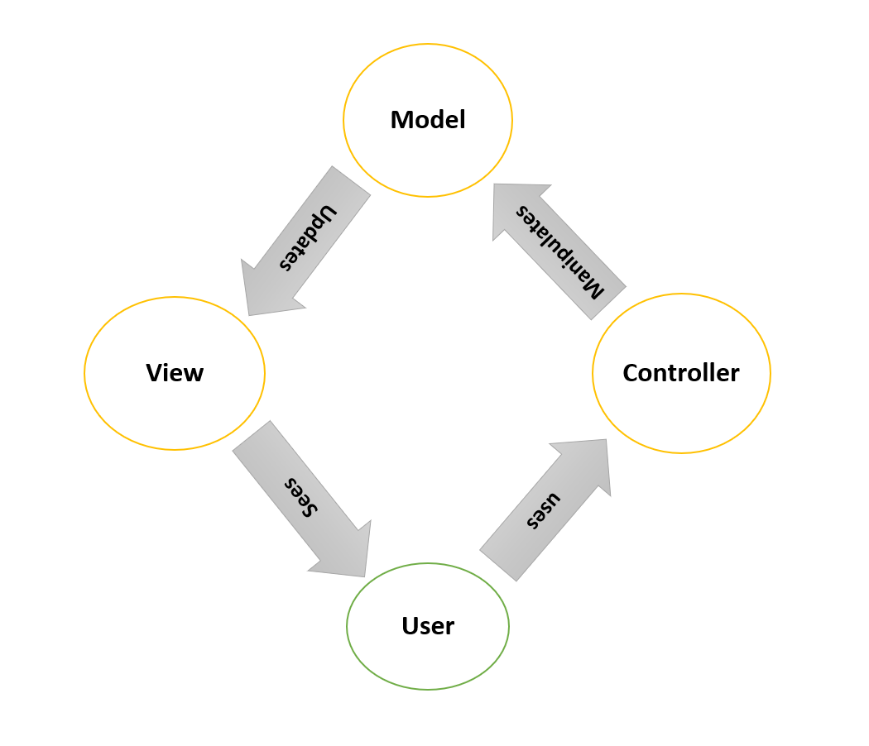

Fig 24 Implementation - MVC Architecture

### Methodology used

I have used waterfall methodology to develop the application. Waterfall is the sequential process of developing application i.e. step by step process so by implementing this methodology I can track my progress pretty smoothly. Other reasons for choosing waterfall methodology are:

* Waterfall model is simple and easy to understand
* Since my project is small and requirements are well understood so using this model will be suitable.
* Project will be easy to manage because the model is rigid itself.

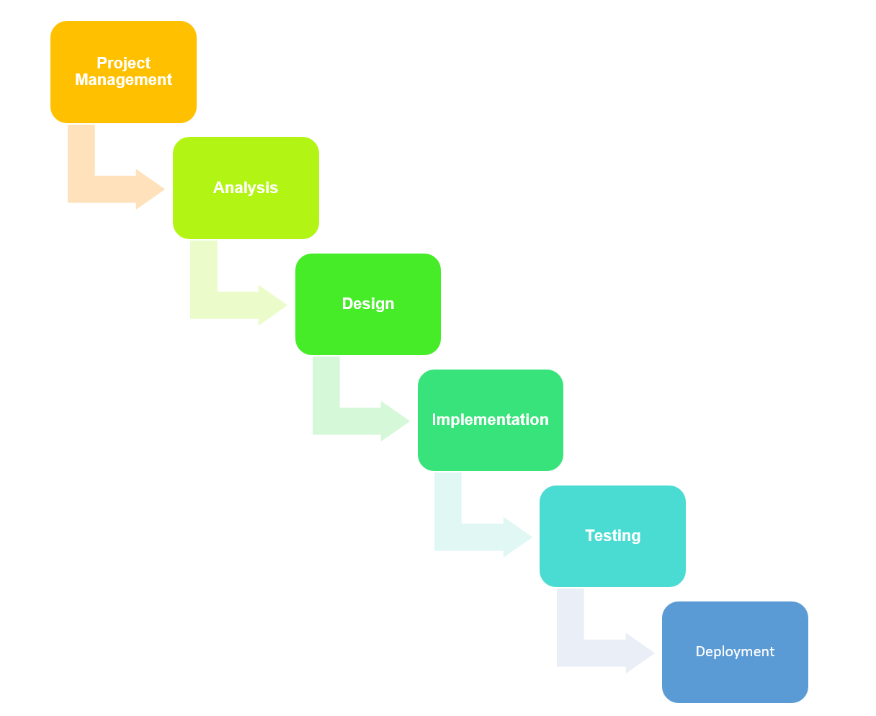

Fig 25 Implementation - Phases of waterfall model

**Note: Snapshot of code and UI are added in appendix of this documentation**

## Chapter 5: Testing

The fifth stage of SDLC is testing where code is tested to make it sure that it is performing as intended. Without any flaws, without any errors. Testing also helps to assure the quality of the code. Basically, it is the process of executing a program in order to find the bugs which will allow us to solve the problem that we have identified. This process of **validating and verifying** helps us to make sure that software/ program is bug free. There are various types of testing methods but in this topic I have particularly focused on unit and black box testing.

**Vendor/bin/phpunit** is used to execute the test and **Vendor/bin/phpunit –filter (function name)** is written in command to execute individual function. Laravel automatically sets configuration for testing in .env file. Laravel also gives us chance to manually conFig environmental variable.

**Black box testing:**

Black box testing is a kind of testing where the internal behavior, implementation etc. is unknown. It is also known as behavioral testing. I have tested my GUI using black box testing. Basically, we identify how the system is performing. We can identify following categories of error using Black box testing: (fundamentals, 2019)

* Error in validation
* Error in performance of the system
* GUI error also called as interface error.

Some of the testing along with their test cases is shown below:

Test Case – 1

|  |  |
| --- | --- |
| **Test Suite** | **Black Box Testing 1** |
| Test Number | 1 |
| Purpose of the test | password validation |
| Expected Result | Successful validation |
| Actual result | success |
|  |  |

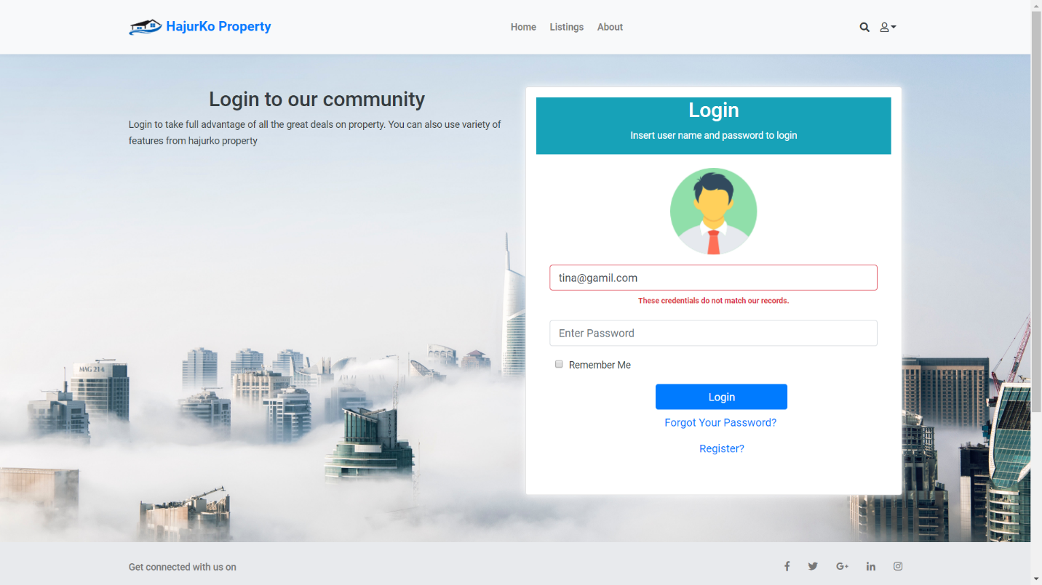

Fig 26 Password validation

Test Case – 2

|  |  |
| --- | --- |
| **Test Suite** | **Black Box Testing 2** |
| Test Number | 2 |
| Purpose of the test | Empty box form validation |
| Expected Result | Successful validation |
| Actual result | success |

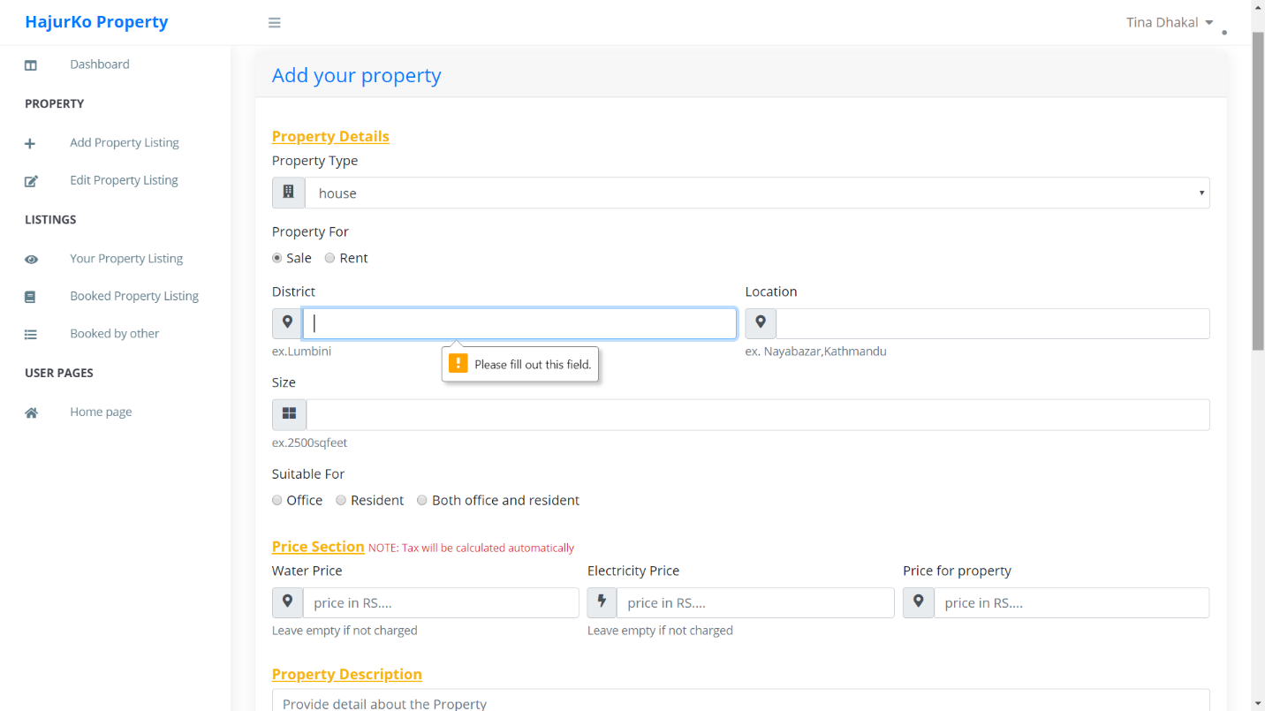

Fig 27 Empty form validation

Test Case – 3

|  |  |
| --- | --- |
| **Test Suite** | **Black Box Testing 3** |
| Test Number | 3 |
| Purpose of the test | email validation |
| Expected Result | Successful validation |
| Actual result | success |

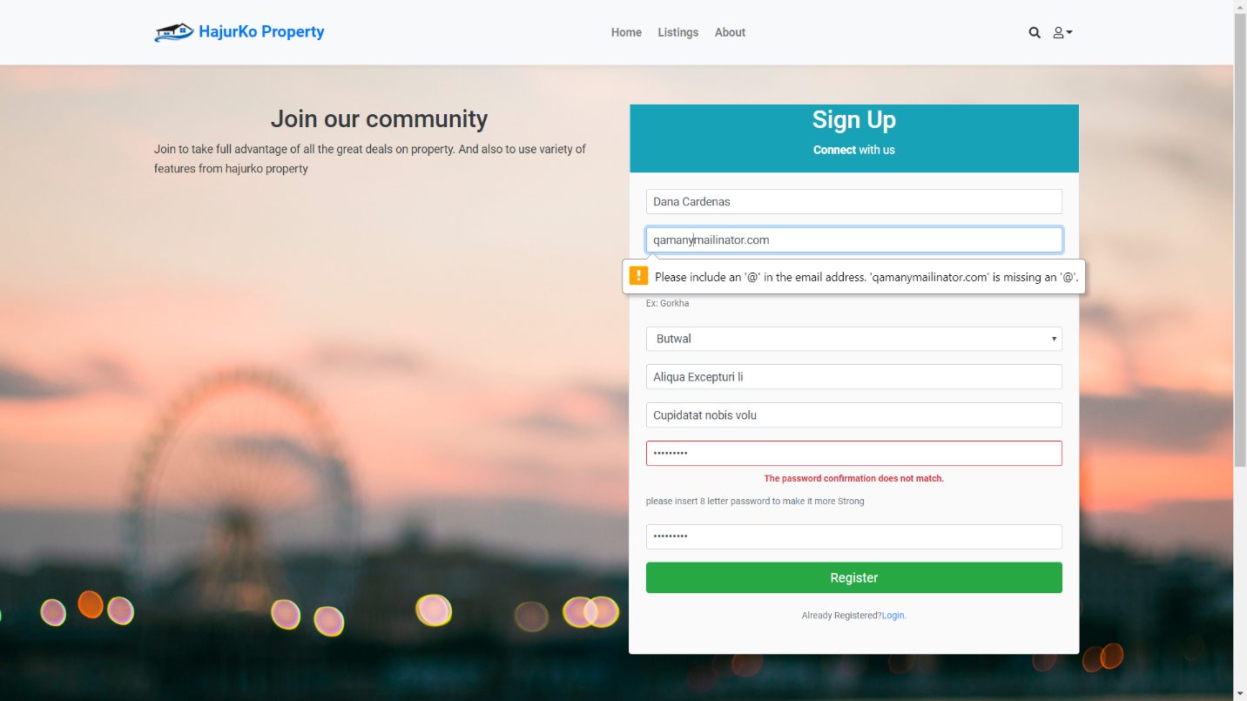

Fig 28 Email validation

**Unit testing:**

Unit testing are the test that focus on very small and isolated part of the code. In fact, most unit test focus on the single method single or small functionality testing. According to **software testing** unit testing is the level of testing where each individual unit are tested. Individual units may be single function, procedure etc. (fundamentals s. t., 2019)

Some unit testing along with their test cases are shown below:

Test Case – 1

|  |  |
| --- | --- |
| **Test Suite** | **Unit Test 1** |
| Test Number | 1 |
| Purpose of the test | To check whether the user can register or not |
| Test Data |  |
| Expected Result | User should be registered successfully. |
| Actual result | User was successfully registered |
| Class involve in test | User |
| Comments |  |

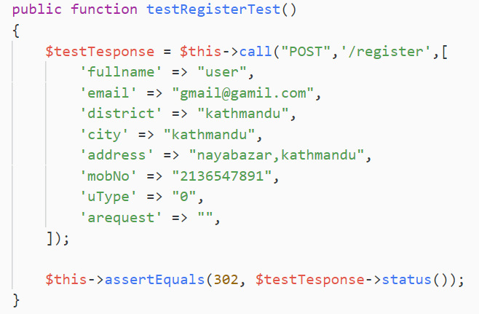

Fig 29 Testing – register

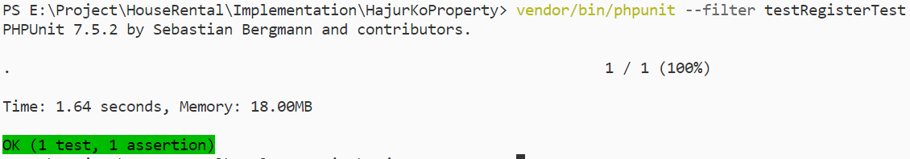

Fig 30 Testing - Register Success

Test Case – 2

|  |  |
| --- | --- |
| **Test Suite** | **Unit Test 2** |
| Test number | 2 |
| Purpose of the test | To check whether the user can login or not |
| Test Data |  |
| Expected Result | User should be able to login successfully |
| Actual result | User can login |
| Class involve in test | User |
| Comments |  |

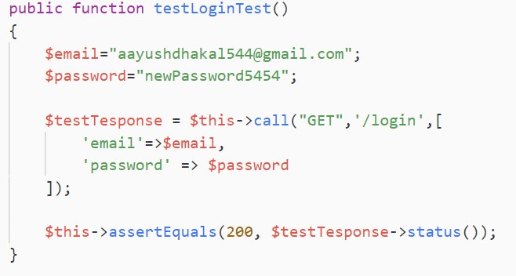

Fig 31 Testing - Login

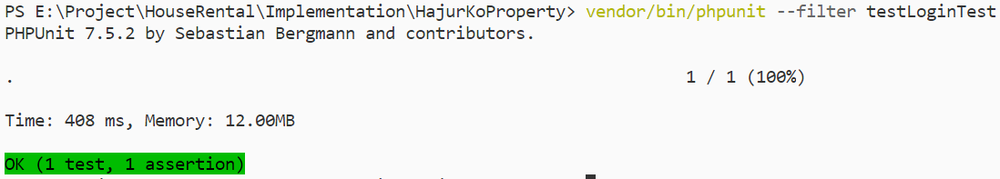

Fig 32 Testing - Login Success

Test Case – 3

|  |  |
| --- | --- |
| **Test Suite** | **Unit Test 3** |
| Test number | 3 |
| Purpose of the test | User should not be able to go to login page once they are logged-in |
| Test Data |  |
| Expected Result | user should be unable to visit the login page |
| Actual result | Test result was positive |
| Class involve in test | User |
| Comments |  |

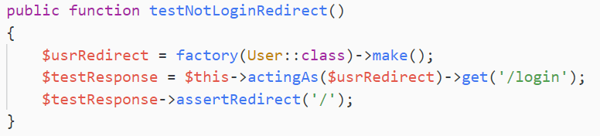

Fig 33 Testing – notLoginRedirect

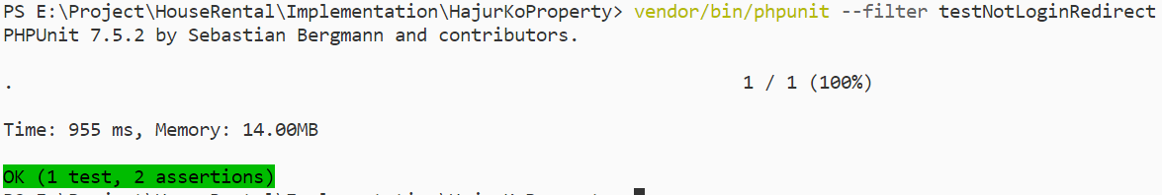

Fig 34 Testing – notLoginRedirect

Test Case – 4

|  |  |
| --- | --- |
| **Test Suite** | **Unit Test 4** |
| Test number | 4 |
| Purpose of the test | Whether user can update the profile or not |
| Test Data |  |
| Expected Result | User should be able to update the profile |
| Actual result | Test was not passed |
| Class involve in test | User |
| Comments | Asserting the provided data failed due to wrong route value passed. |

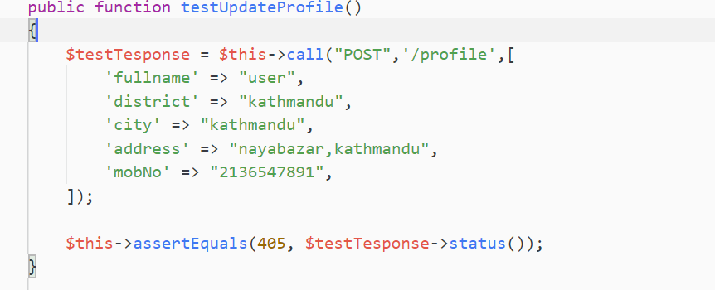

Fig 35 Testing - Update profile

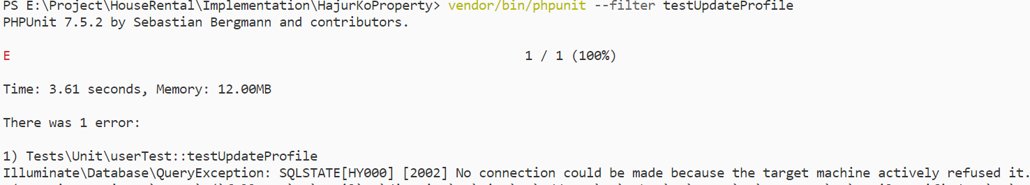

Fig 36 Testing - Update profile failed

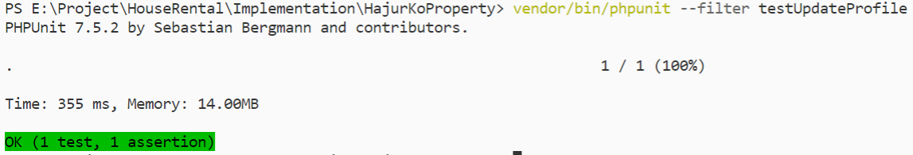

Fig 37 Testing - Update profile passed

Test Case – 5

|  |  |
| --- | --- |
| **Test Suite** | **Unit Test 5** |
| Test number | 5 |
| Purpose of the test | Testing whether the user is admin or not. |
| Test Data |  |
| Expected Result | User should be admin |
| Actual result | Test was passed |
| Class involve in test | User |
| Comments | User was identified as admin as 1 bool value was given for admin |

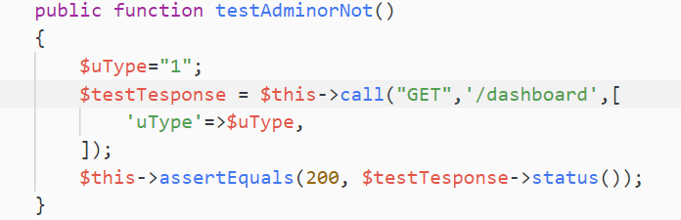

Fig 38 Testing - User is admin or not

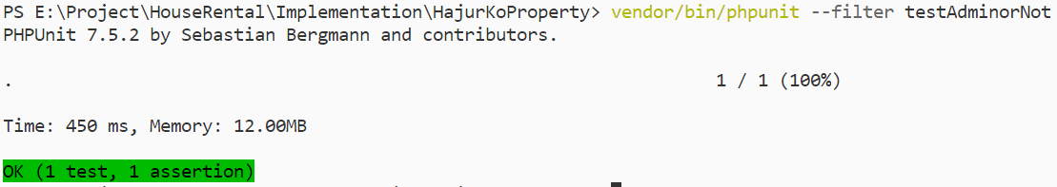

Fig 39 Testing - User is admin or not – success

Test Case – 6

|  |  |
| --- | --- |
| **Test Suite** | **Unit Test 6** |
| Test number | 6 |
| Purpose of the test | Whether user can search by location or not |
| Test Data | Kathmandu |
| Expected Result | User should be able to search via location |
| Actual result | Search was successful |
| Class involve in test | Properties |
| Comments | Was able to search via location |

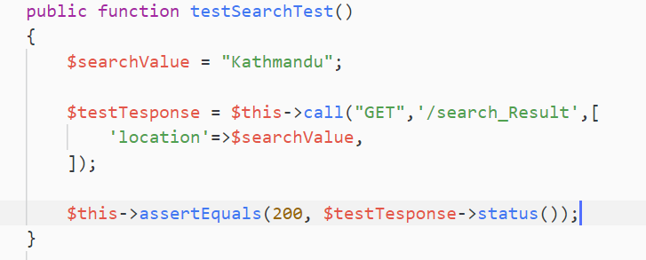

Fig 40 Testing – Searching

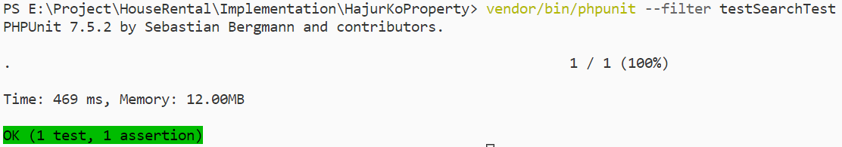

Fig 41 Testing - Searching - success

Test Case – 7

|  |  |
| --- | --- |
| **Test Suite** | **Unit Test 7** |
| Test number | 7 |
| Purpose of the test | Whether property type is empty or not |
| Test Data |  |
| Expected Result | Property type box should not be empty |
| Actual result | Result was positive |
| Class involve in test | Proptypes |
| Comments | Property type was empty until admin added it. |

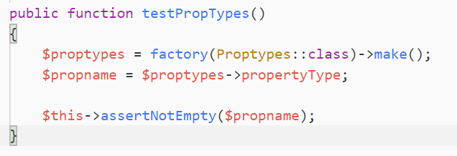

Fig 42 Testing – Property Type is empty or not

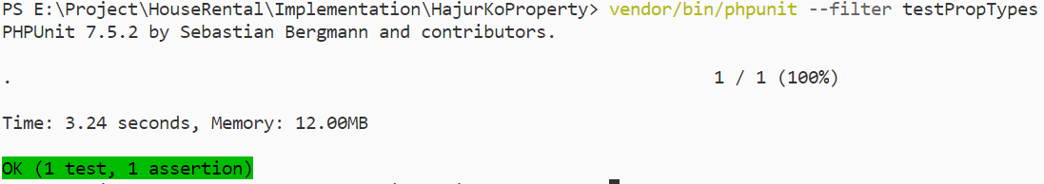

Fig 43 Testing - Property Type is empty or not - success

Test Case – 8

|  |  |
| --- | --- |
| **Test Suite** | **Unit Test 8** |
| Test number | 8 |
| Purpose of the test | Whether property can be added or not |
| Test Data | Property insert fields |
| Expected Result | Property should be added |
| Actual result | Test passed |
| Class involve in test | Properties |
| Comments | User was able to add new property |

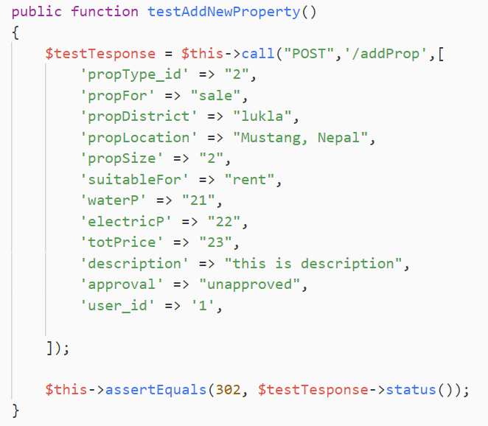

Fig 44 Testing - property can be added or not

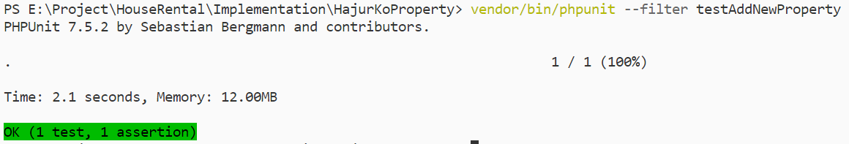

Fig 45 Testing - Adding property success

Test Case – 9

|  |  |
| --- | --- |
| **Test Suite** | **Unit Test 9** |
| Test number | 9 |
| Purpose of the test | Whether user can add property if they aren’t logged-in |
| Test Data |  |
| Expected Result | They should not be able to visit the add property page at all |
| Actual result | Test result was positive |
| Class involve in test | Properties, Facilities, Rooms |
| Comments | User was unable to visit the page |

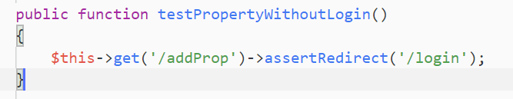

Fig 46 Testing - add property without login

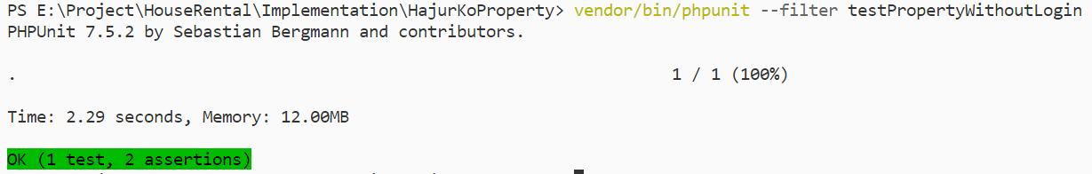

Fig 47 Testing - add property without login success

Test Case – 10

|  |  |
| --- | --- |
| **Test Suite** | **Unit Test 10** |
| Test number | 10 |
| Purpose of the test | Whether user can view property without login or not |
| Test Data |  |
| Expected Result | They should be able to view the property |
| Actual result | Success |
| Class involve in test | Properties, Facilities, Rooms, User |
| Comments | User was able to view the property |

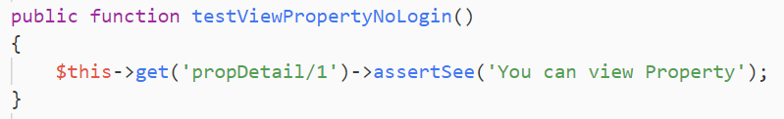

Fig 48 Testing - view property without login

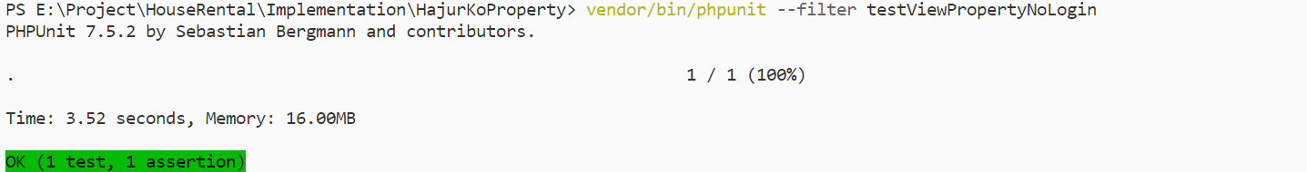

Fig 49 Testing - view property without login success

Test Case – 11

|  |  |
| --- | --- |
| **Test Suite** | **Unit Test 11** |
| Test number | 11 |
| Purpose of the test | Whether user can book property if they are not logged-in |
| Test Data | unbook |
| Expected Result | Should not be able to book property if not logged-in |
| Actual result | Test passed |
| Class involve in test | Properties, Bookings |
| Comments | Used was redirected to login as I have provided the route. |

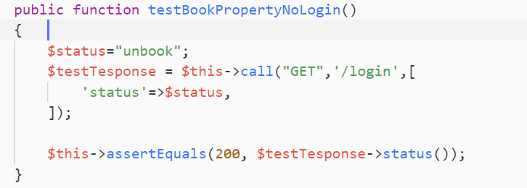

Fig 50 Testing - book property

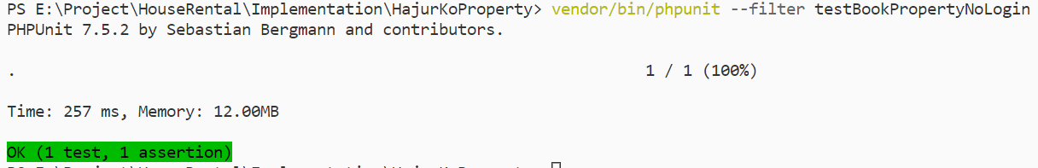

Fig 51 Testing - Book property success

## Chapter 6: Other project issues

### Work Breakdown Structure

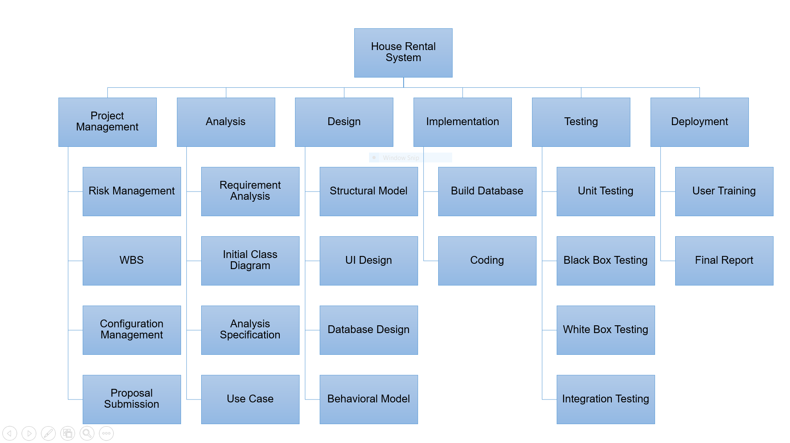

Fig 52 Work Breakdown Structure (WBS)

**Work Breakdown Structure (WBS)**

Process of dividing complex project to simpler and manageable form is called Work Breakdown structure. Larger tasks that is hard for us to understand are broken down into small chunks which is more manageable and can be understand easily. By dividing large project into smaller chunk, we can also keep track of our work and allocate the time as per the importance of the tasks. This will definitely help to manage time and remove frustration which may cause due to project. (Target, 2019)

### Milestones

|  |  |
| --- | --- |
| **Milestones** | **Date** |
| **Project Management**  Risk Management  Work Breakdown Structure  Configuration Management  Proposal Submission | **12/21/2018 -1/1/2019**  12/21/2018 - 12/23/2018  12/24/2018 - 12/26/2018  12/27/2018 - 12/30/2018  12/31/2018 - 1/1/2019 |
| **Analysis**  Requirement Analysis  Use Case  Architecture (Initial Class Diagram)  Analysis Specification | **1/2/2019 - 1/25/2019**  1/2/2019 - 1/8/2019  1/9/2019 - 1/13/2019  1/14/2019 - 1/18/2019  1/19/2019 - 1/25/2019 |
| **Design**  Structural Diagram  Behavioral Diagram  UI Design  Database Design (ER, Data Dictionary) | **1/26/2019 - 2/24/2019**  1/26/2019 - 2/4/2019  2/5/2019 - 2/14/2019  2/15/2019 - 2/19/2019  2/20/2019 - 2/24/2019 |
| **Implementation**  Building Database  Coding | **2/25/2019 - 3/28/2019**  2/25/2019 - 3/1/2019  3/2/2019 - 3/28/2019 |
| **Testing**  Unit Testing  Integration Testing  Blackbox Testing  Whitebox Testing | **3/29/2019 - 4/8/2019**  3/29/2019 - 3/31/2019  4/1/2019 - 4/3/2019  4/4/2019 - 4/6/2019  4/7/2019 - 4/8/2019 |
| **Deployment**  User Training  Final Report | 4/9/2019 - 4/18/2019  4/9/2019 - 4/149*-/2019  4/15/2019 - 4/18/2019 |

**Description of Milestones:**

* **Project Management (12 days)**
  + - Risk Management (3 days)
    - Work Breakdown Structure (3 days)
    - Configuration Management (4 days)
    - Proposal Submission (2 days)
* **Analysis (24 days)**
  + - Requirement Analysis (7 days)
    - Use Case (5 days)
    - Architecture (Initial Class Diagram) (5 days)
    - Analysis Specification (7 days)
* **Design (30 days)**
  + - Structural Diagram (10 days)
    - Behavioral Diagram (10 days)
    - UI Design (5 days)
    - Database Design (ER, Data Dictionary) (5 days)
* **Implementation (32 days)**
  + - Building Database (5 days)
    - Coding (27 days)
* **Testing (11 days)**
  + - Unit Testing (3 days)
    - Integration Testing (3 days)
    - Blackbox Testing (3 days)
    - Whitebox Testing (2 days)
* **Deployment (10 days)**
  + - User Training (6 days)
    - Final Report (4 days)

### Scheduling / Gantt Chart

Scheduling is a process of arranging the daily tasks that is to be performed. I computing we schedule to keep track of our work and move forward. To see the complete plan of the project (When is it going to start and end) scheduling is done. There are various means of scheduling the project one of them is Gantt chart. I have addressed milestone using Gantt chart shown below.

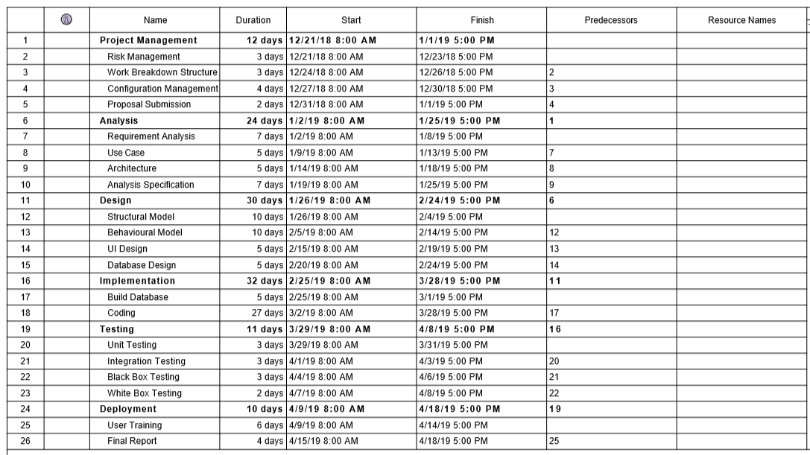

Fig 53 Date and time assigned for tasks

### Risk Management

Risk management is the process of identifying, accessing and prioritizing the risk that may occur in the system. Risk is prioritized according to the harmfulness of the risk and the risk that harms the most is either solved or an alternative solution is prepared for it. It is the situation where the project is exposed to danger. **Risk cannot be solver completely but it can be minimized to make sure that system is running smoothly.** So, being proactive to these kings of problem will definitely help in minimizing the risk.

In this particular project I have calculated risk by using formula that is:

**Impact = Likelihood * Consequences**

**Risk Likelihood values are shown as follows**

|  |  |
| --- | --- |
| Likelihood | Value |
| Low | 1 |
| Medium | 2 |
| High | 3 |

**Risk Consequence values are shown below**

|  |  |
| --- | --- |
| Consequence | Value |
| Very low | 1 |
| Low | 2 |
| Medium | 3 |
| High | 4 |
| Very High | 5 |

**Some of the risk that I have identified are:**

|  |  |  |  |  |  |
| --- | --- | --- | --- | --- | --- |
| S.NO | Risks | Likelihood | Consequences | Impact | Solution |
| 1 | Schedule risk | 2 | 4 | 8 | Task should be completed in time from the very beginning to an end |
| 2 | Cost and resources risk | 2 | 3 | 6 | Available resources should be managed properly to use them in future. |
| 3 | Failure to meet requirement | 2 | 5 | 10 | We should not proceed our work until we are clear about the requirement. |
| 4 | System failure | 1 |  | 5 | Project should be backed up properly so it can be used even there is system failure. Eg: backup in cloud. |
| 5 | Lack of planning | 2 | 4 | 8 | Better planning should be done to avoid above mentioned risks. |
| 6 | Hardware failure | 1 | 4 | 5 | Make sure all the hardware components are working properly. Check if unusual heating has occurred. |

# Configuration Management

Configuration Management is the process of establishing and maintaining consistency of the product’s performance, functional and physical attributes with its requirements, design and operation information through its life (Rouse, 2019) . In Information Technology it is also called **Software Configuration Management (SCM). SCM** process is looked up by the active person searching for the best solution to handling changes in software projects. Git hub is also one of the ways to manage the modified code where all of the changes are updated regularly.

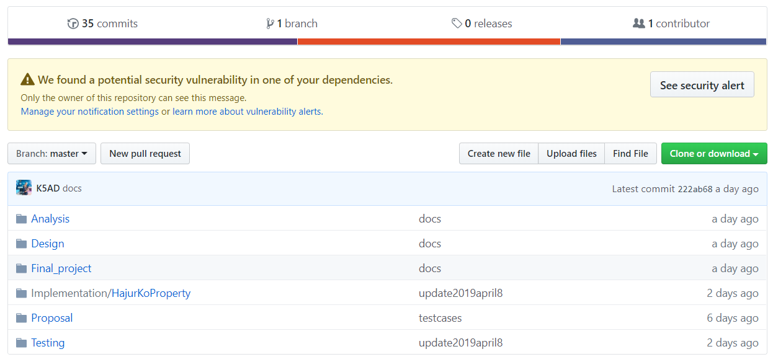

Fig 54 Configuration Management - gilt repo

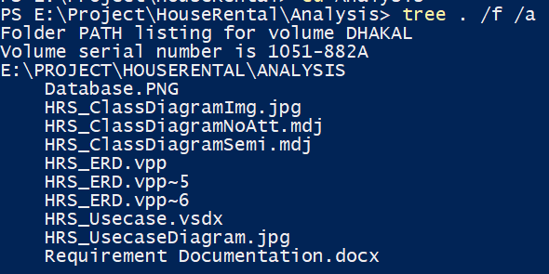

Fig 55 Configuration Management - tree structure – Analysis

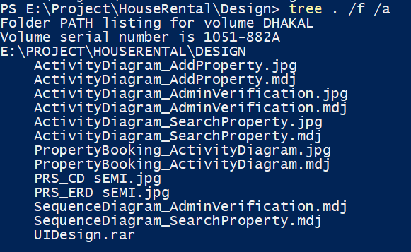

Fig 56 Configuration Management - tree structure - Design

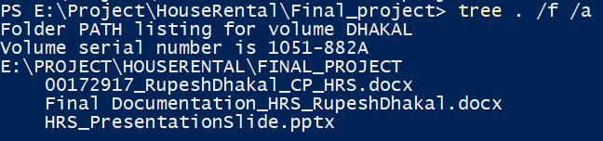

Fig 57 Configuration Management - tree structure - Final project

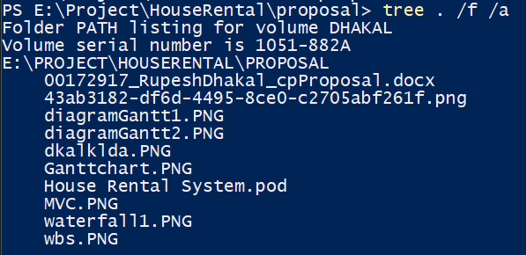

Fig 58 Configuration Management - tree structure – Proposal

### Future work

There was some work that was not completed due to some issues like time management and so on. Those work was holed for future development i.e. in the next update of this application.

Some of the future work are listed below:

* Improvement in design using UI/UX: Improving design will make user feel that there were certain changes made and also make them to stick for longer period of time.
* Realtime chat system between owner and buyer. it can also be said as community forum where one person places their queries and get rid of their confusions.
* Online payment system: This time around user can only book the property which is not very comfy. Enabling online payment will allows them to buy the property wherever they are.
* Strong security mechanism: Currently this web application consists of basic verification which updated to version 2.
* Google map API implementation: it’s costly to apply google map for startup project hence it will also be implemented in future applications update.

### User manual

User manual is necessary for guiding user about using the application. User manual are intended to assist user, providing the detail about the system and inform on how to use a particular system.

**Login System**

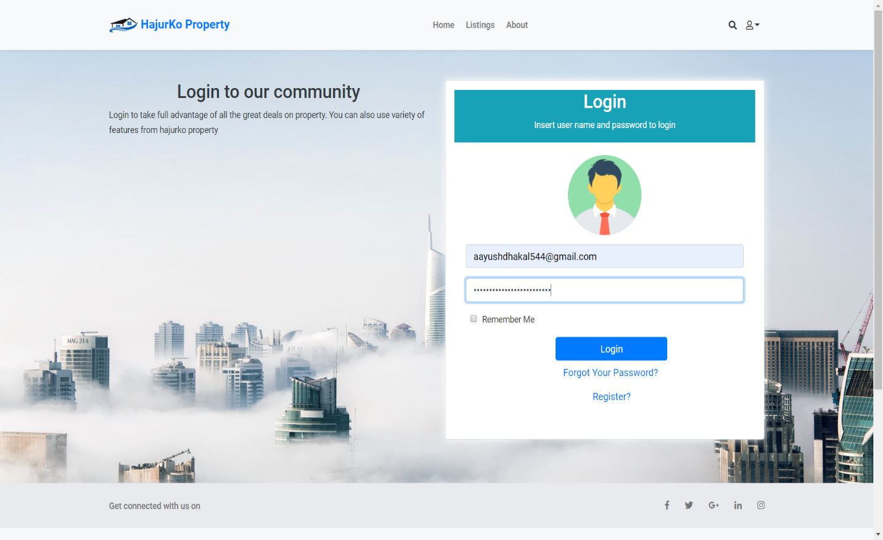

Fig 59 User Manual – login

**Steps to follow:**

* Firstly, enter correct website URL
* Insert valid credentials (Email and Password)
* Click login button
* Then, system will validate information you have given
* If information matched with the database information you will be successfully logged-in.

**Registration System**

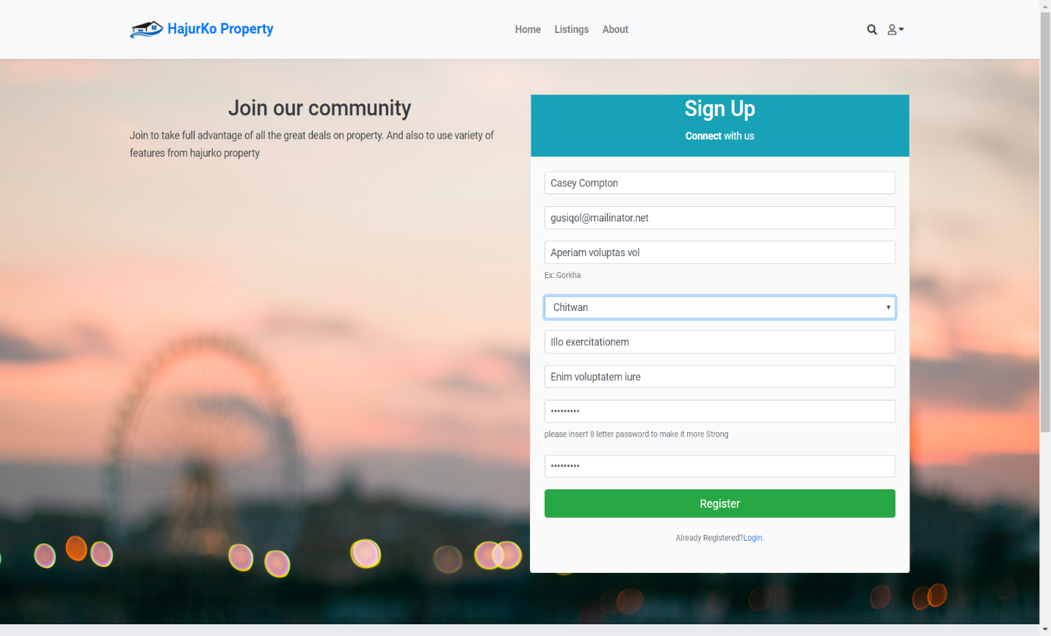

Fig 60 User Manual – Registration

**Steps to follow:**

* Firstly, enter correct website URL
* Insert valid credentials **as shown in the above diagram**
* Click register button
* Then, system will validate information you have given like valid email, valid passwords (password length)
* If information matched with the database information you will be successfully logged-in.

**Quick Search Property**

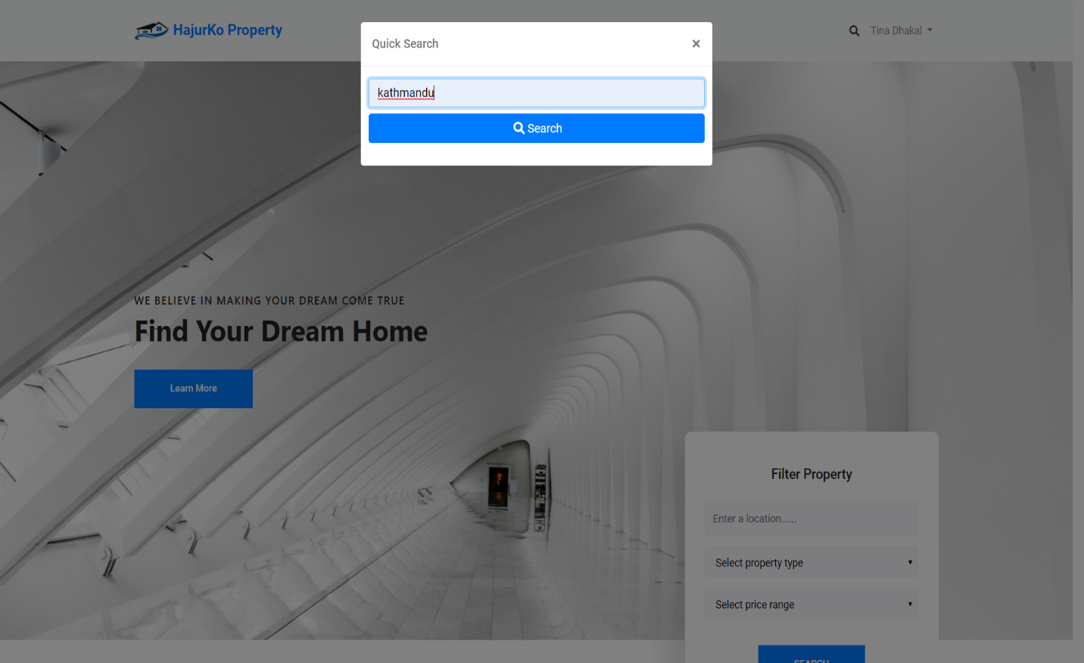

Fig 61 User Manual - Quick Search

**Steps to follow**

* Firstly, enter correct website URL
* Click on search icon that is shown in navigation bar (left hand side of user’s name dropdown)
* Quick search window will appear
* Insert in location of the property as you can only search the property via location here
* Click on search button
* You can view your result if it is available in the database

**Custom property searching**

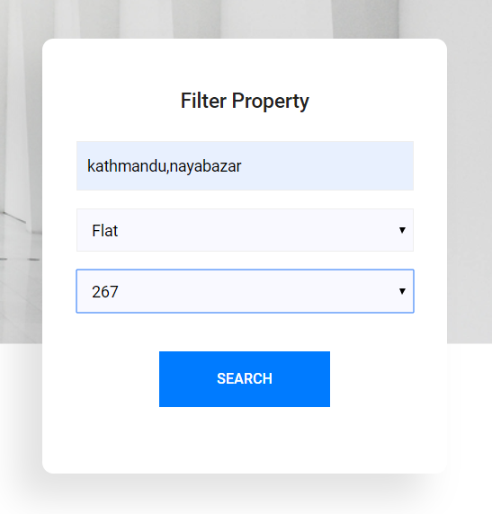

Fig 62 User Manual - Custom Search

**Steps to follow**

* Firstly, enter correct website URL
* Scroll down the home page until you find the box that looks similar as above Fig.
* Insert in the desired location, property type, price
* Click on search button
* You can view your result if it is available in the database

**Add property window**

**Steps to follow**

* Firstly, you have to be logged-in to add the property
* Click on user name shown on top right corner of navigation bar as highlighted in Fig below



Fig 63 User Manual – navbar

* You will be presented with menu like this:

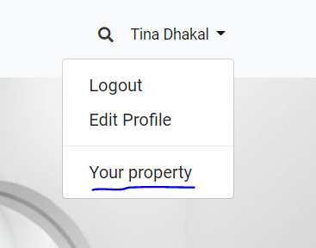

Fig 64 User Manual – dropdown

* Click on your property as highlighted in above Fig

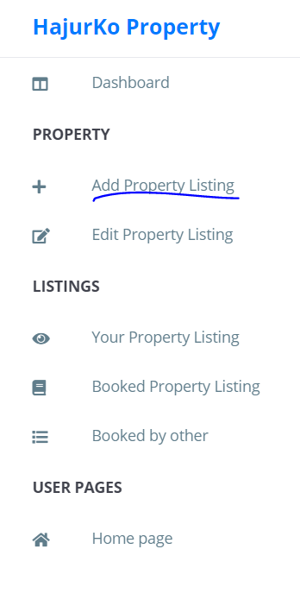

* You will get the side navigation as shown in the above Fig
* Then, click on add property as highlighted in above Fig
* You will be directed to adding property page as shown in Fig below

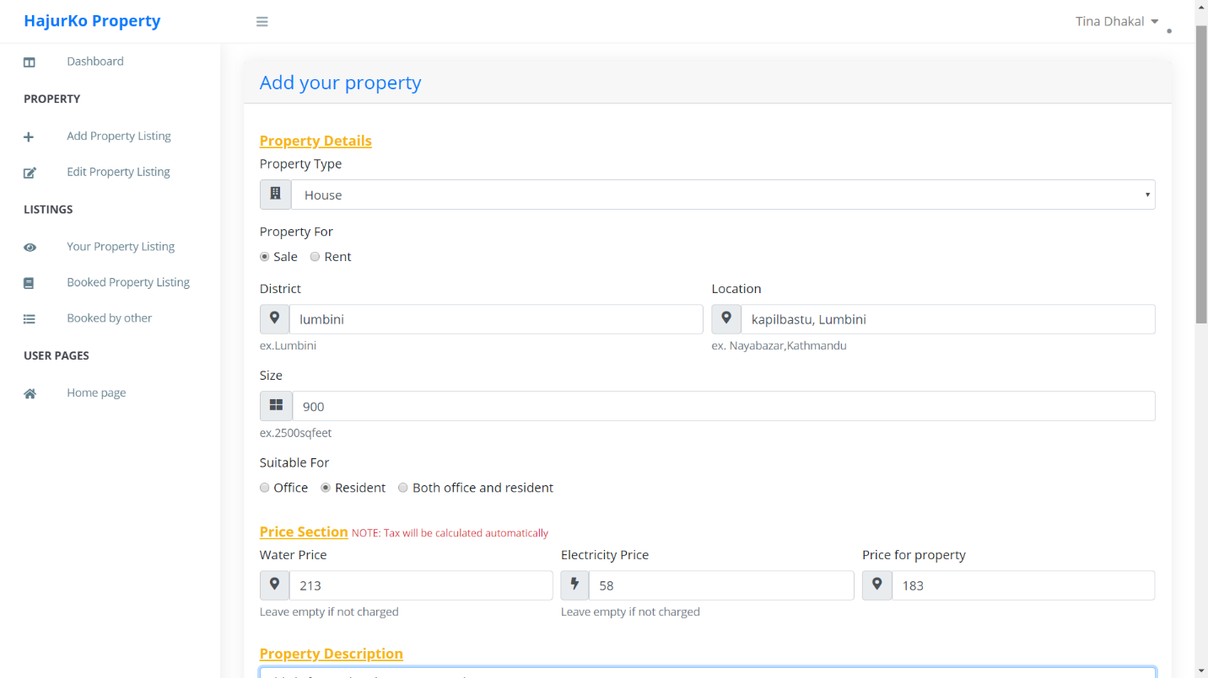

Fig 65 User Manual - Adding property

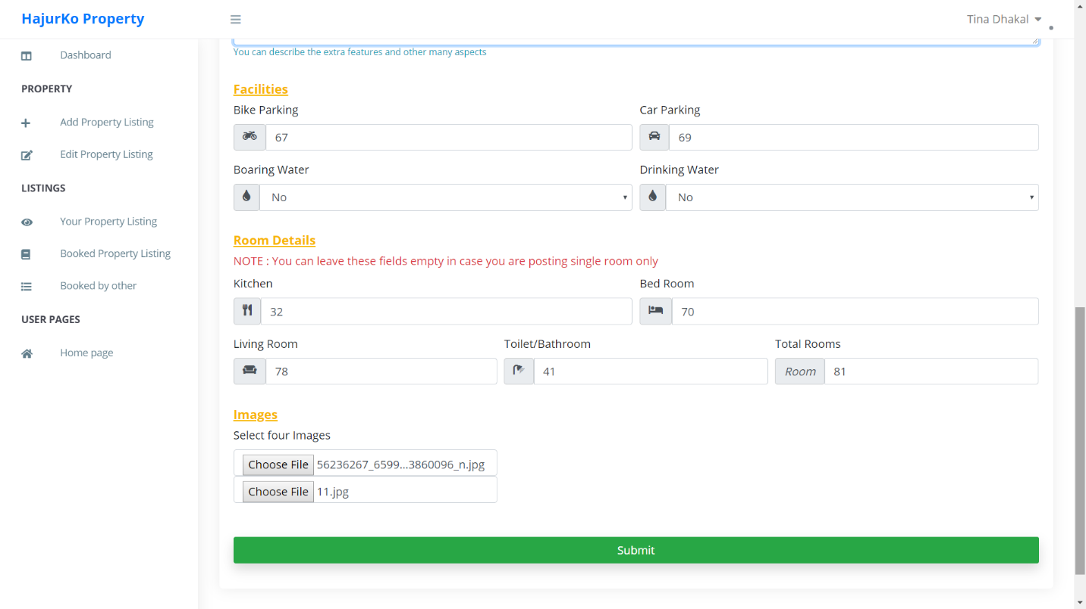

Fig 66 User Manual - Adding Property 2

* Insert all the fields and click on submit button

### Limitations

Even though web application was completed successful performing main functions there are some limitation in the very application those are:

* Strong Verification: There is verification process that verifies whether the user property is genuine or not but it’s just a static method where admin contact the owner and ask about it. Which in my view can be improved?
* Lack of communication: Real time communication(chat) between customer and owner of the property is not available. This might make user bit lousy to contact user by other means of communication
* Map API: customer might not be able to view exact location of property due to lack of google map API which is costly and may not be afforded as a startup project.
* Online payment: It would be great if user would have a facility to pay for the property online but in other hand people tend to ask owner and pay manually once they find suitable properties.

# Chapter 7: Conclusion

At conclusion I successfully created web application that performs main task which I intended. All the basics requirements were fulfilled. Some of the functionality are missing due to some reason which is listed in future work above. I hope this project will solve the current problem that is faced by people to search property. Firstly, analysis was done to identify the project purpose. Then design was created (different dynamic and structural models). Based on the design implementation was done which created working application. The application is also completely tested in crucial parts to ensure it work as intended. Lastly, other issues regarding the project was mentioned.

# Chapter 8: Reference and bibliography

fundamentals, s. t. (2019, 4 9). *software testing fundamentals*. Retrieved from software testing fundamentals: http://softwaretestingfundamentals.com/unit-testing/

fundamentals, S. t. (2019, 4 9). *Software testing fundamentals*. Retrieved from Software testing fundamentals: http://softwaretestingfundamentals.com/black-box-testing/

Point, T. (2019, 4 8). *Tutorials Point*. Retrieved from Tutorials Point: https://www.tutorialspoint.com/object_oriented_analysis_design/ooad_object_oriented_analysis.htm

ReqTest. (2019, 4 8). *ReqTest*. Retrieved from ReqTest: https://reqtest.com/requirements-blog/understanding-the-difference-between-functional-and-non-functional-requirements/

TutorialPoints. (2019, 02 19). *TutotialPoints*. Retrieved from tutorialPoints: https://www.tutorialspoint.com/uml/uml_activity_diagram.htm

ValueCoders. (2019, 4 9). *ValueCoders*. Retrieved from ValueCoders: https://www.valuecoders.com/blog/technology-and-apps/laravel-best-php-framework-2017/

# Chapter 9: Appendix

Screen shot of all the codes are shown below:

**Model**

Here, I have shown all the models that were created

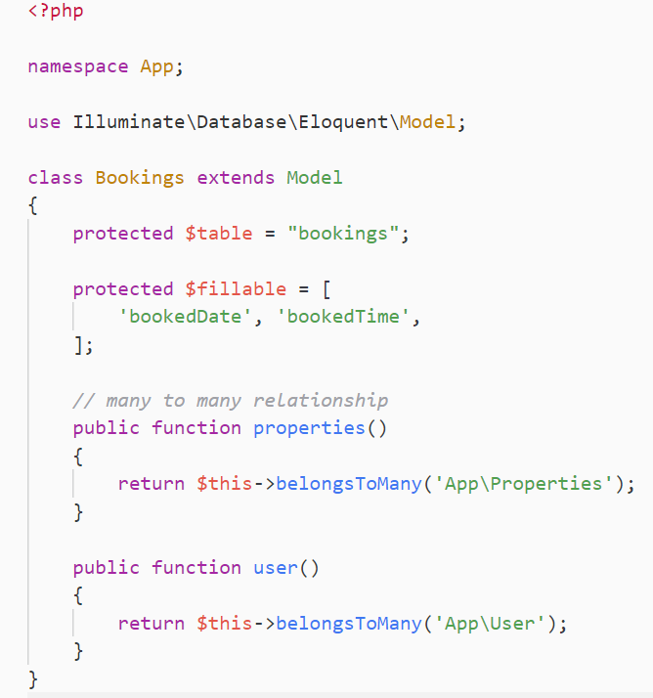

Fig Model – Bookings

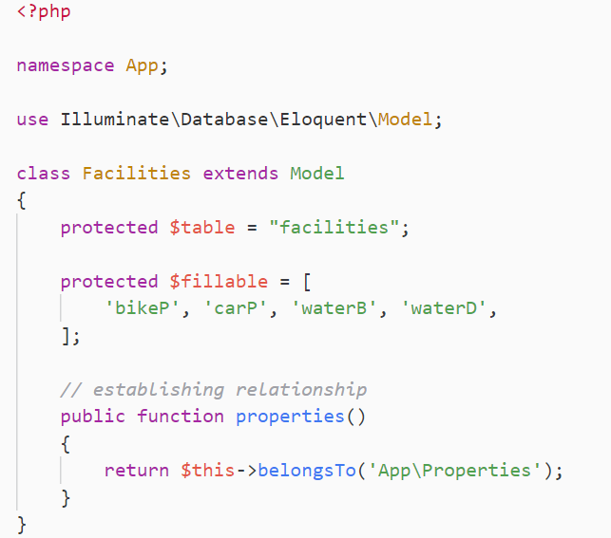

Fig Model – Facilities

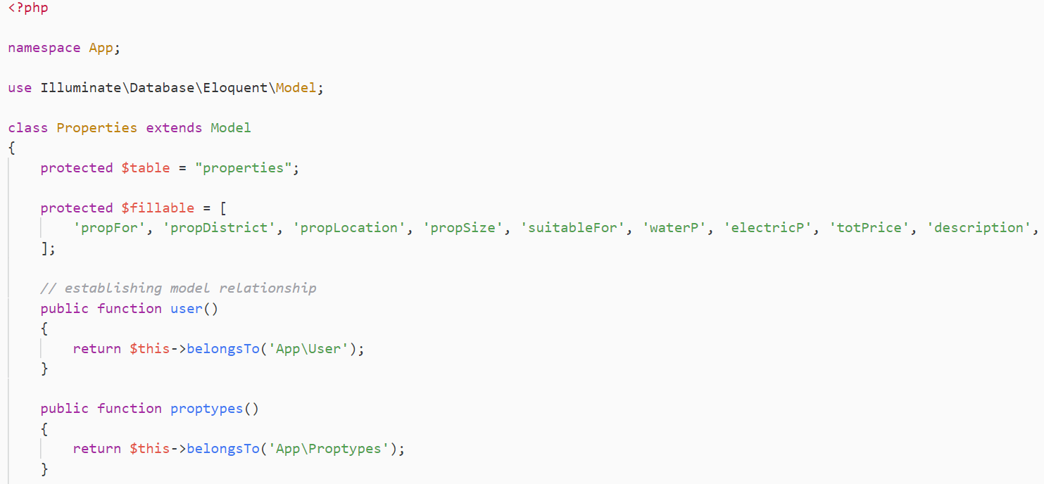

Fig Model - Properties 1

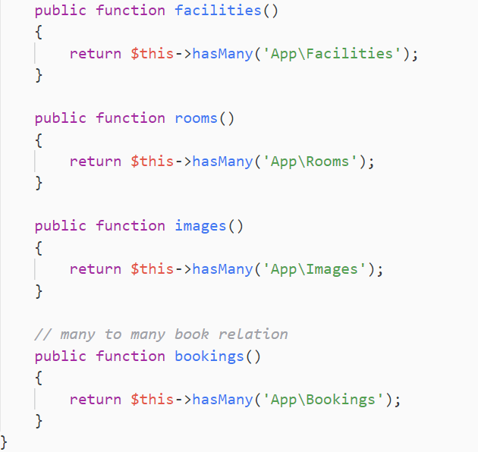

Fig Model - Properties 2

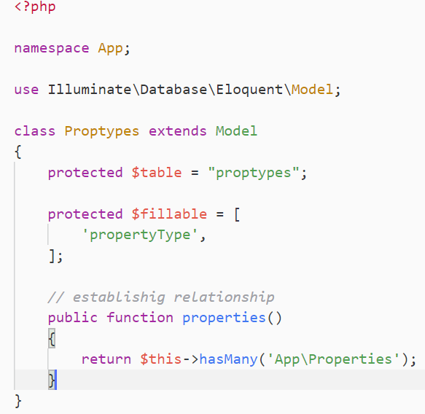

Fig Model – Proptypes

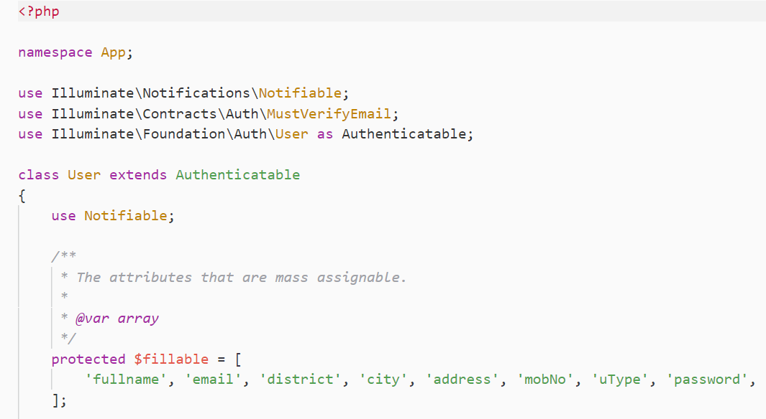

Fig Model - User 1

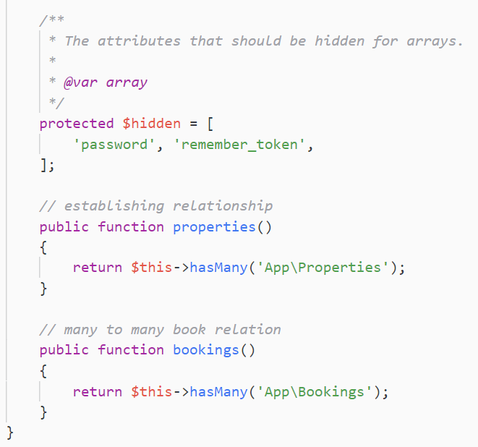

Fig Model - User 2

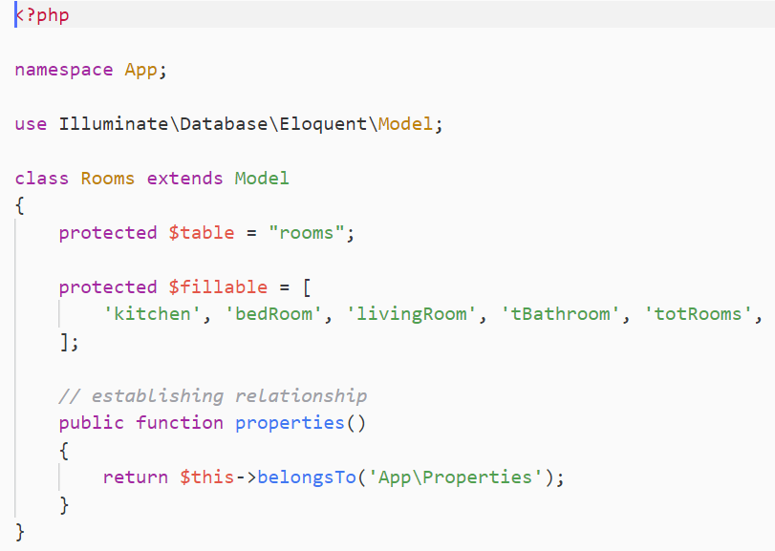

Fig Model – Rooms

**Routes**

List of all the routes are given below

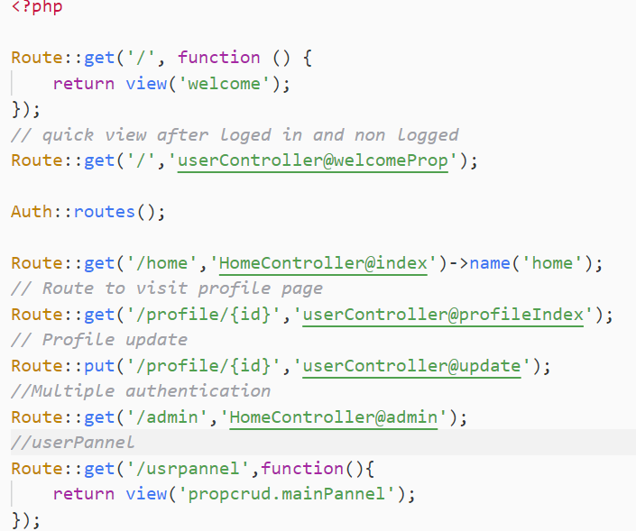

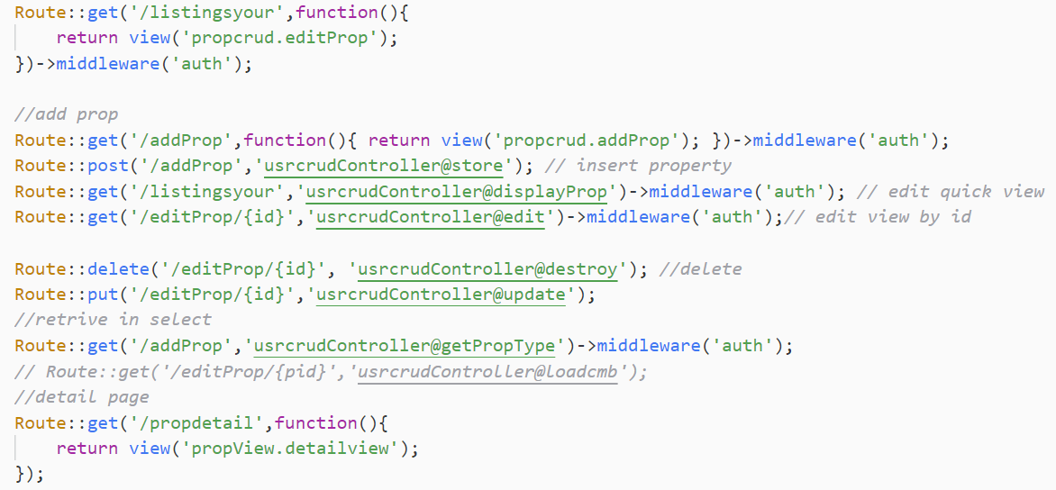

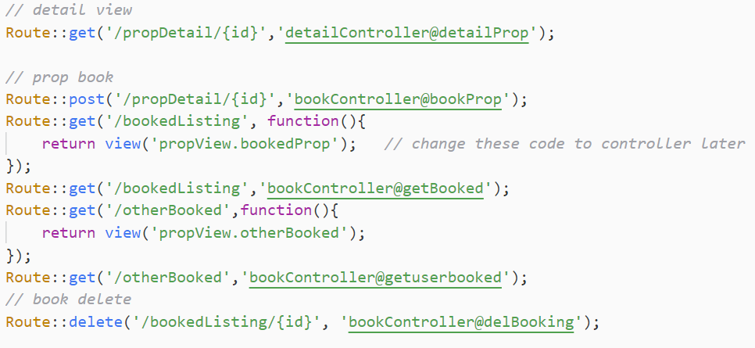

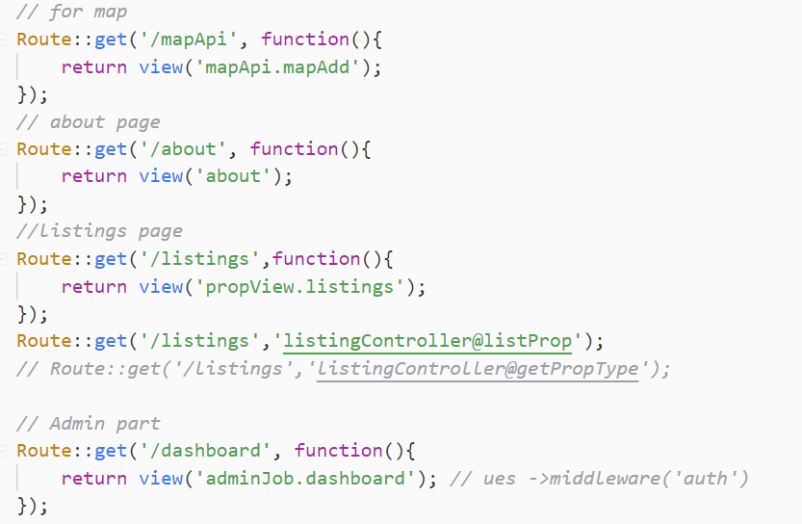

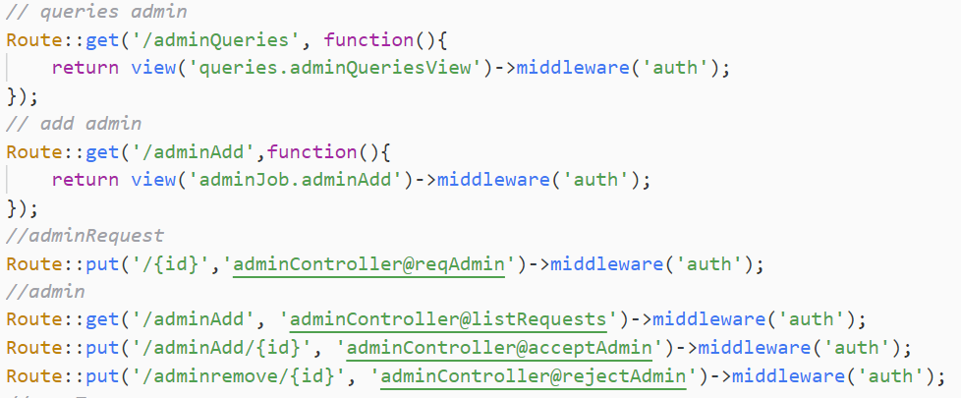

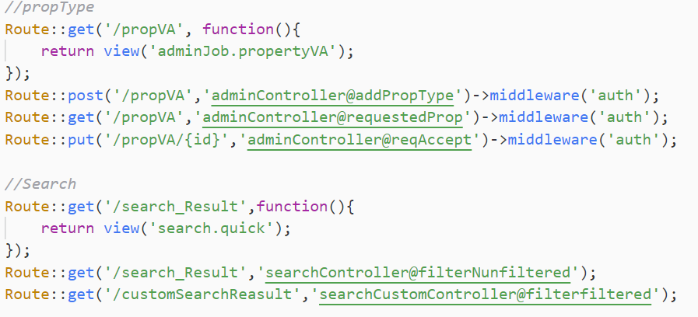

Fig Route - All routes

**Database Migration**

All the database migrations are shown below

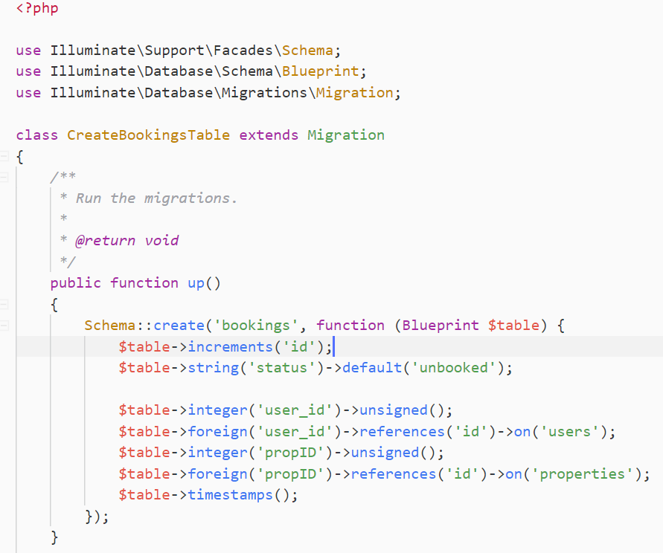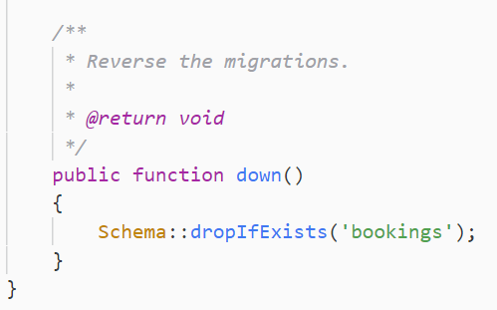

Fig Migration - Bookings

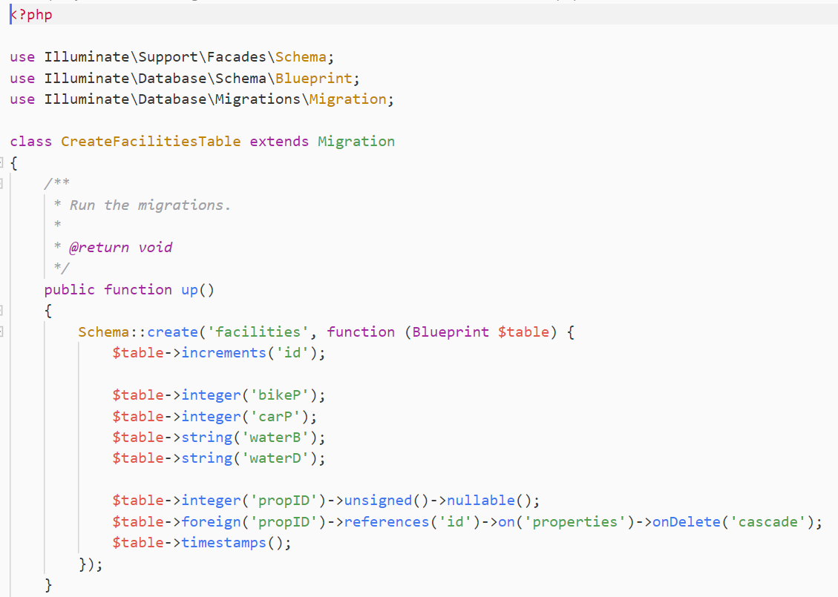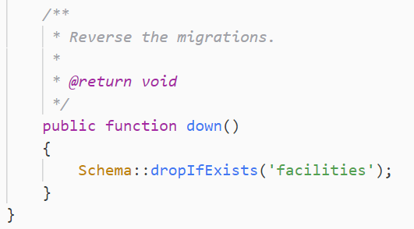

Fig Migration – Facilities

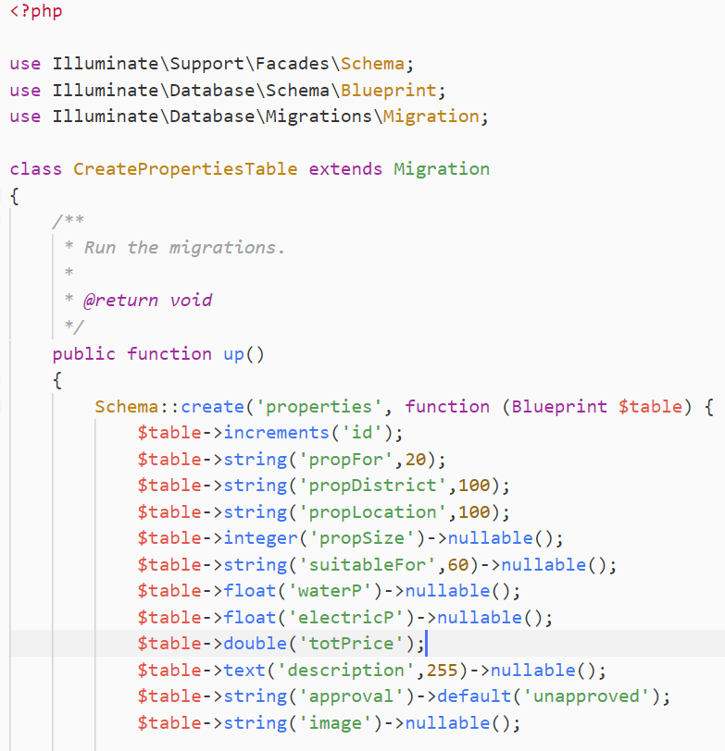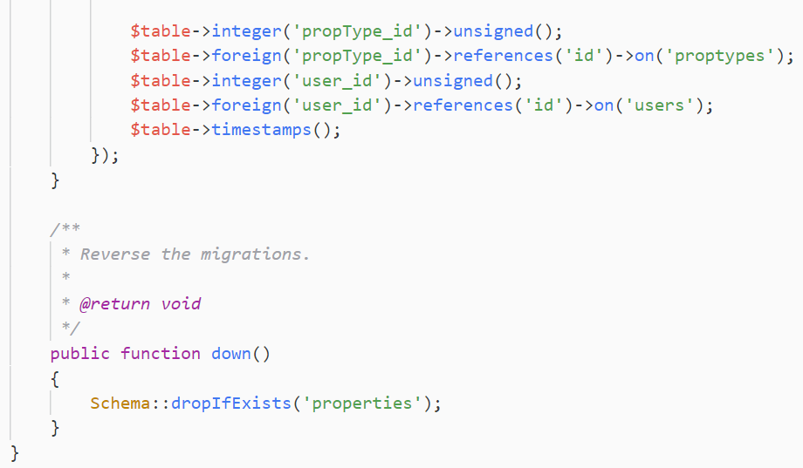

Fig Migration – Properties

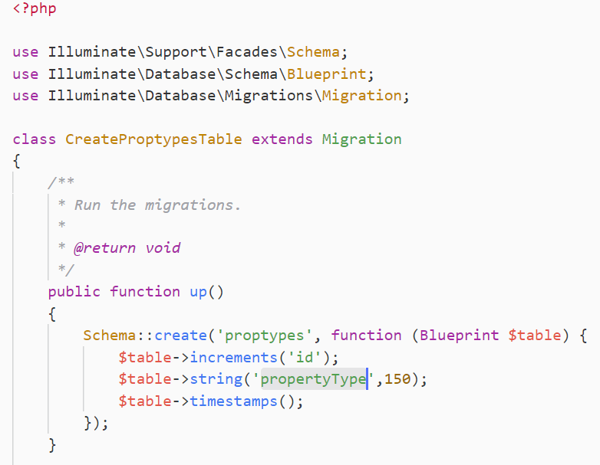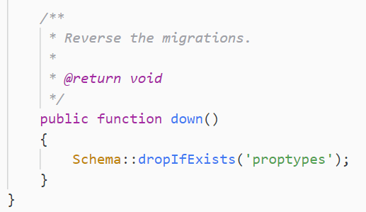

Fig Migration – Proptypes

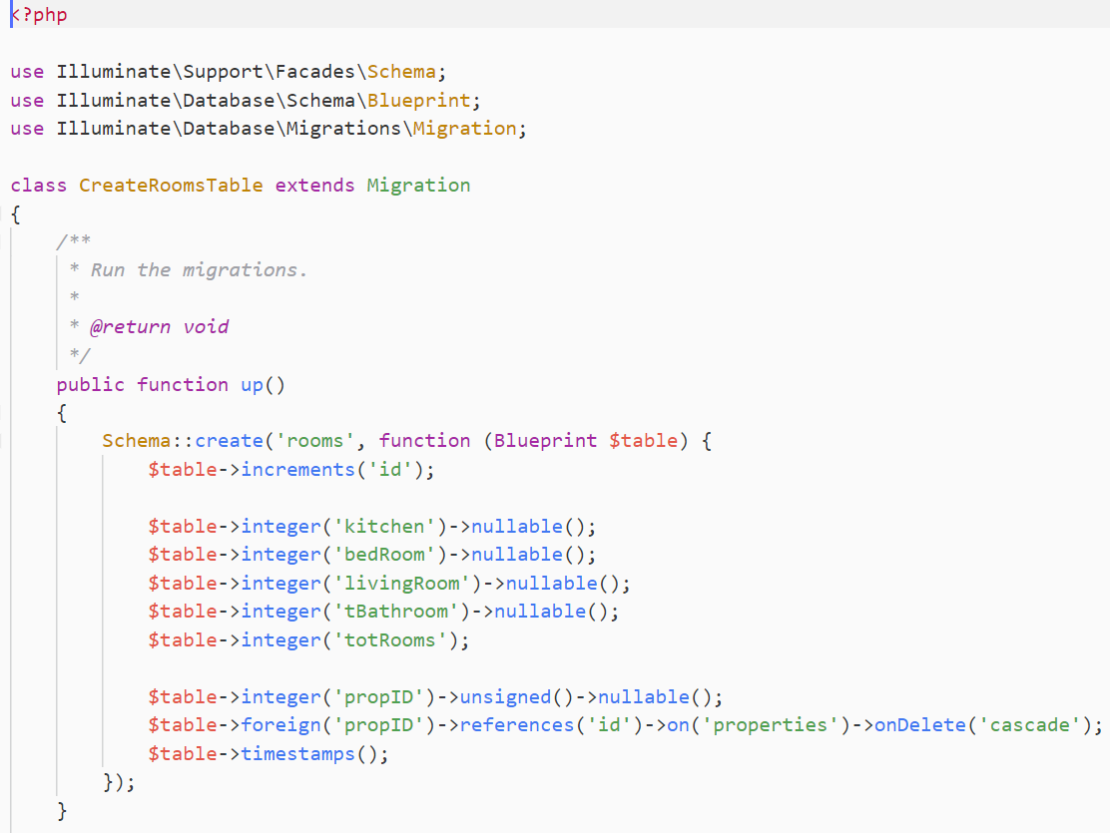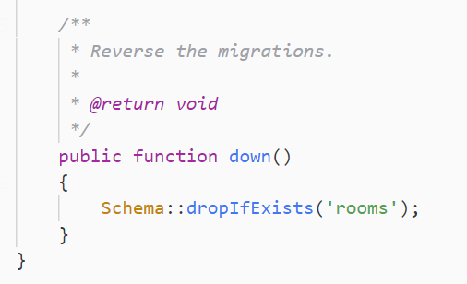

Fig Migration – Rooms

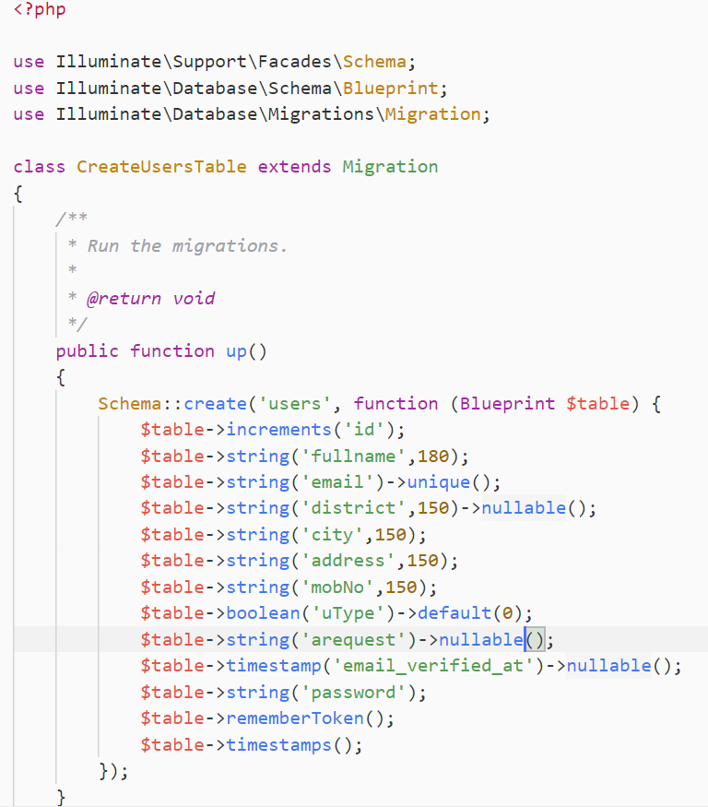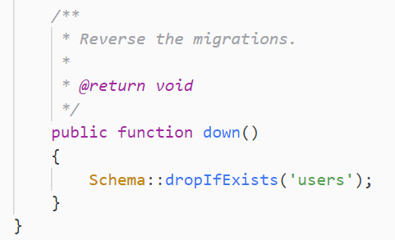

Fig Migration – Users

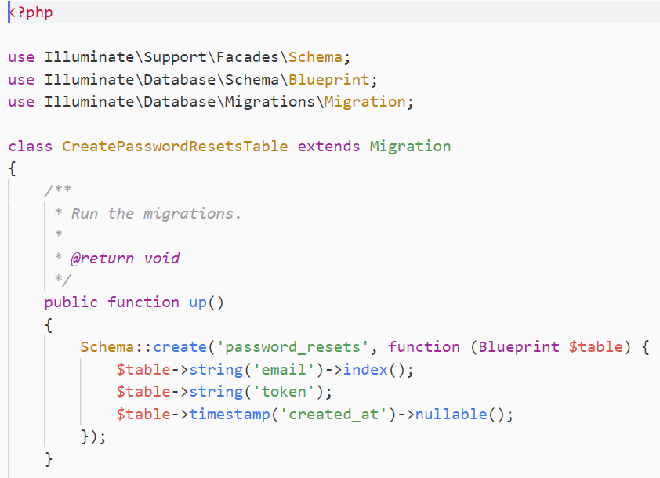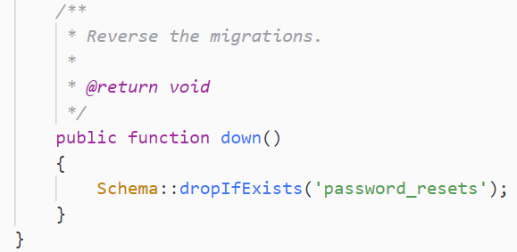

Fig Migration - password_resets

**View**

All the view of the project is shown below

**About page view**

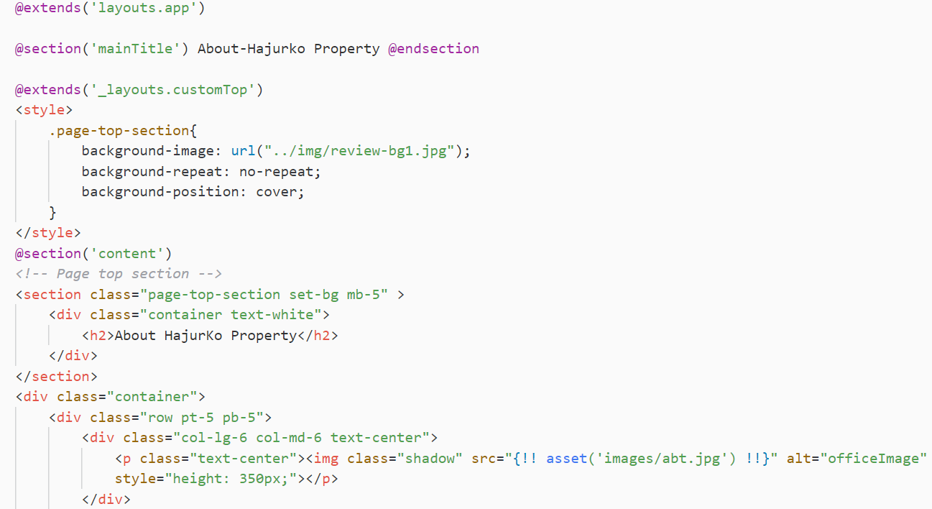

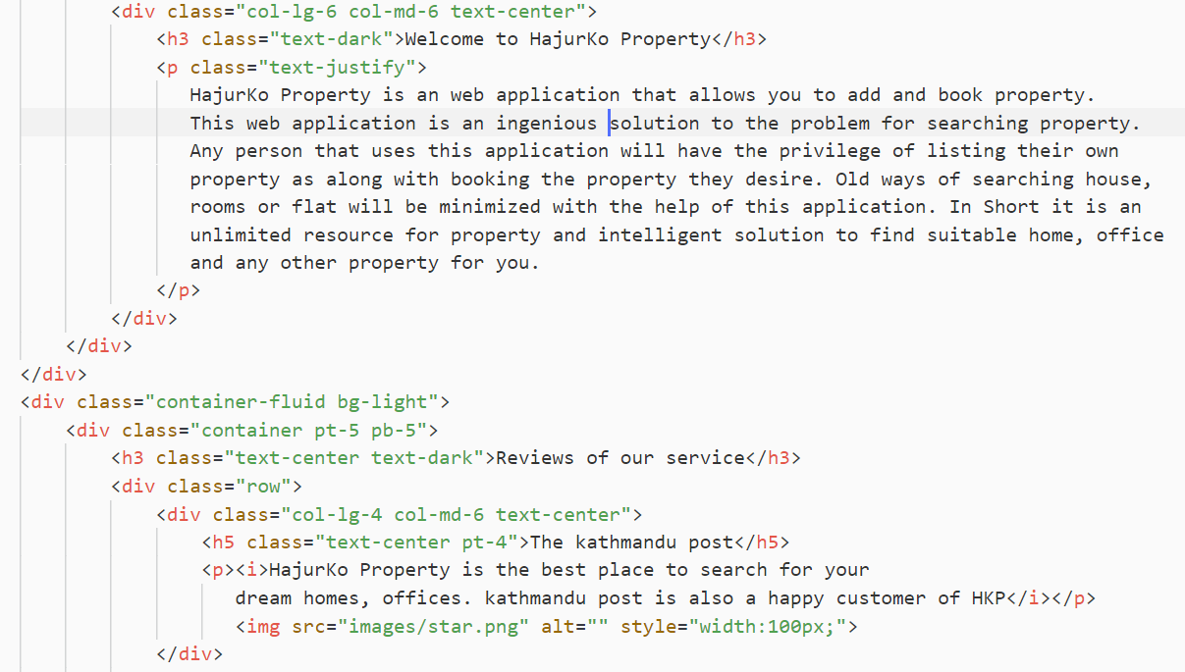

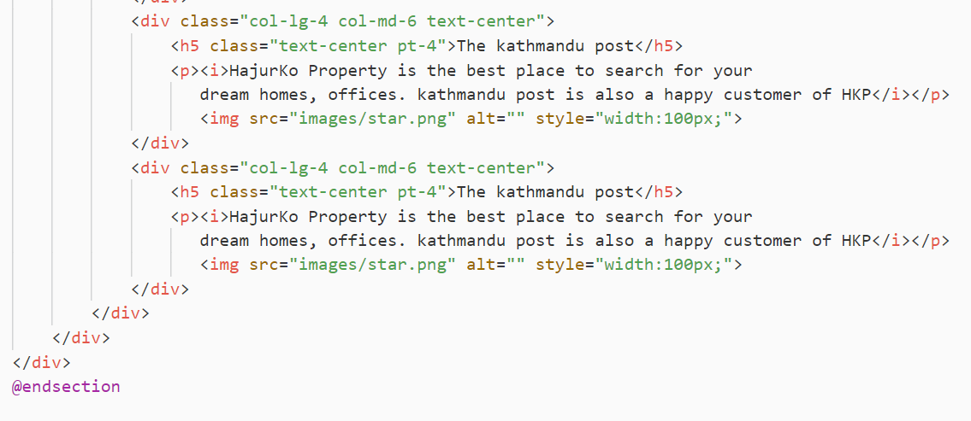

Fig View - About Page

**Admin View**

**Admin Dashboard**

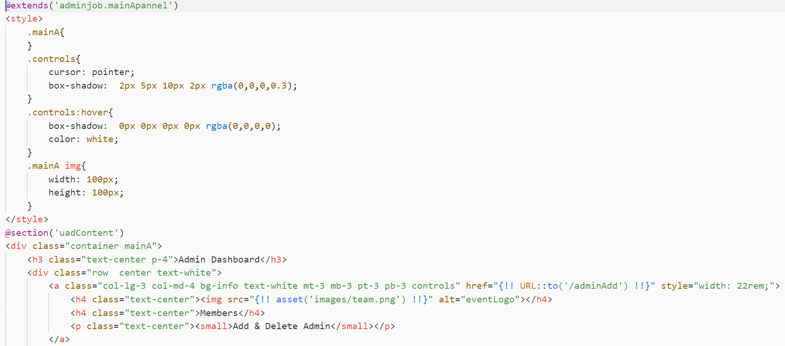

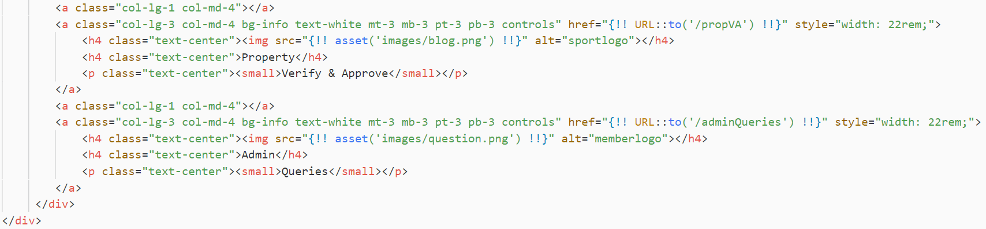

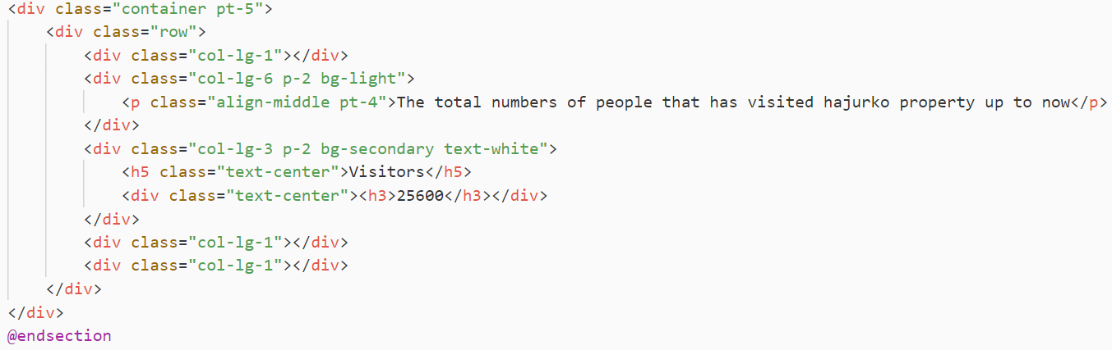

Fig Admin – Dashboard

**Main admin layouts**

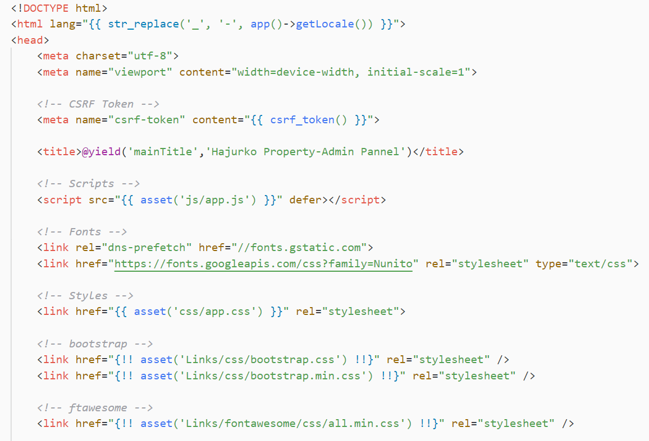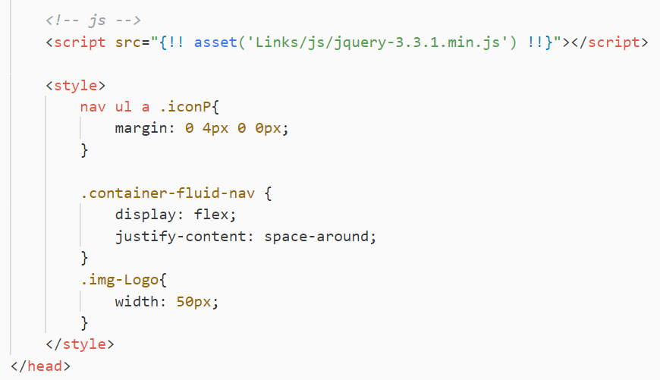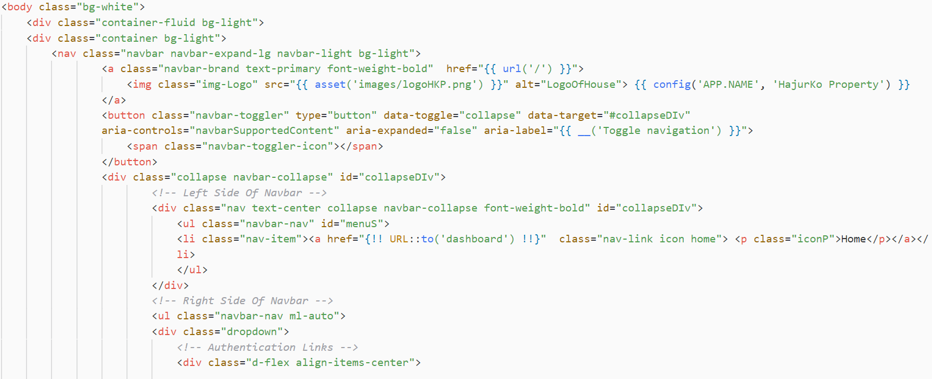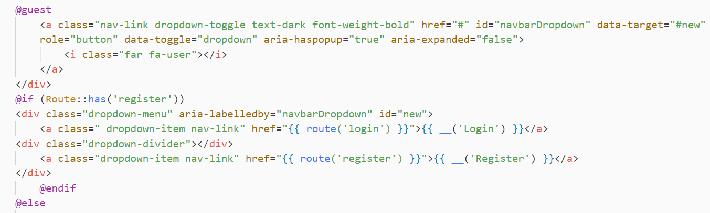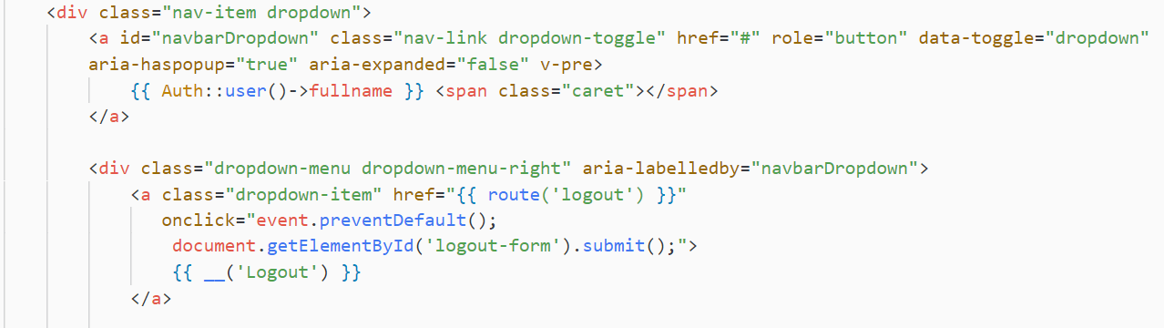

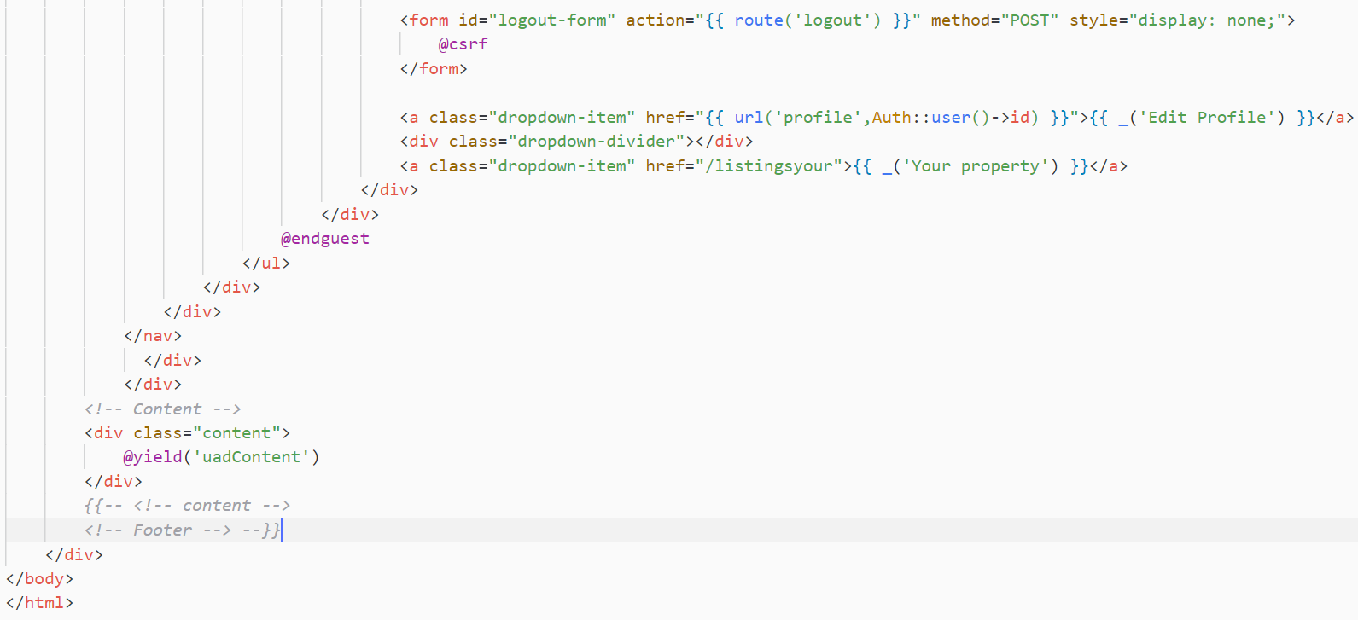

Fig Admin - Main panel

**Property posting address respond**

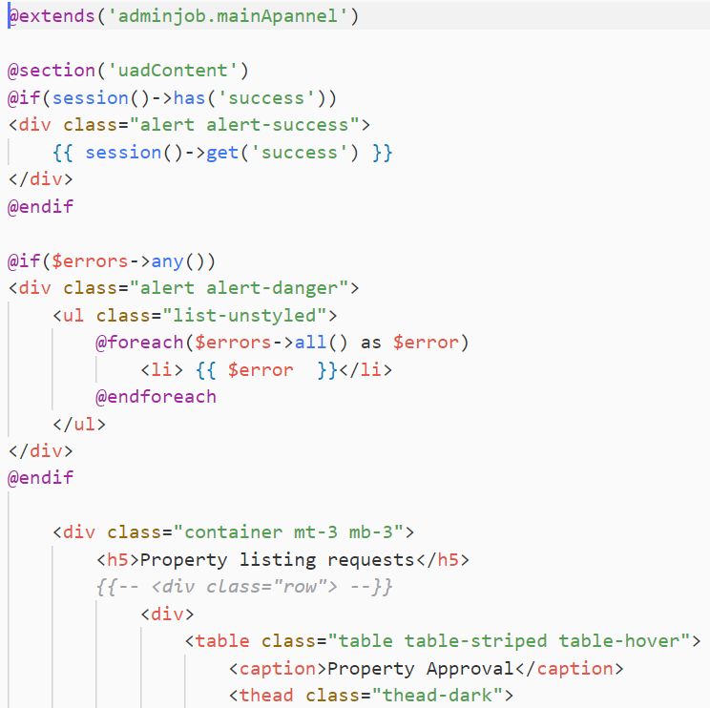

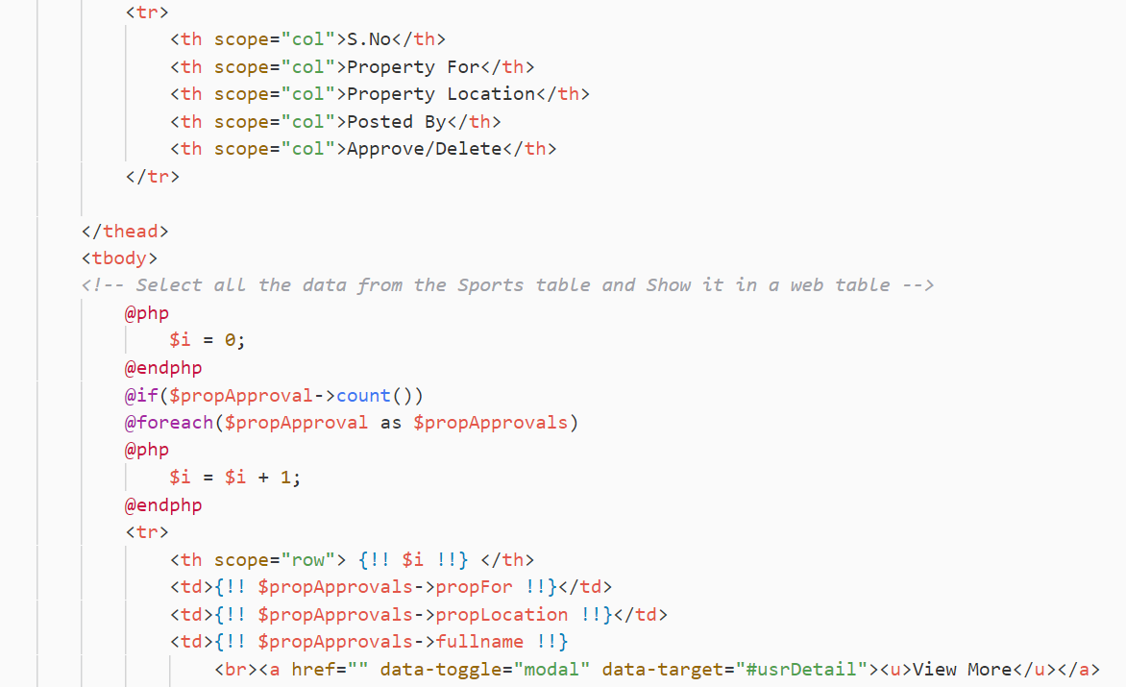

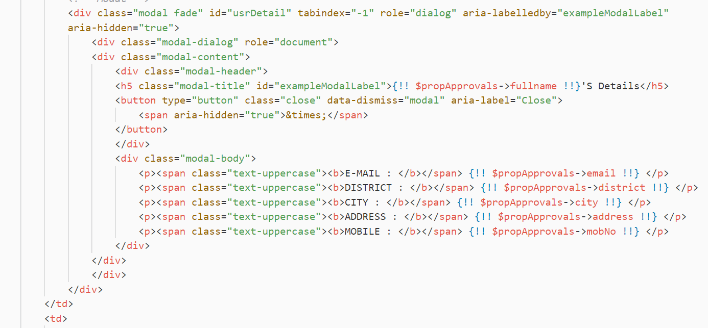

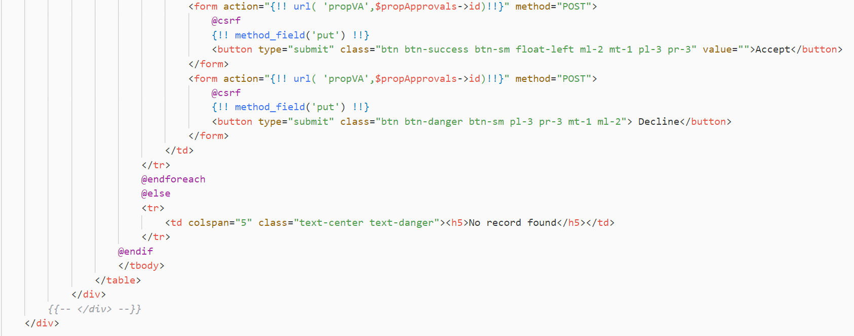

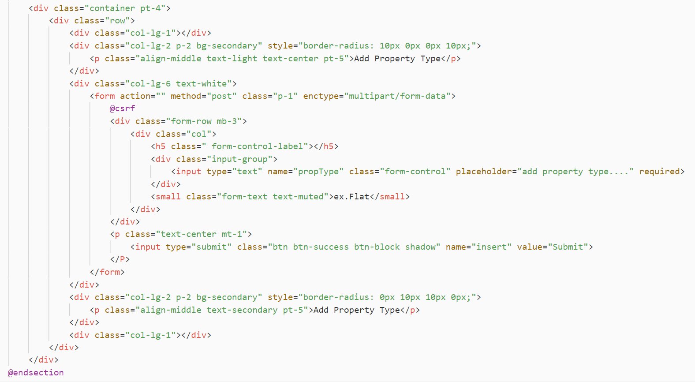

Fig Admin - Property posting request accept

**Accept and reject admin requests**

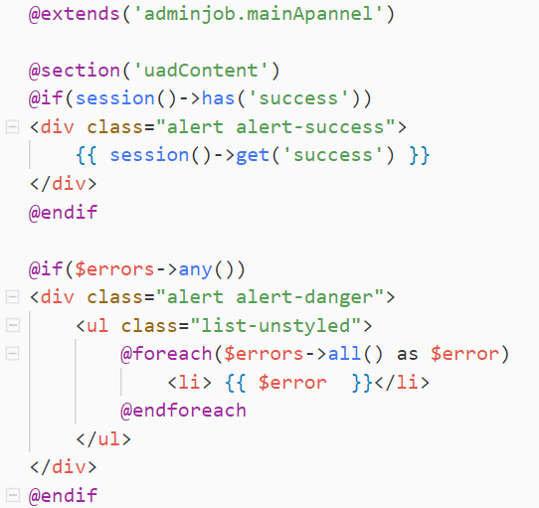

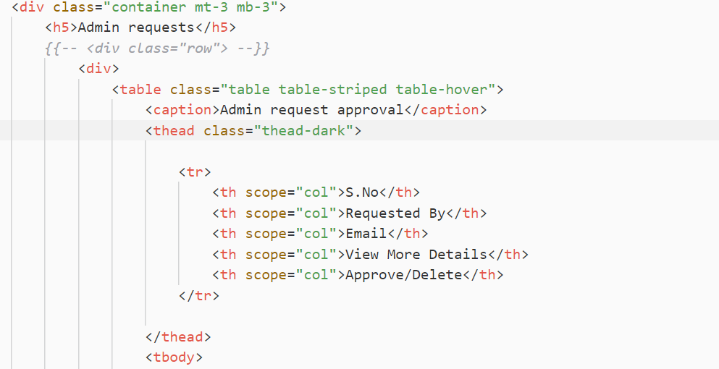

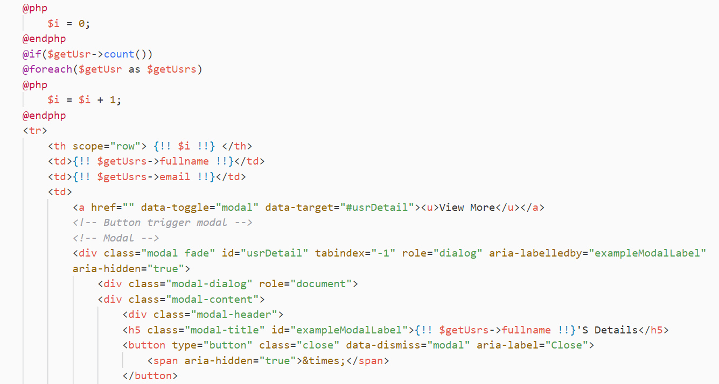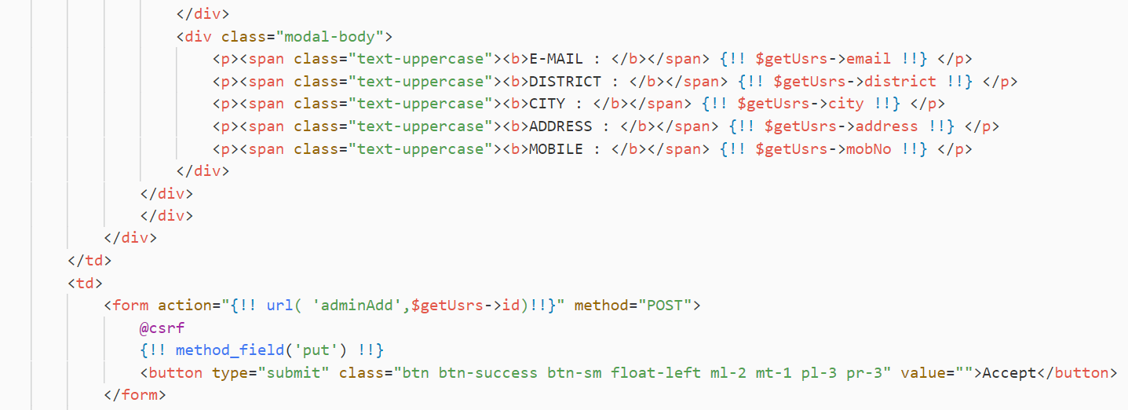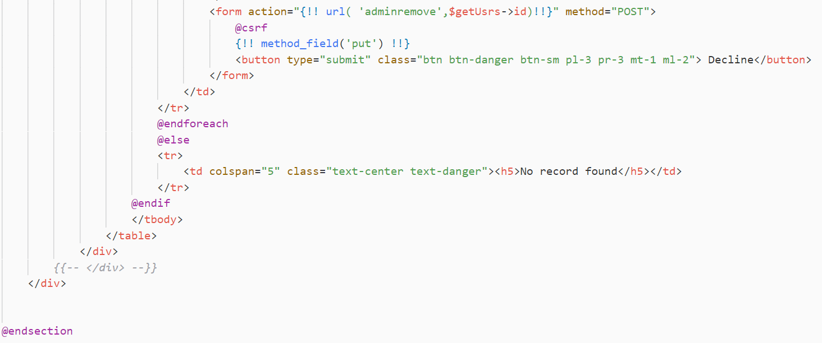

Fig Accept or reject admin request

**Auth View**

**Login view**

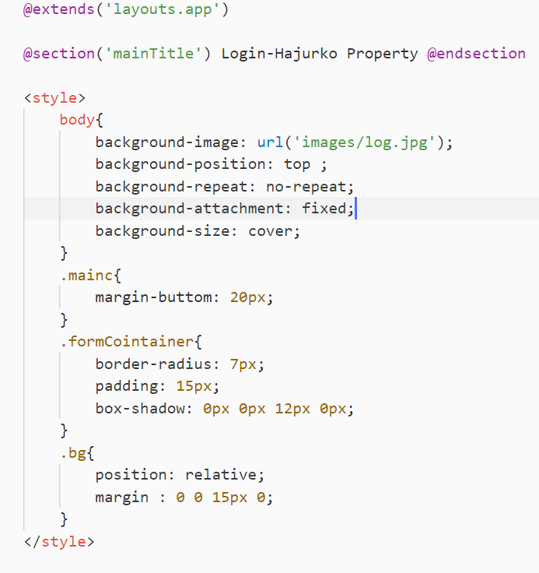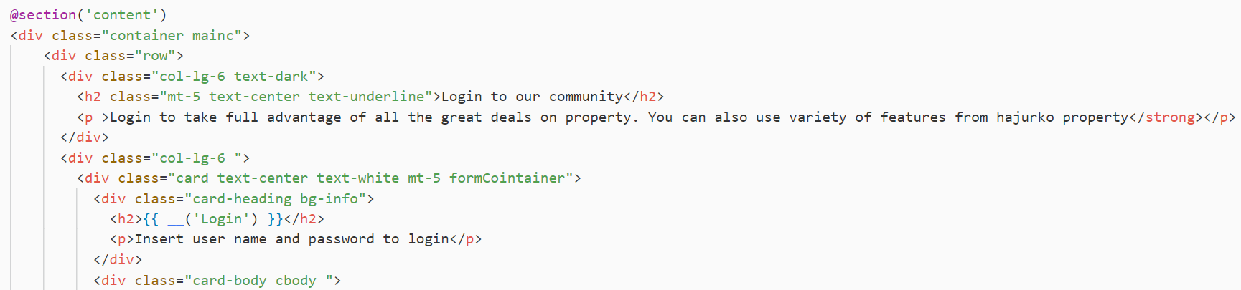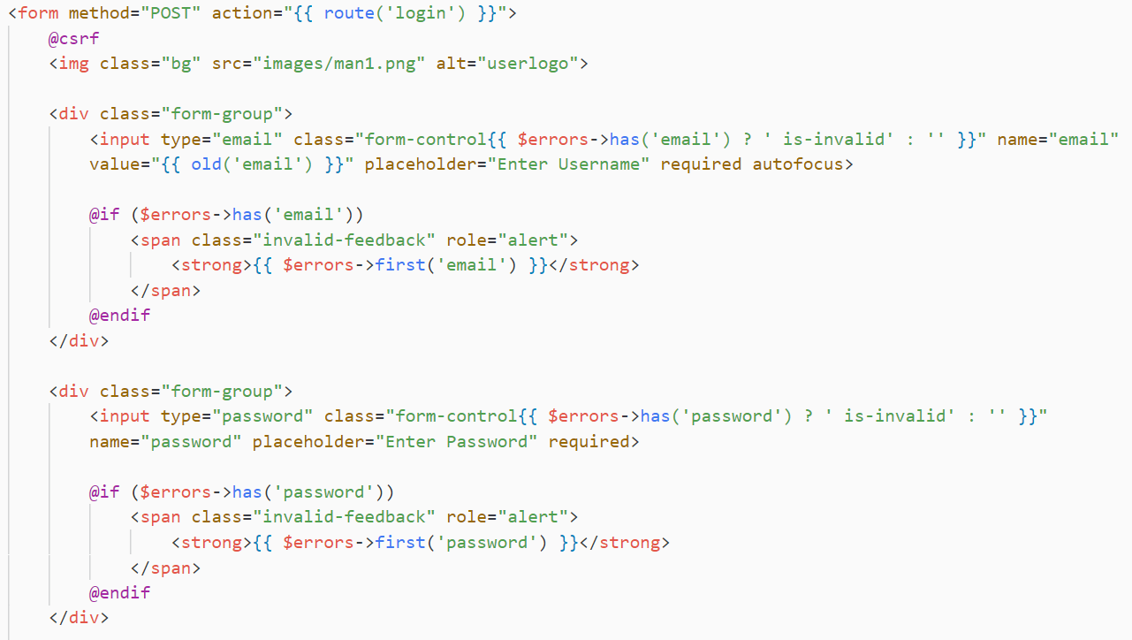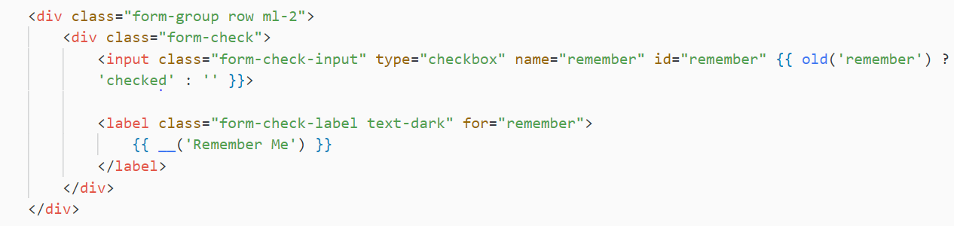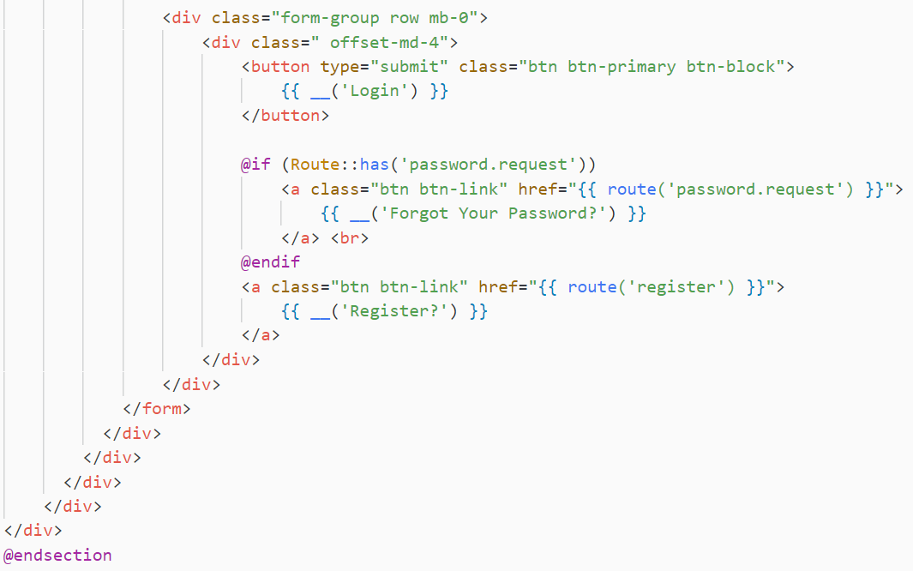

Fig Auth - Login View

**Register View**

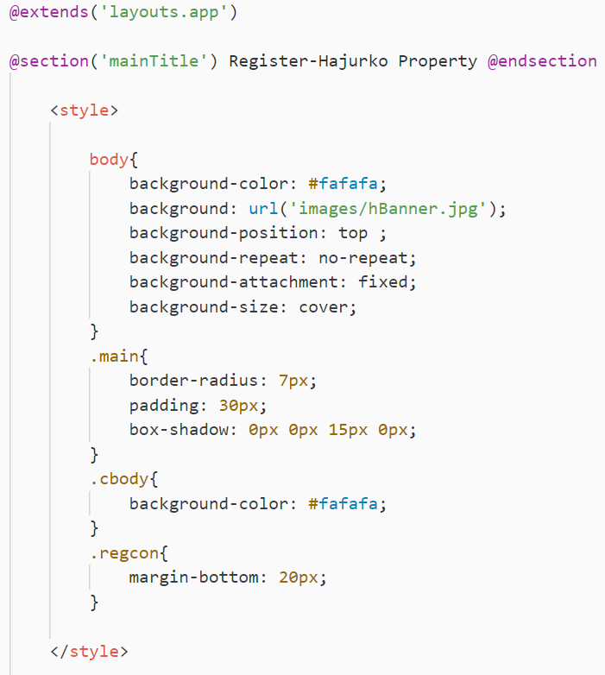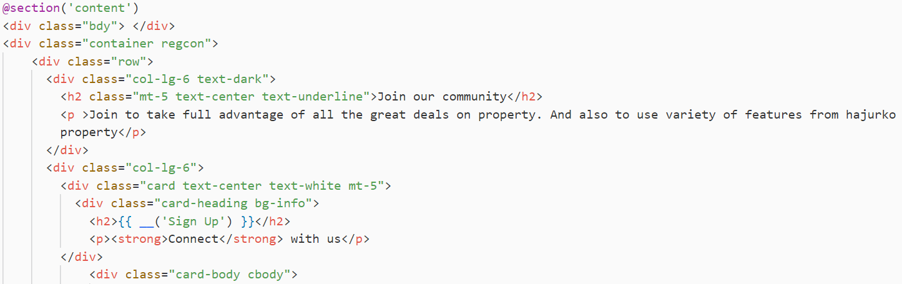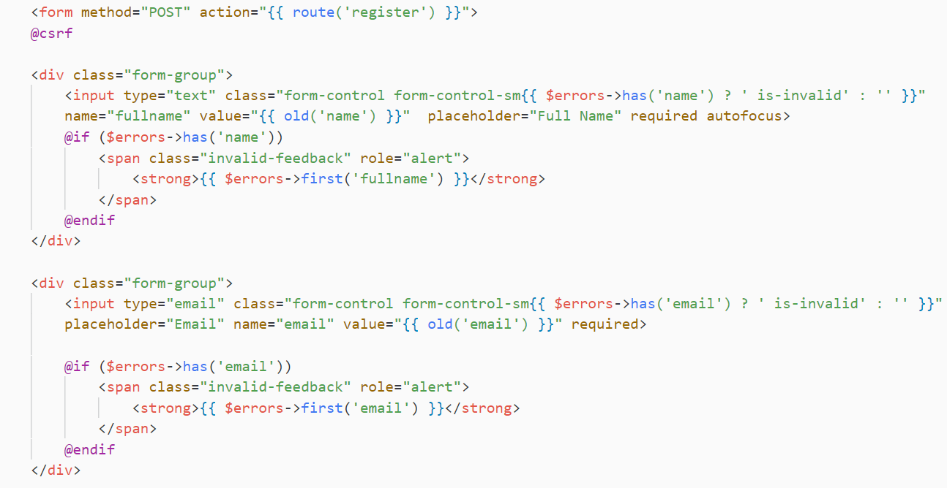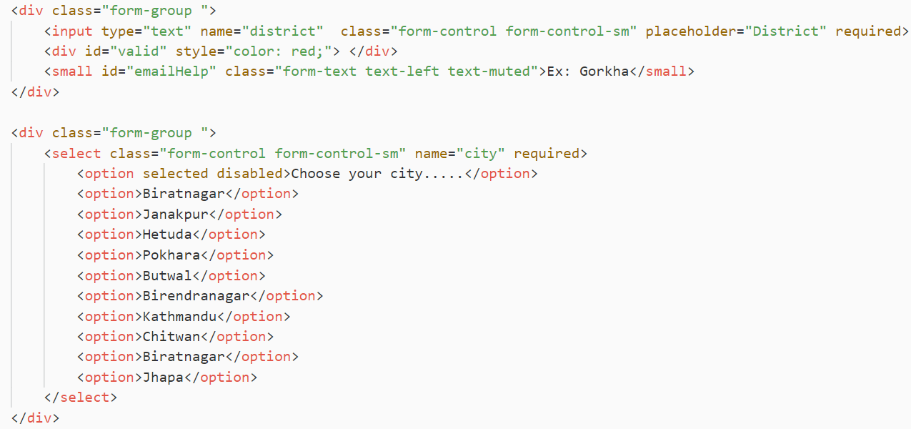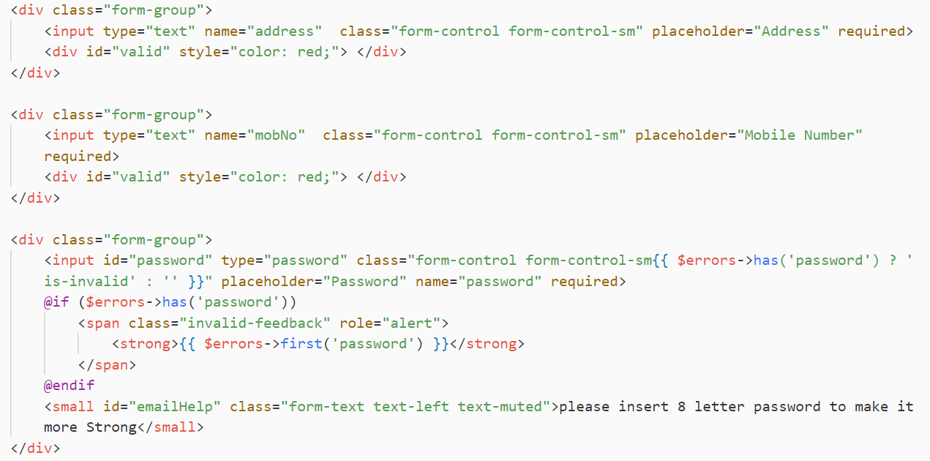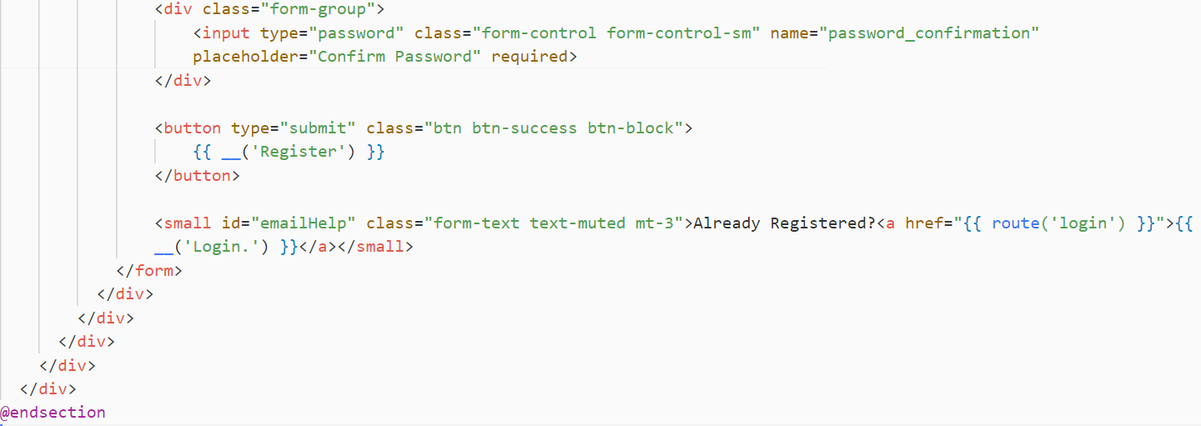

Fig Auth - Register View

**Email verification**

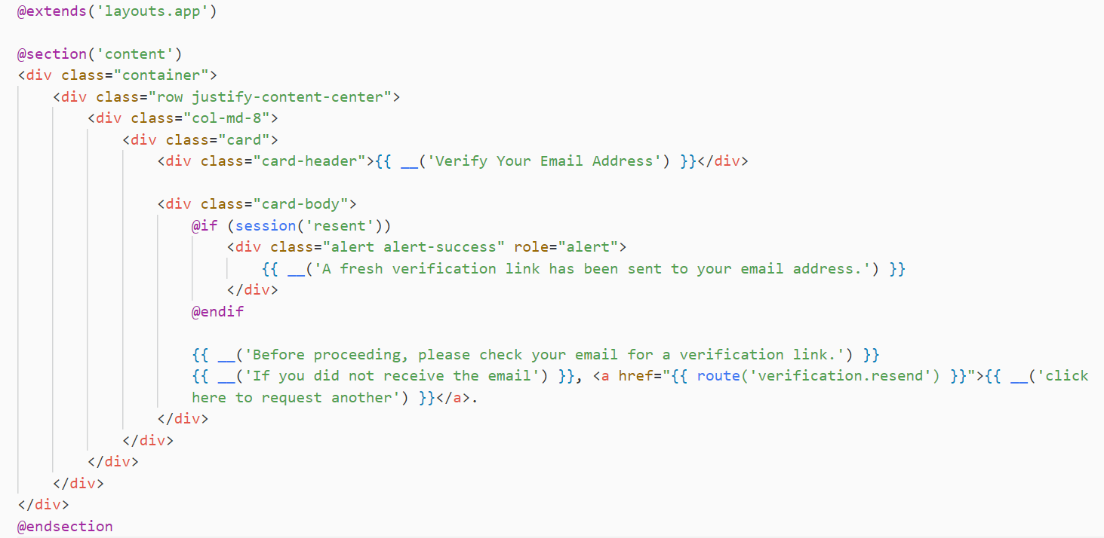

**Password reset link**

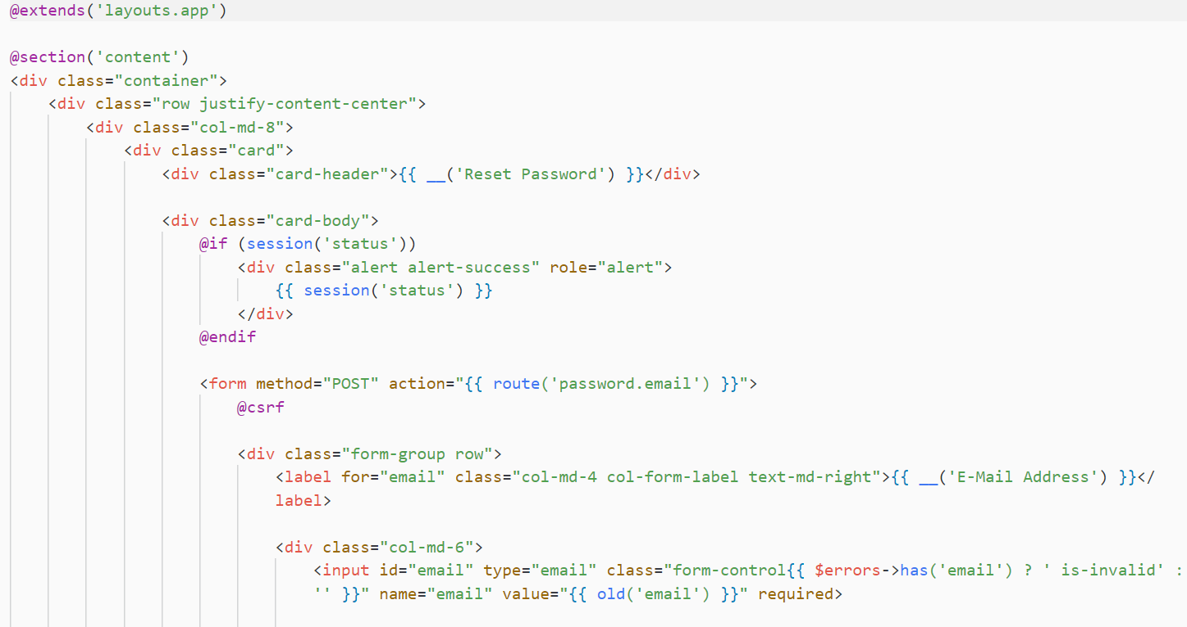

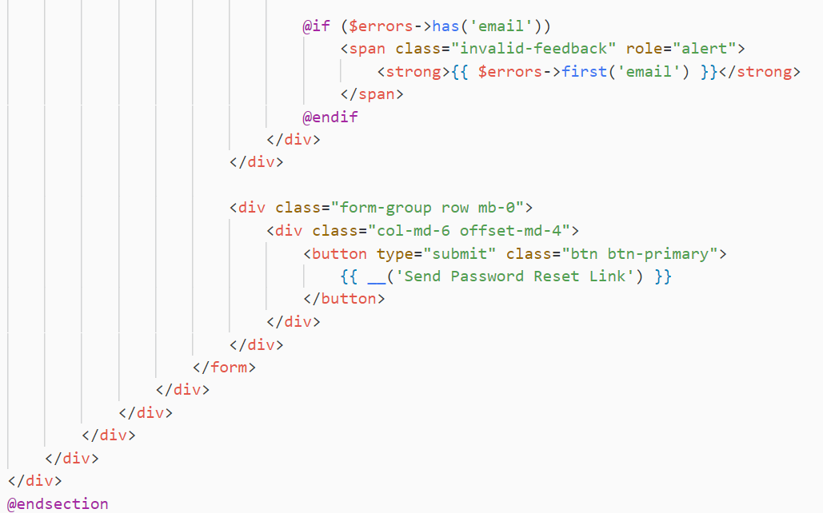

Fig Auth - Password reset

**Password reset**

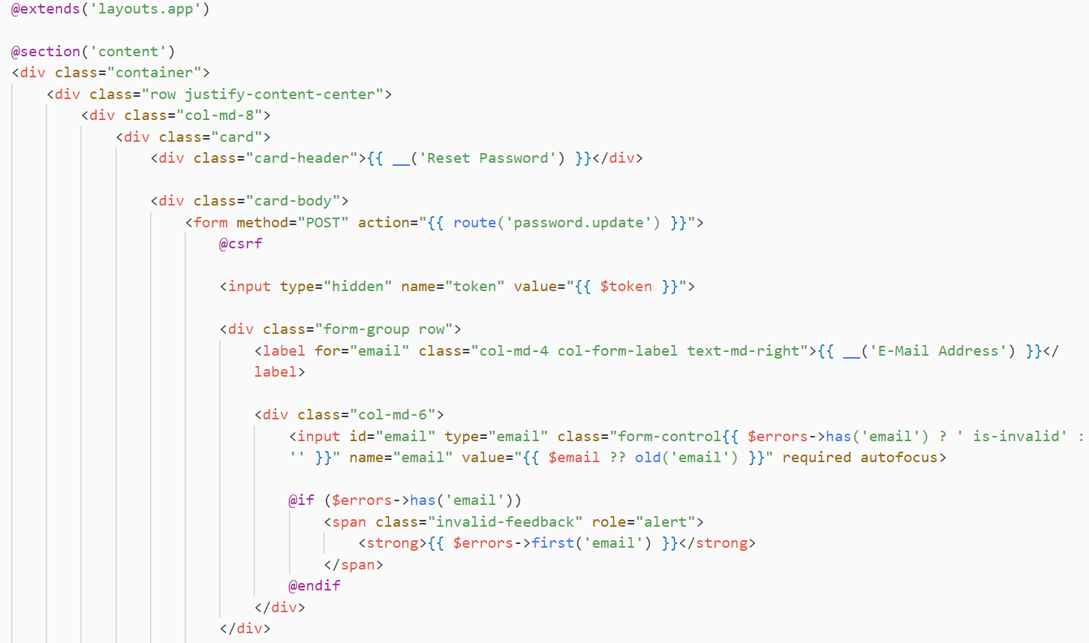

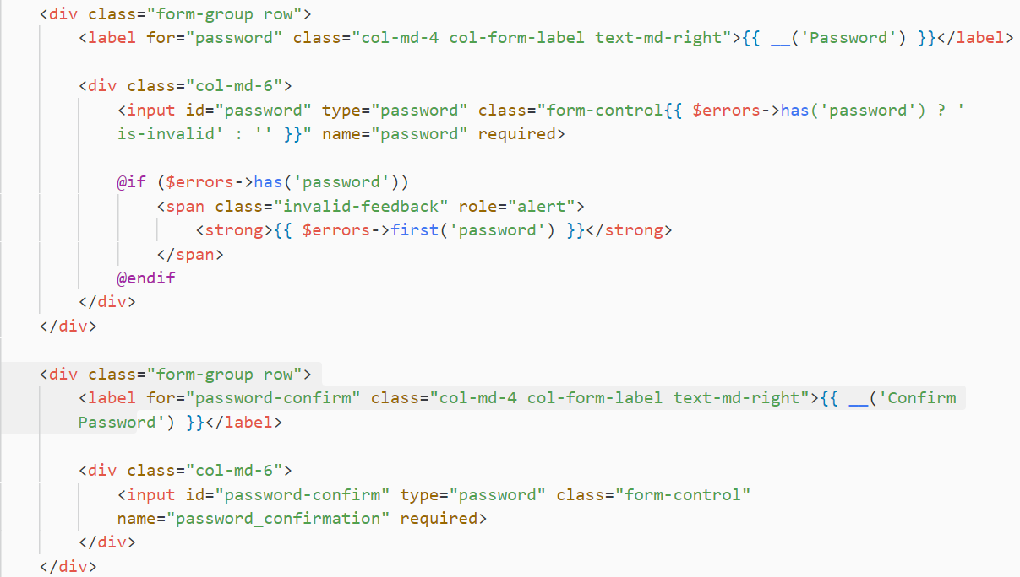

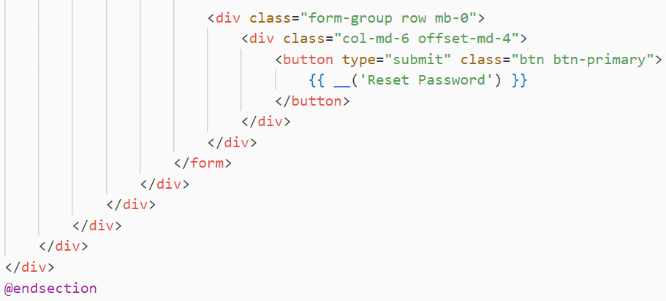

Fig Auth - Password reset

**Main Layout view**

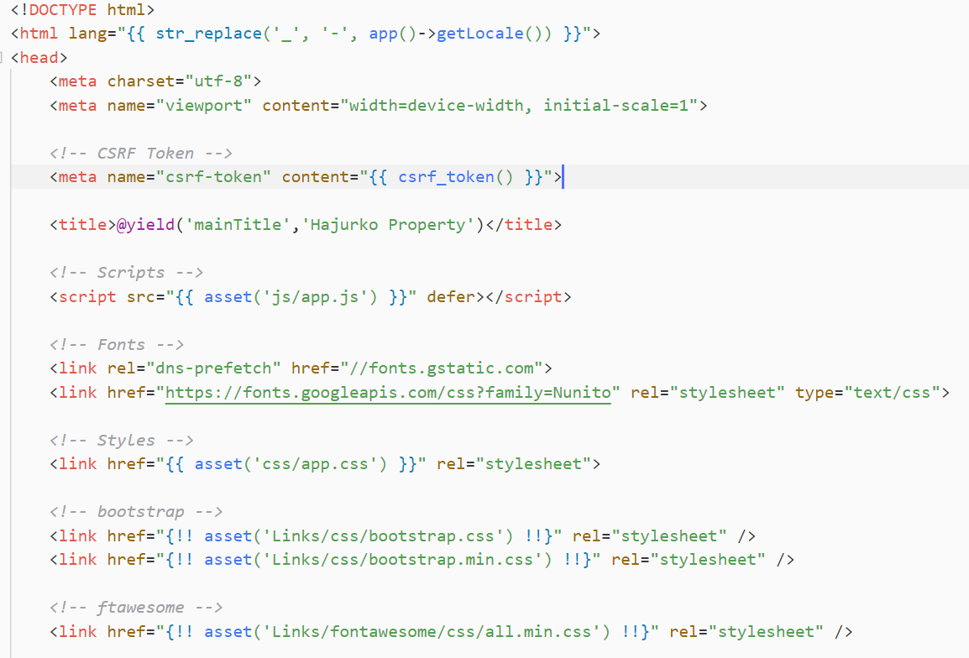

Fig Main Layout – links

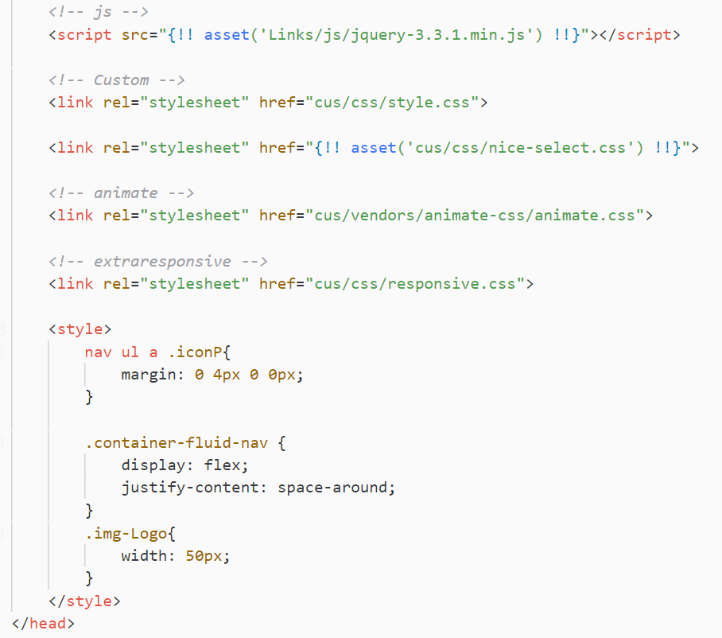

Fig Main Layout - Links 1

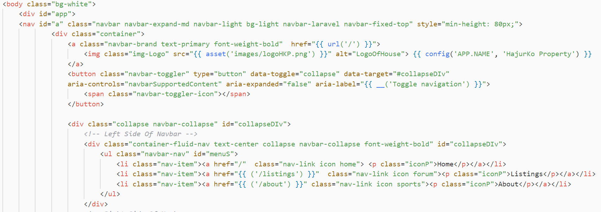

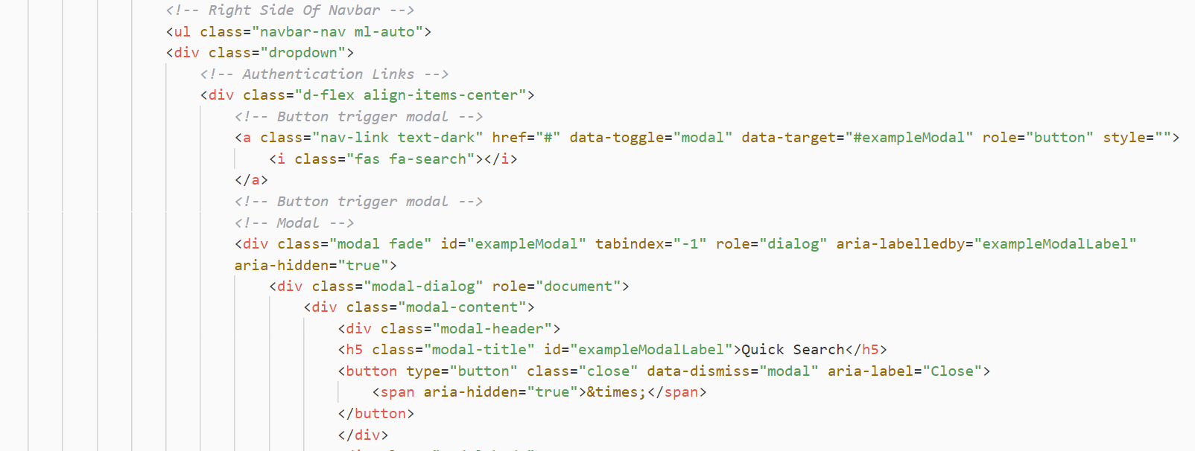

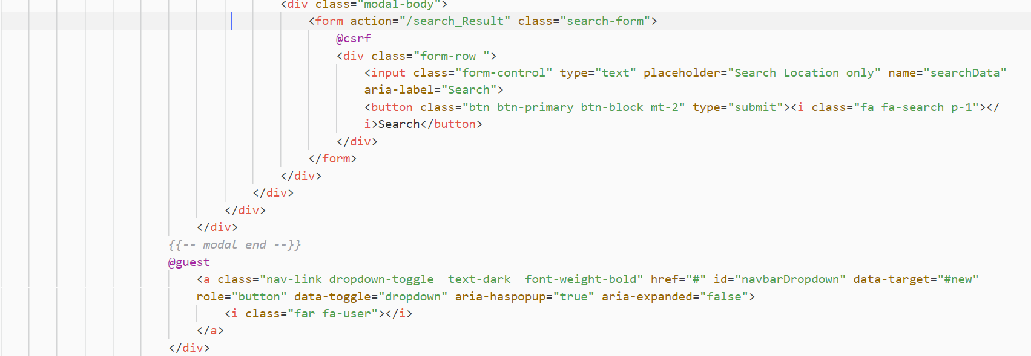

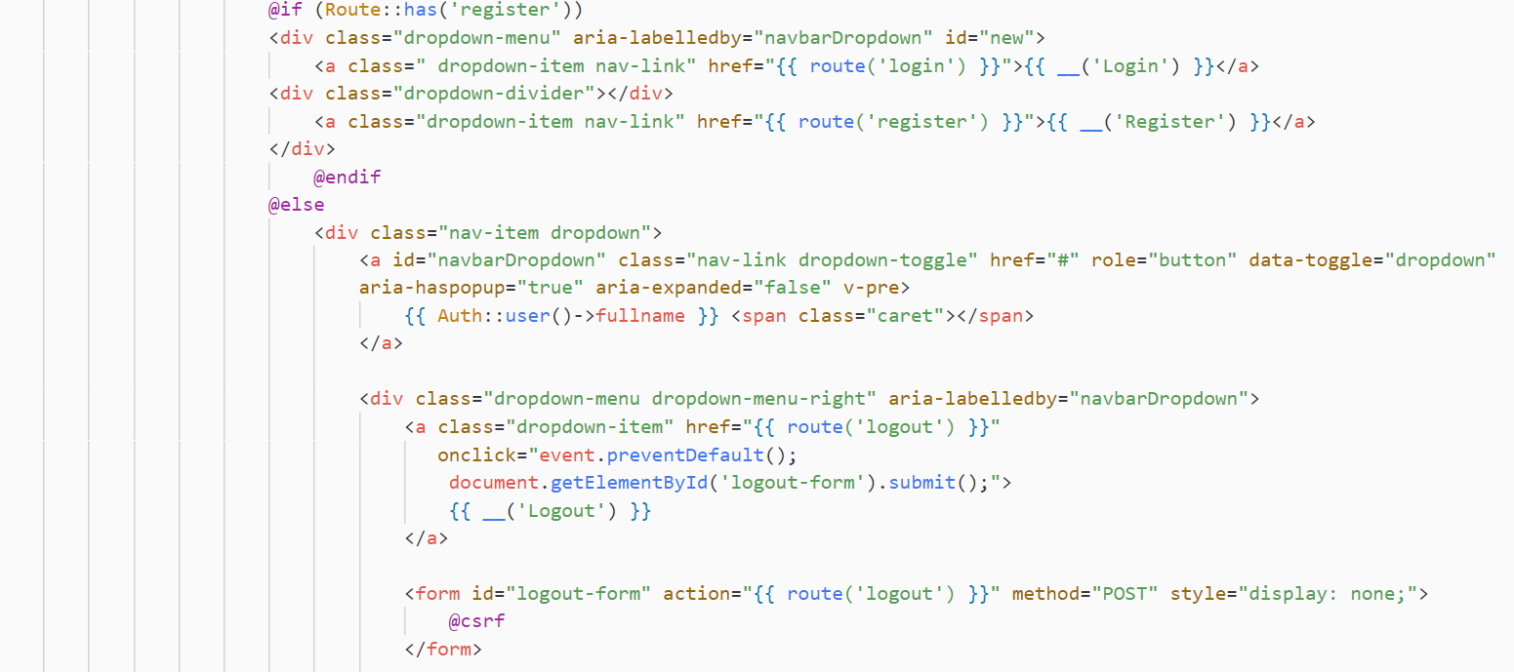

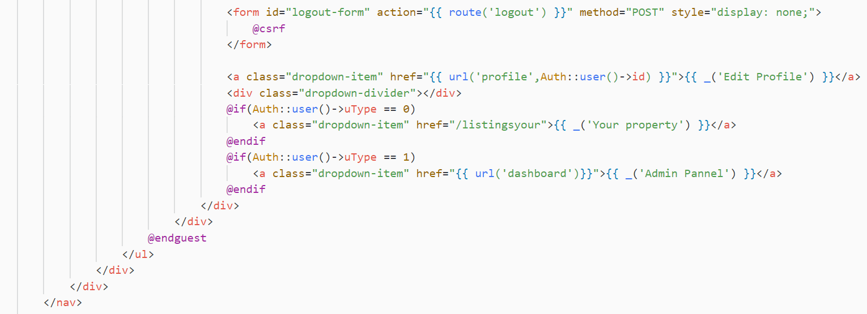

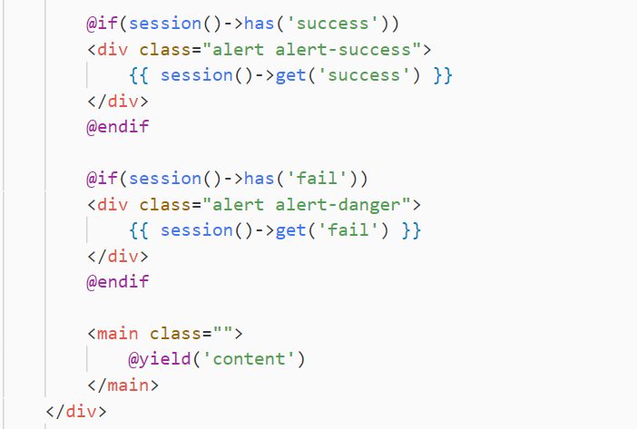

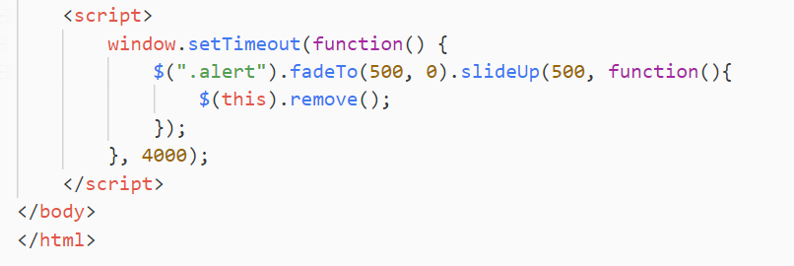

**Main Layouts – Footer**

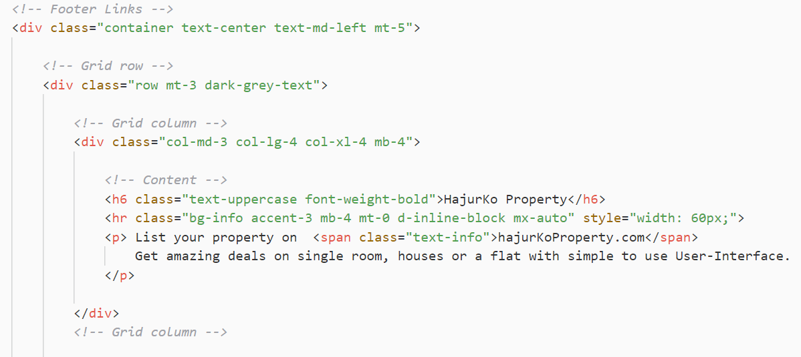

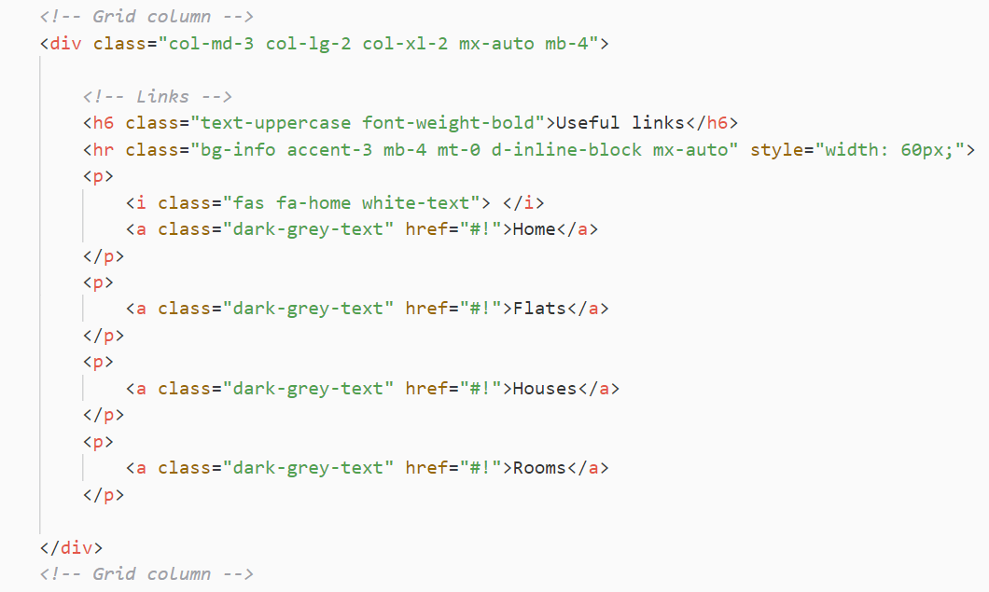

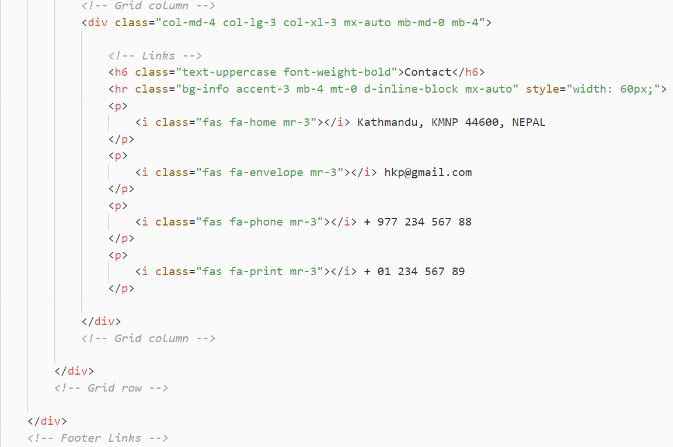

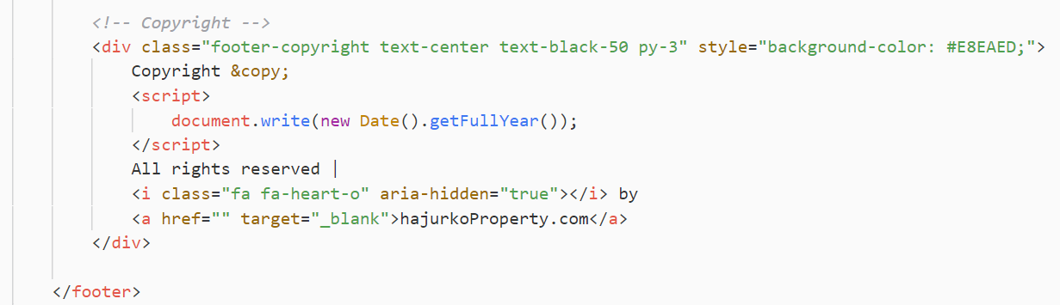

**Profile Update**

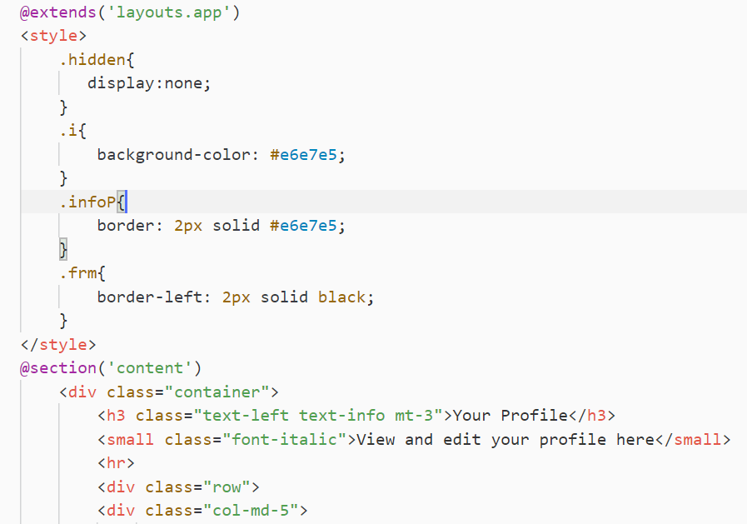

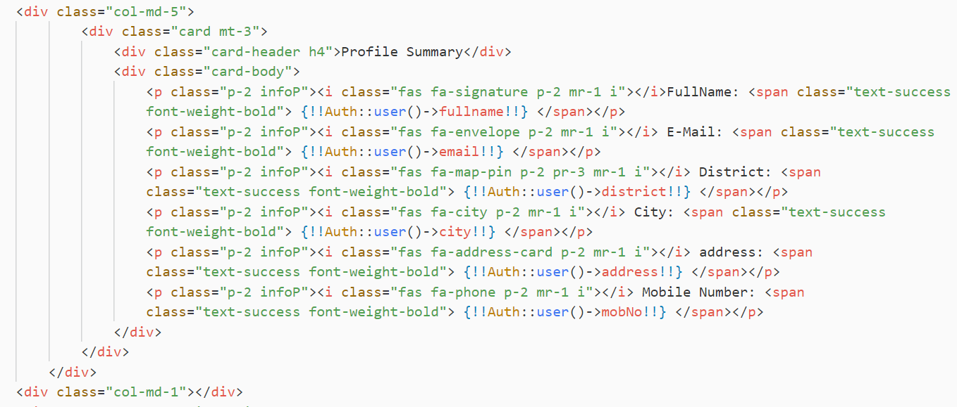

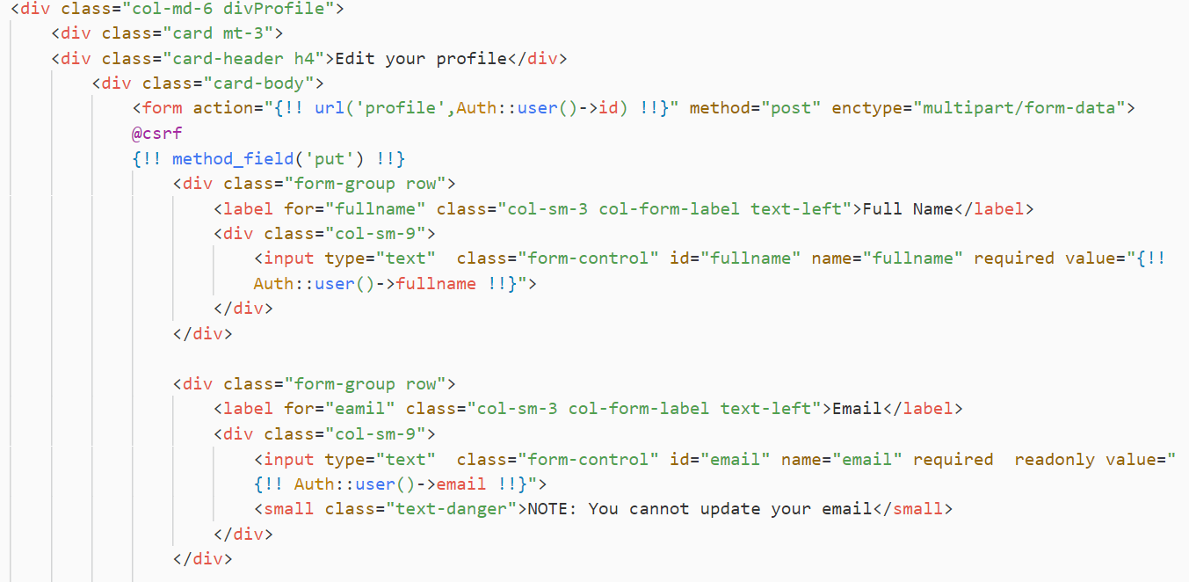

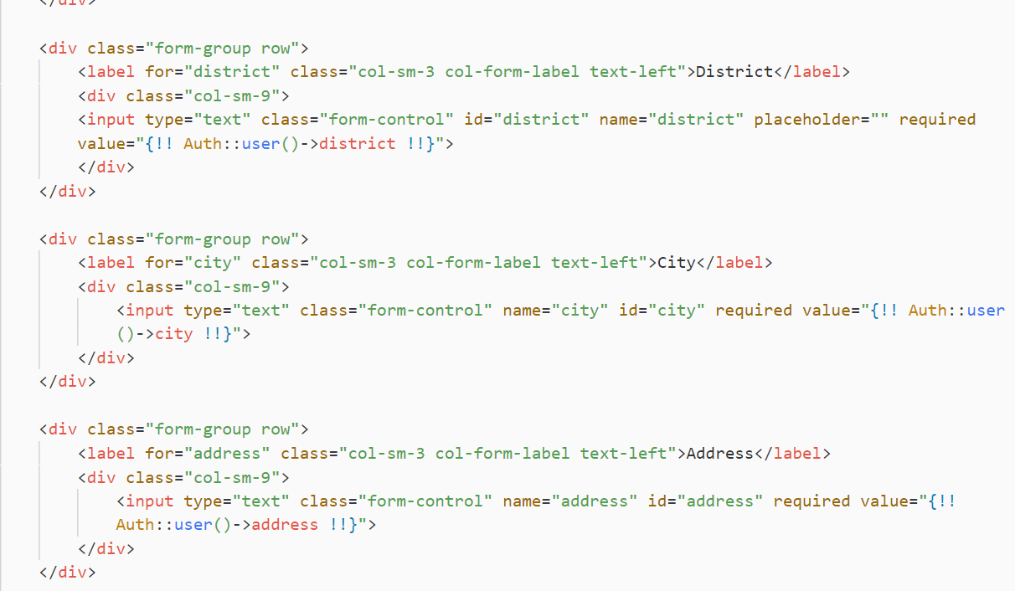

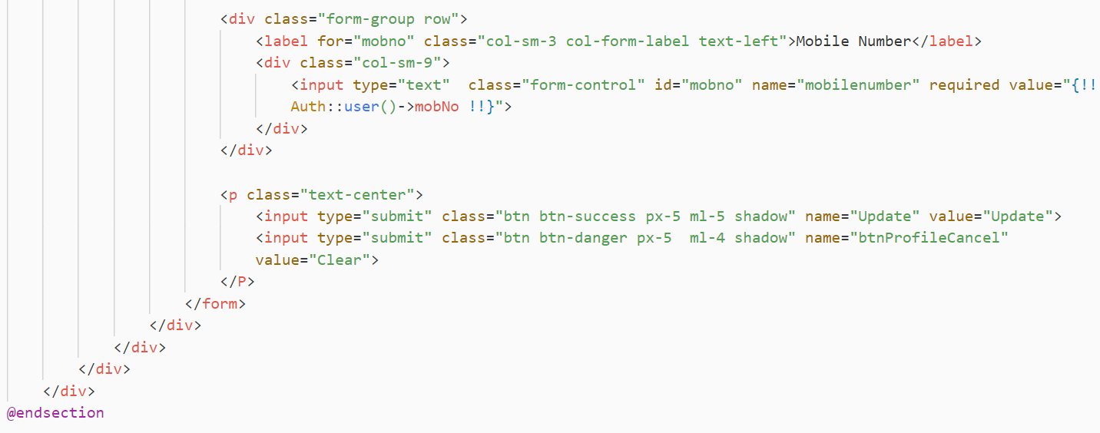

**Property View**

Add property

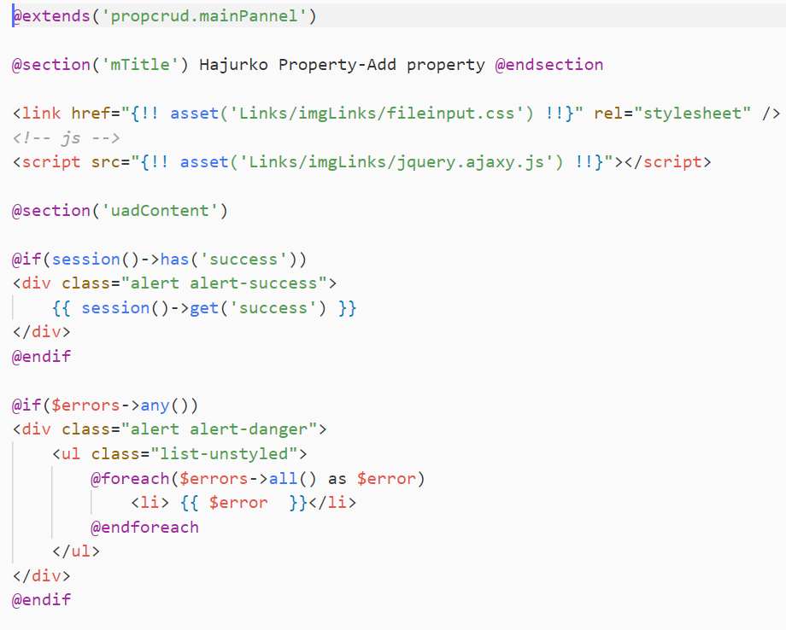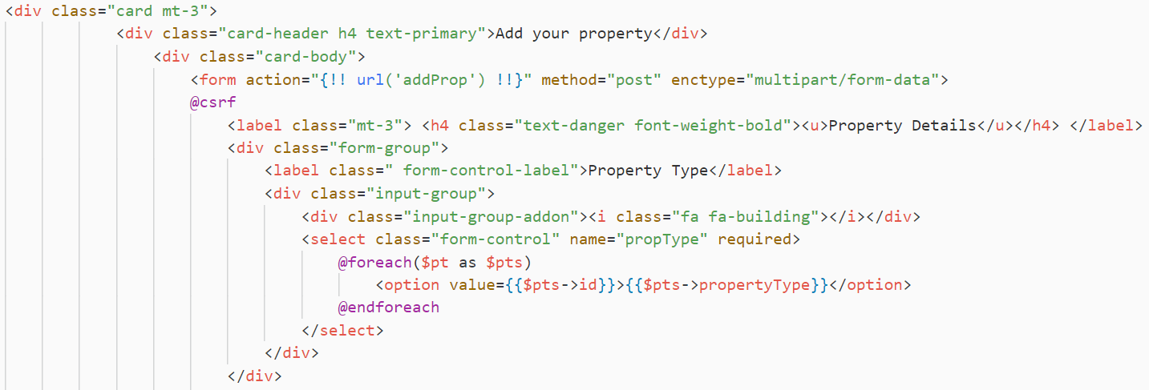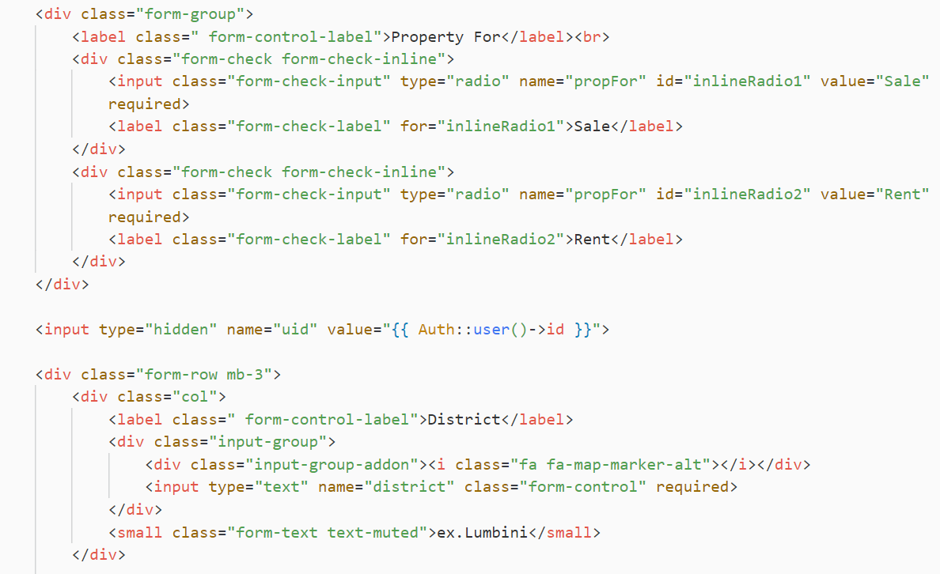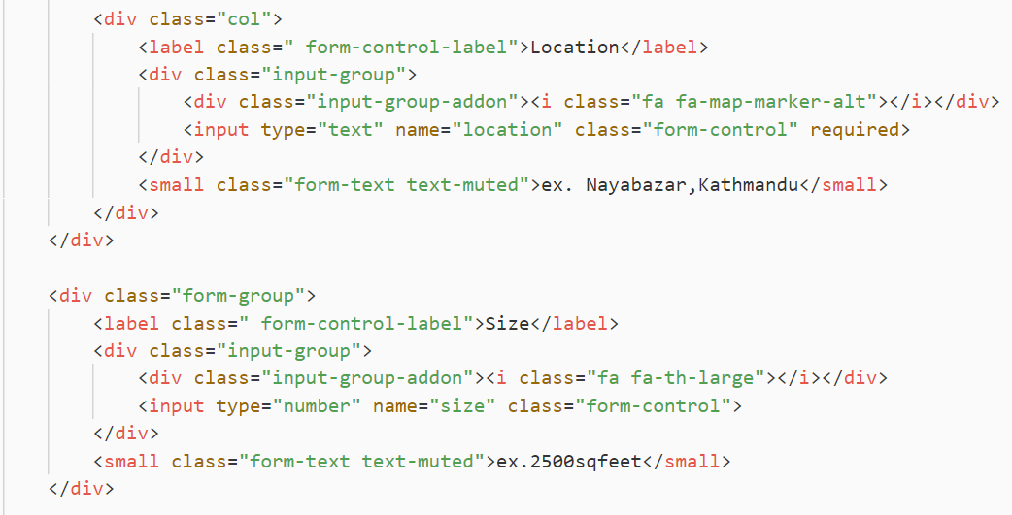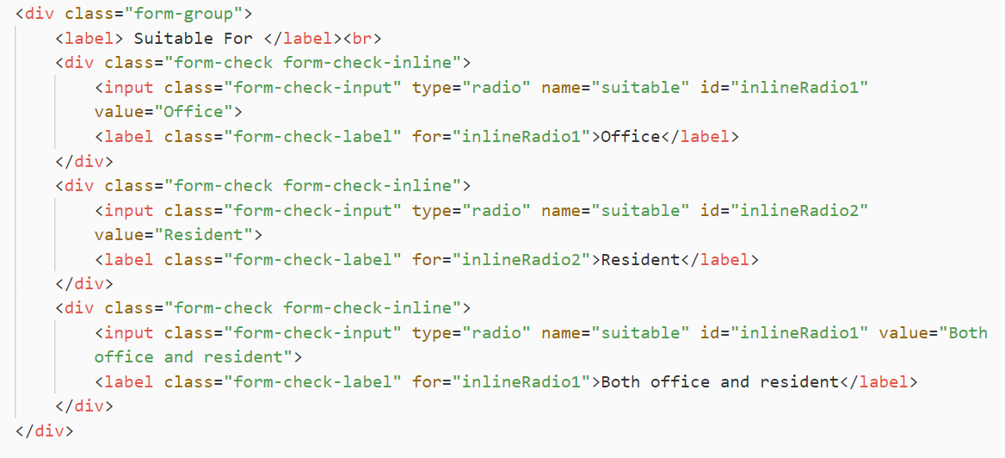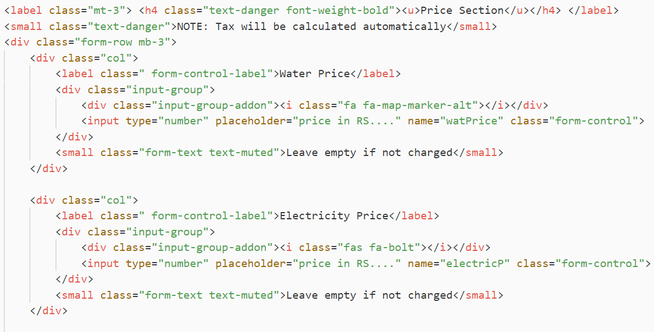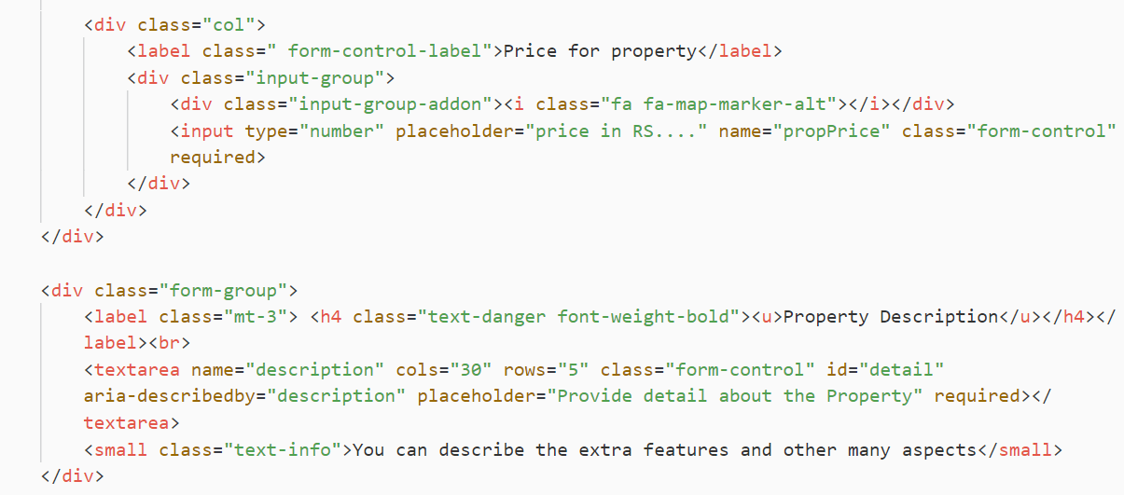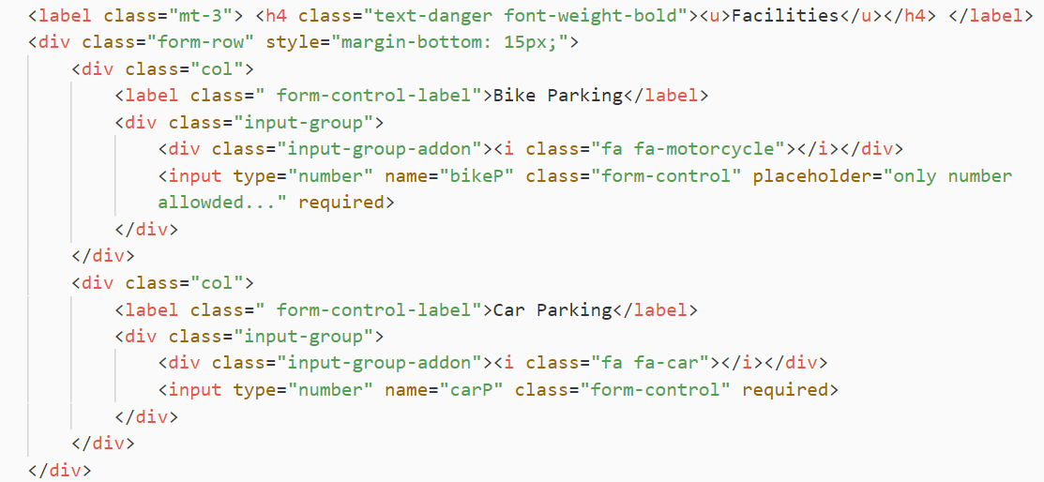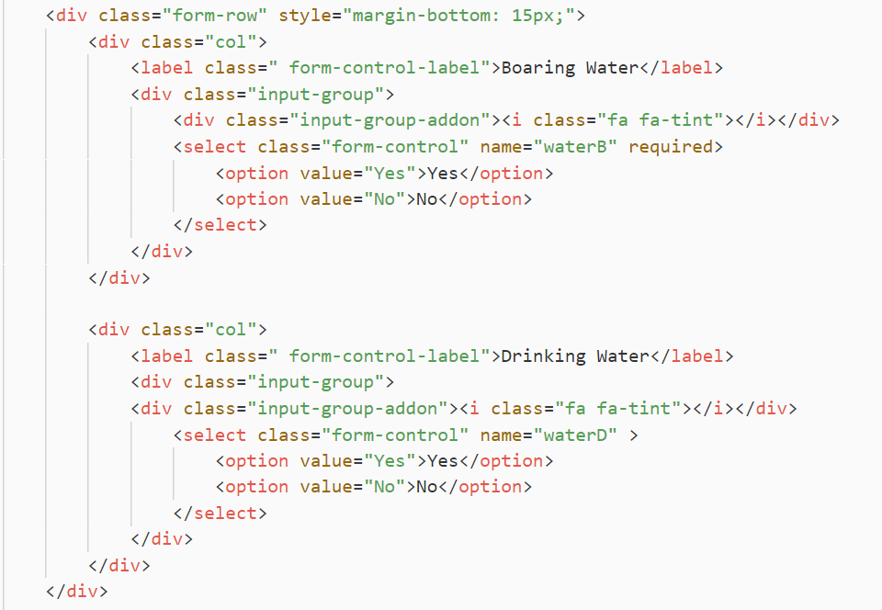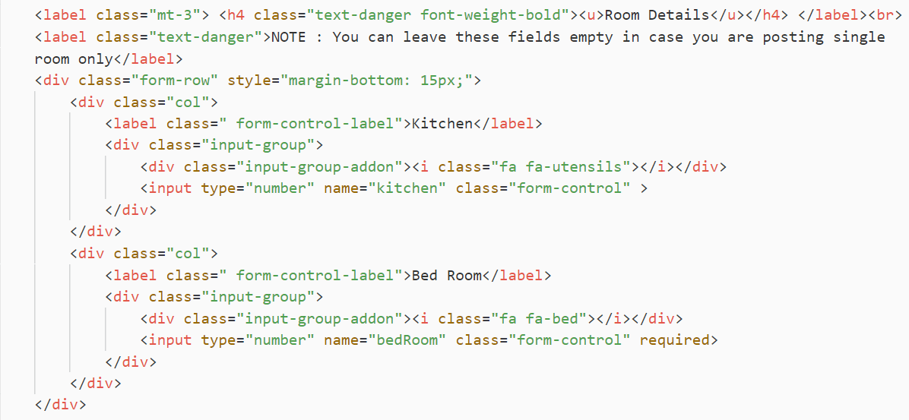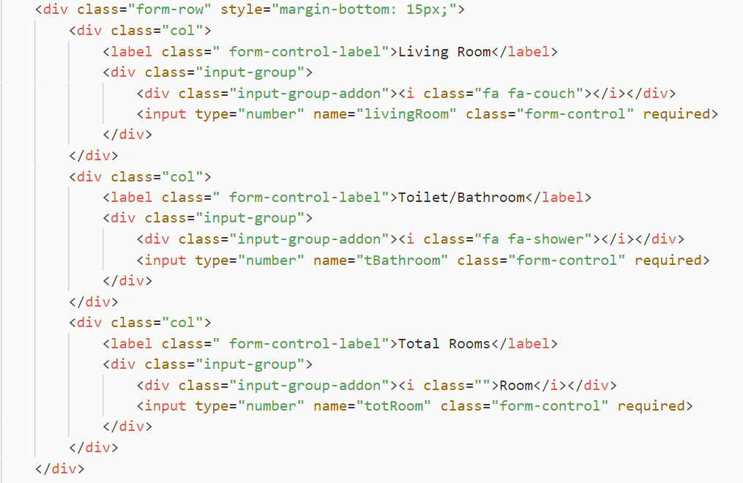

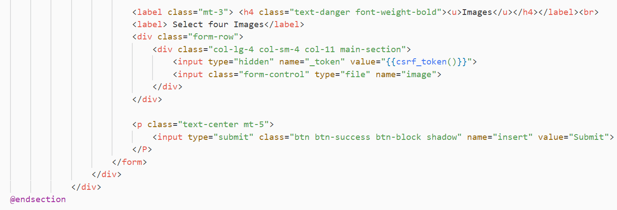

Fig Property - Add property

Edit product

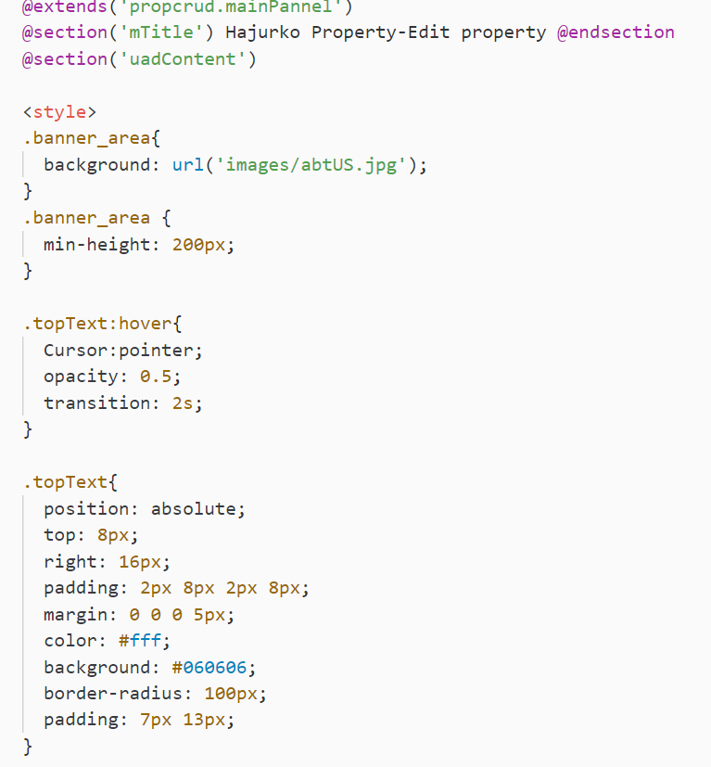

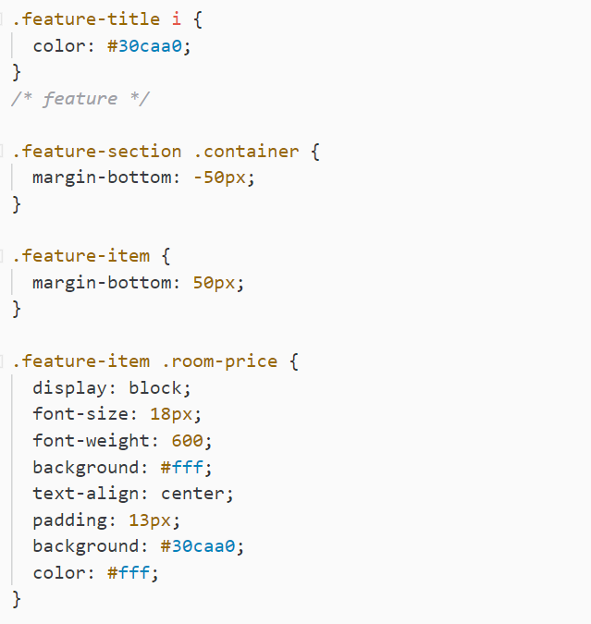

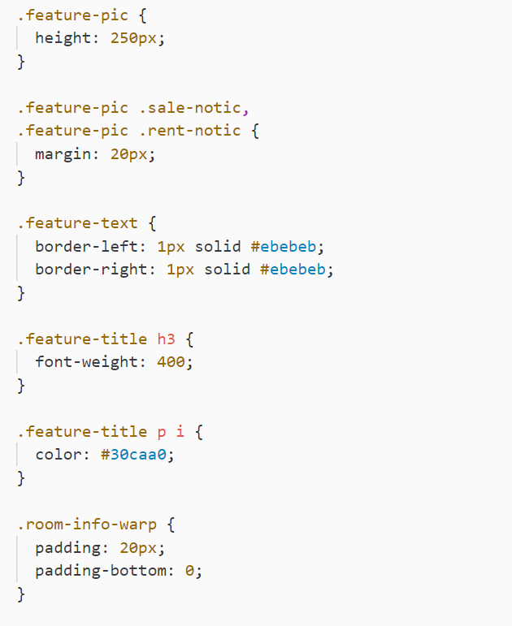

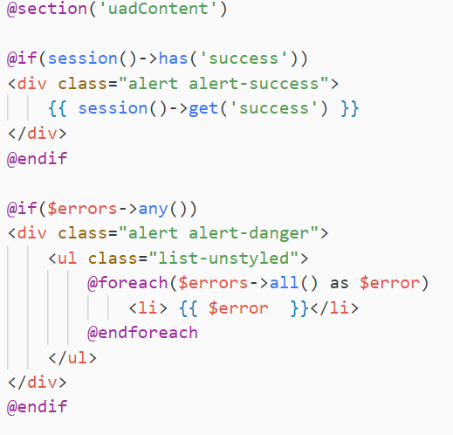

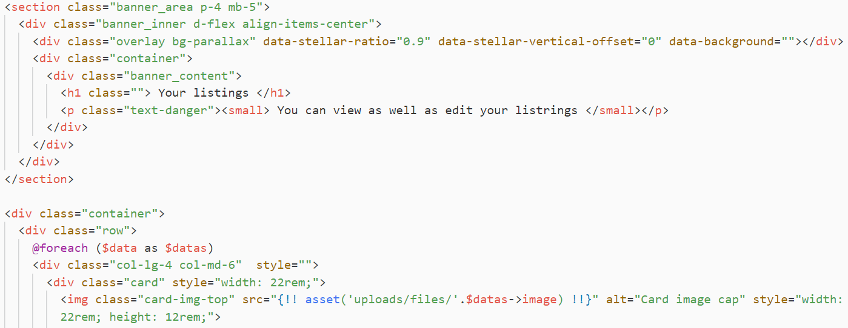

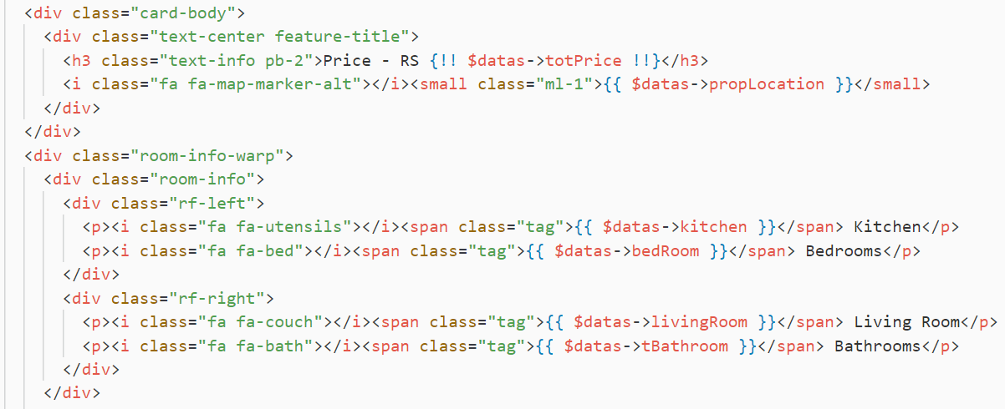

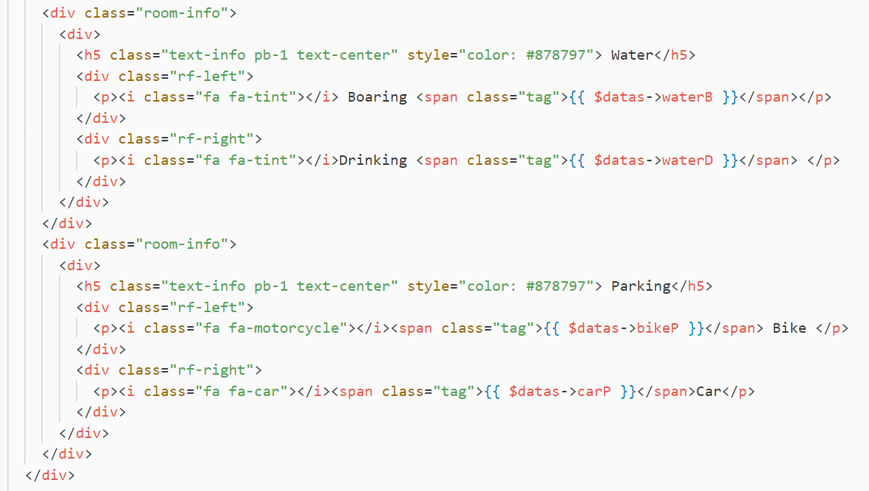

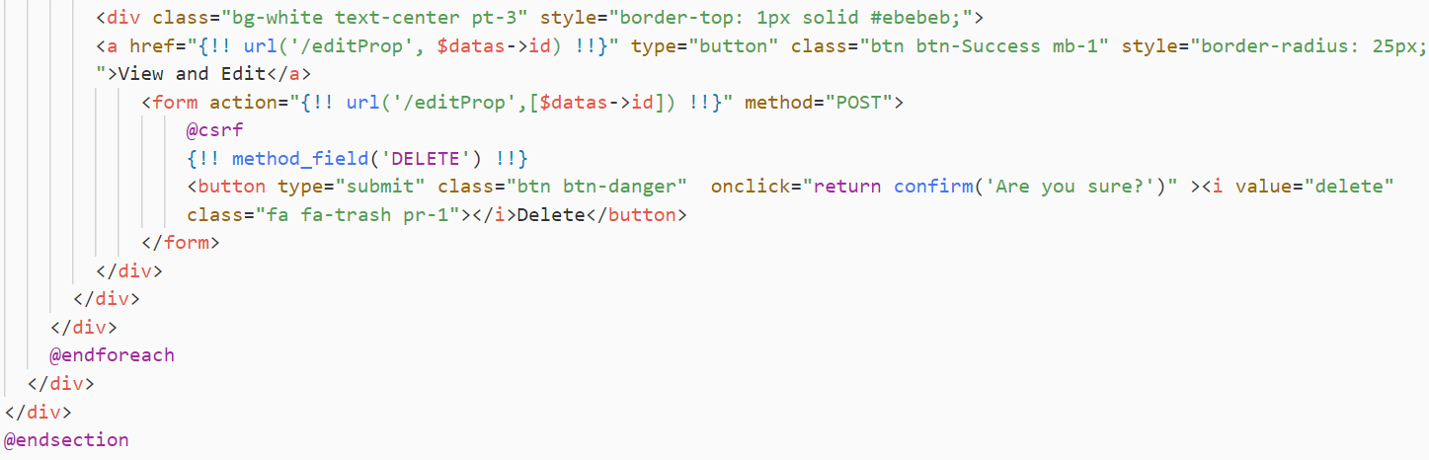

Update property

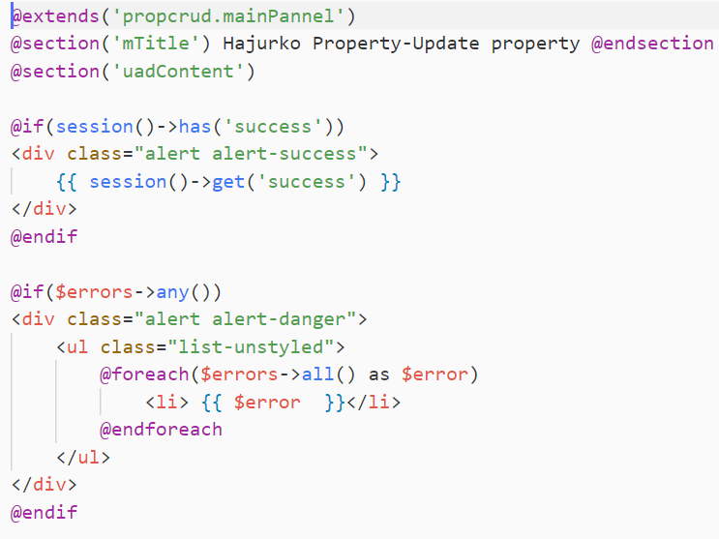

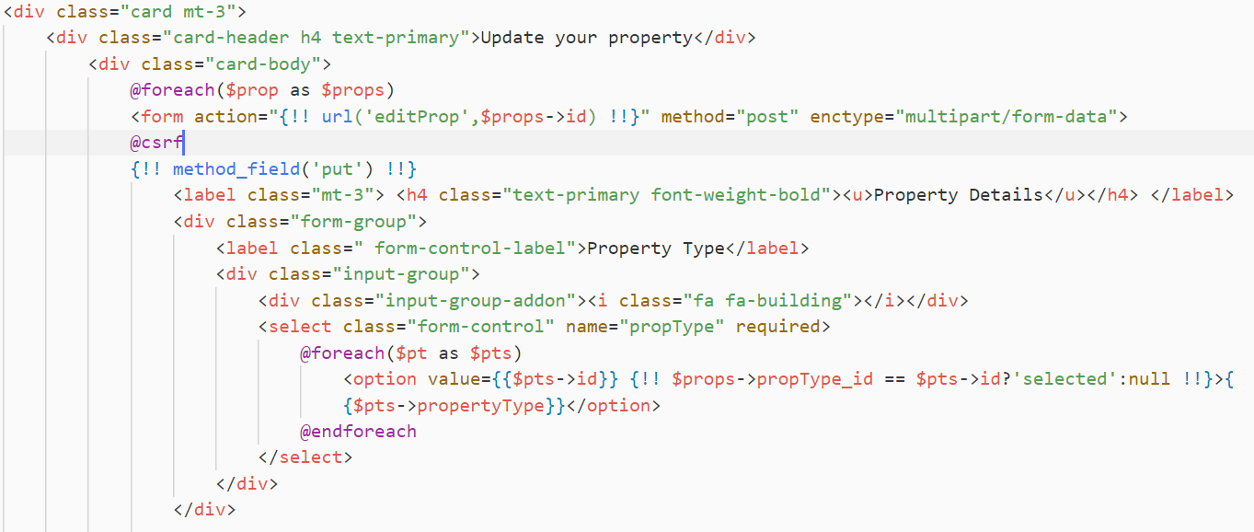

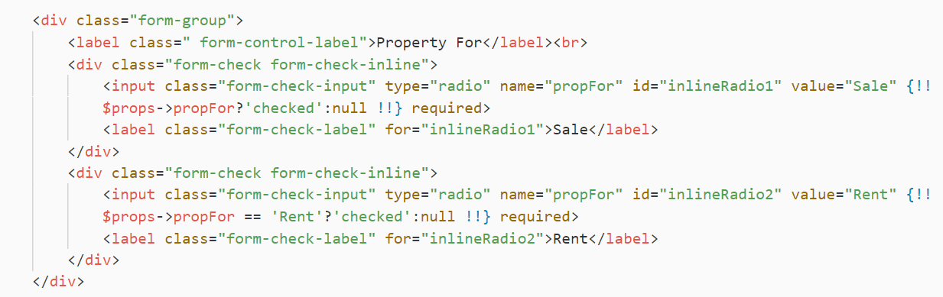

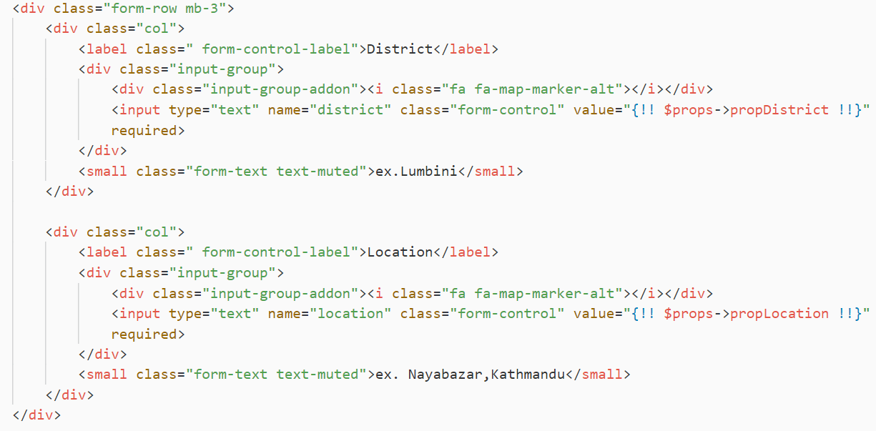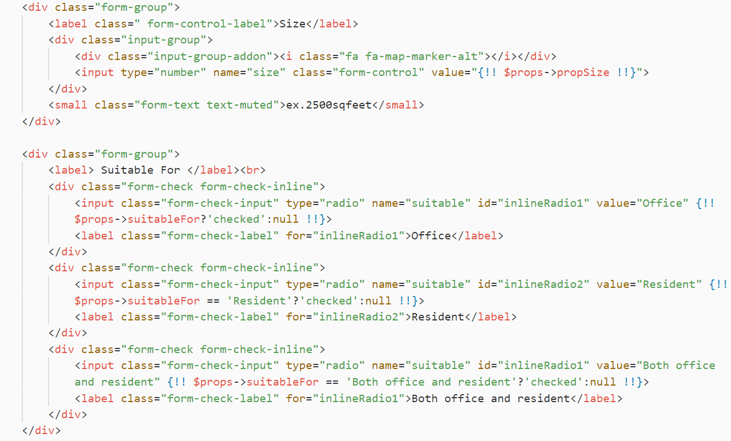

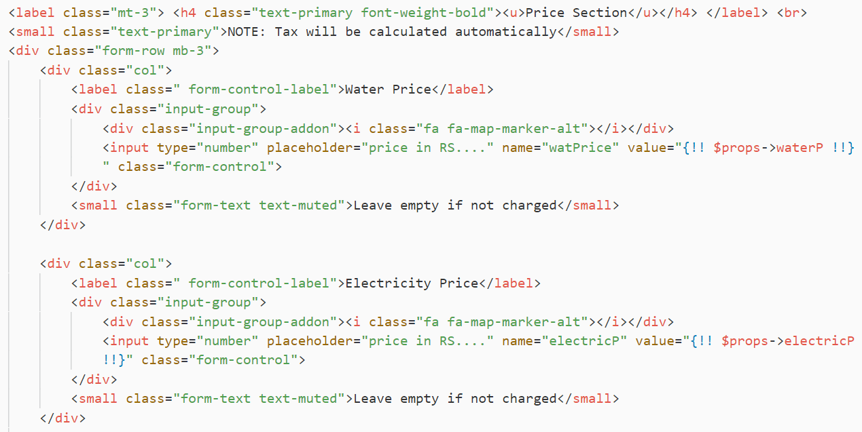

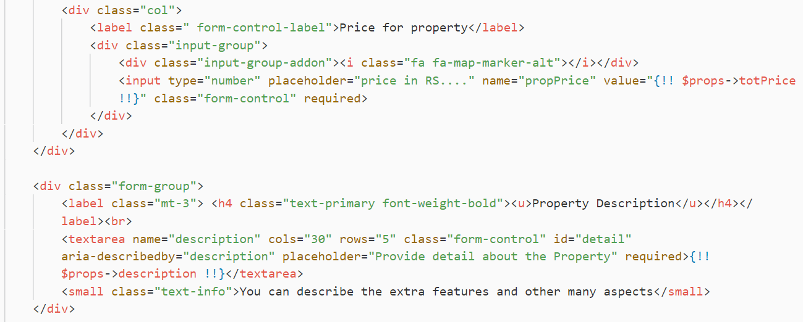

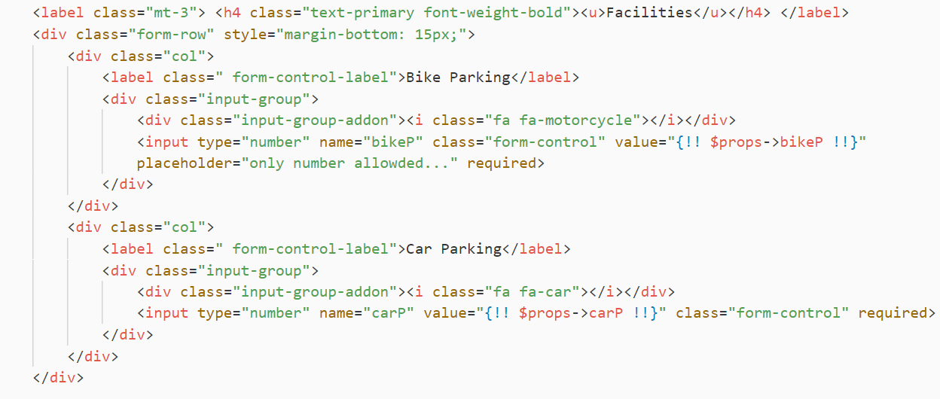

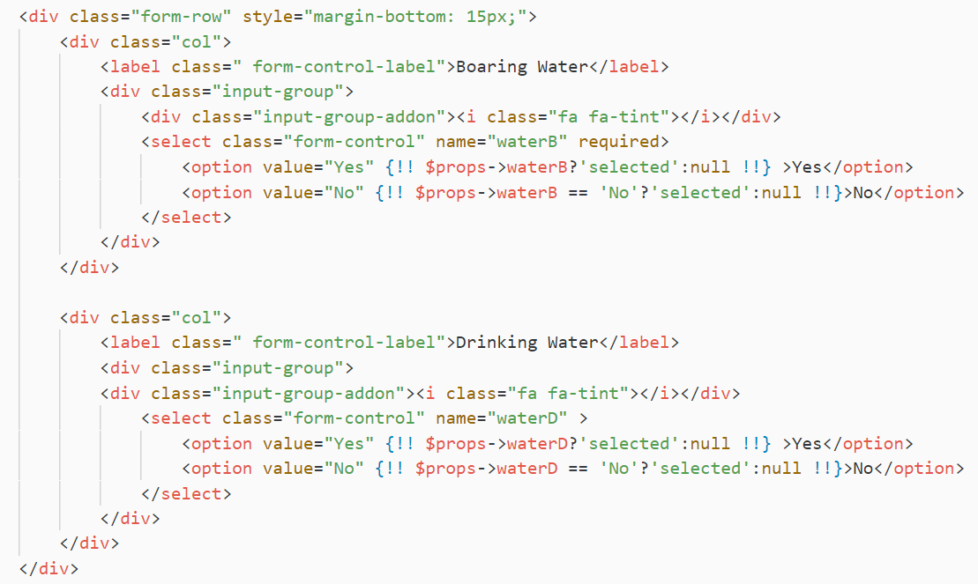

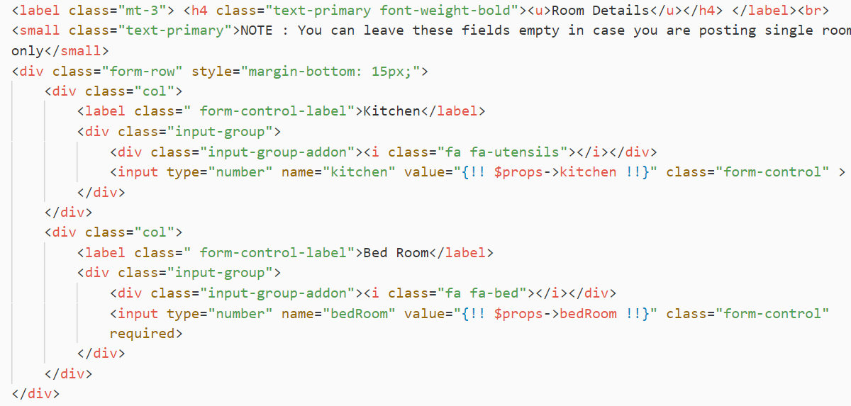

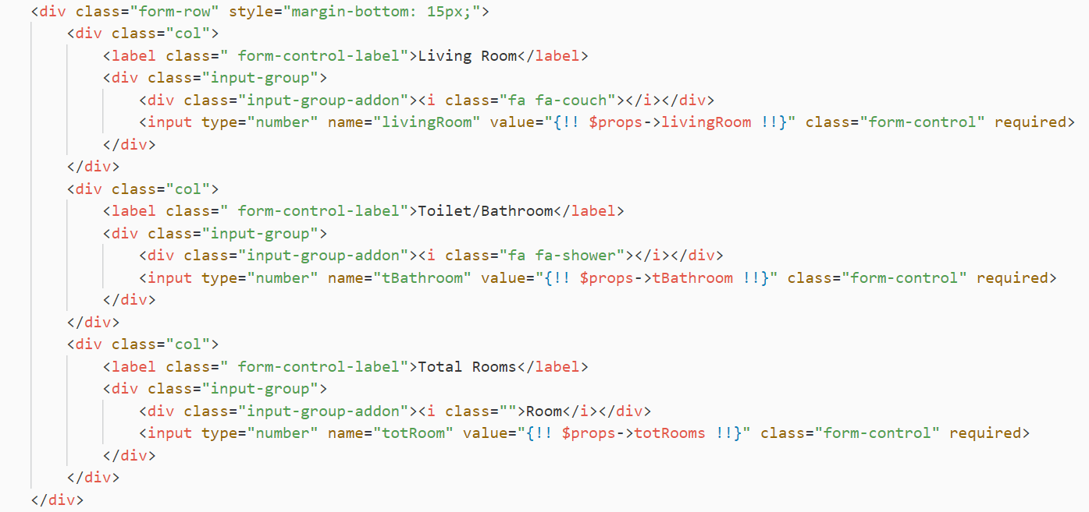

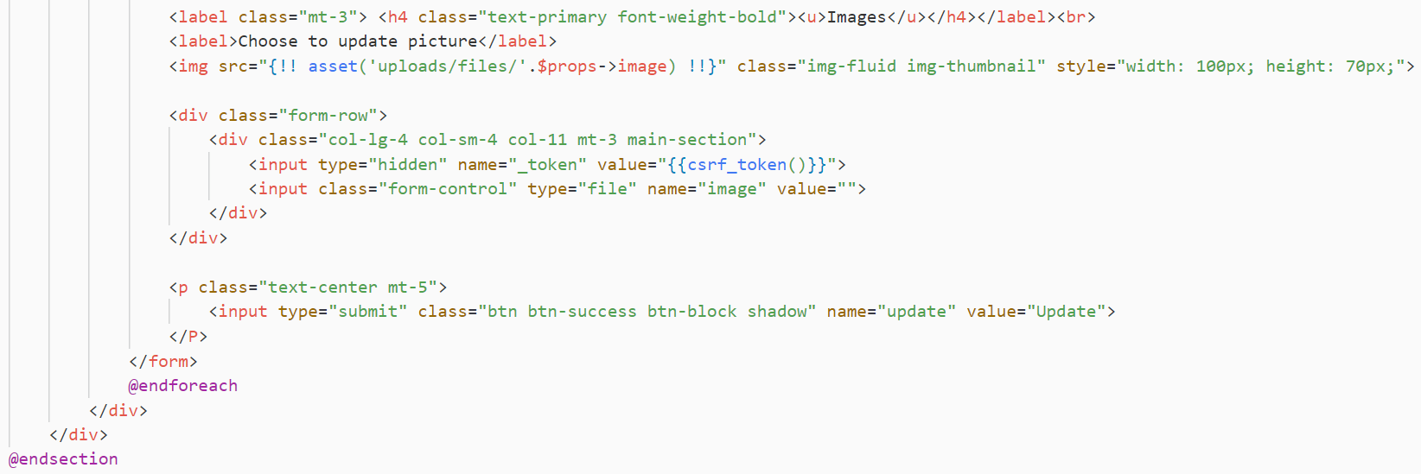

Fig Property – Update

**Property View**

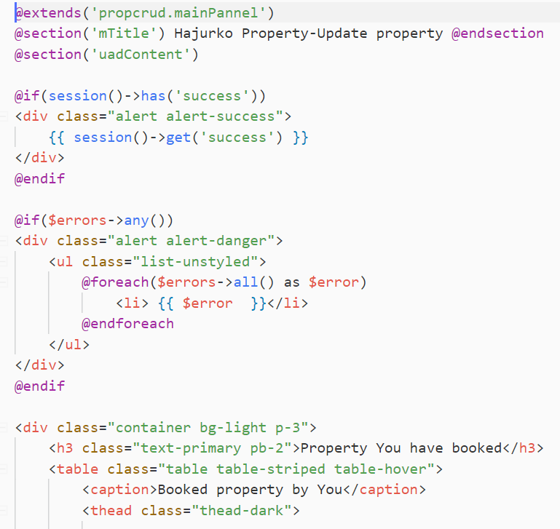

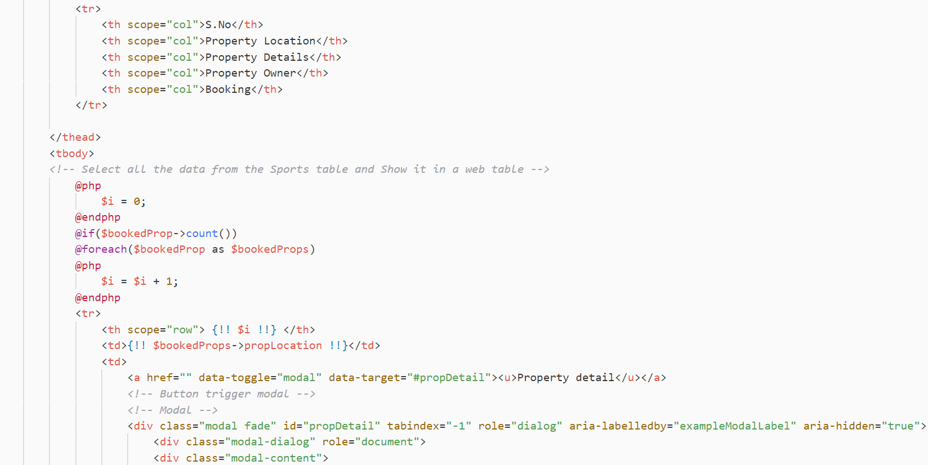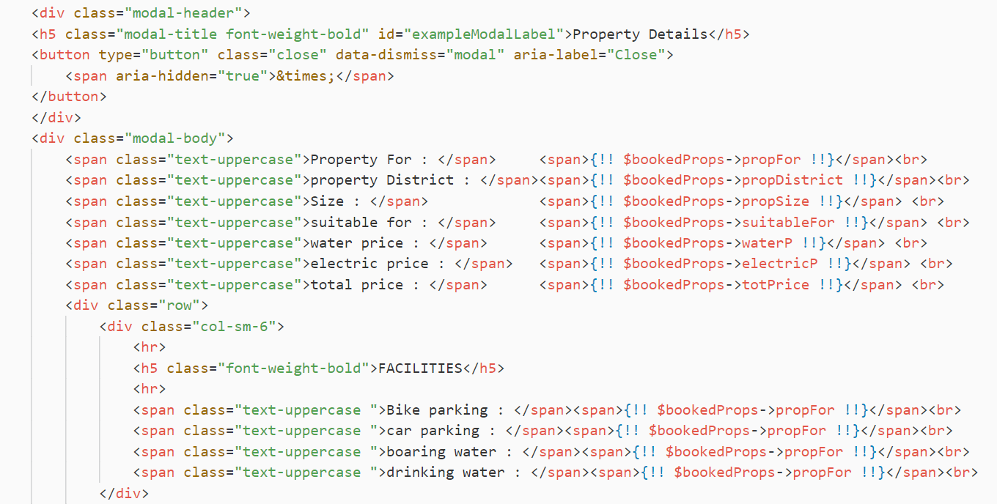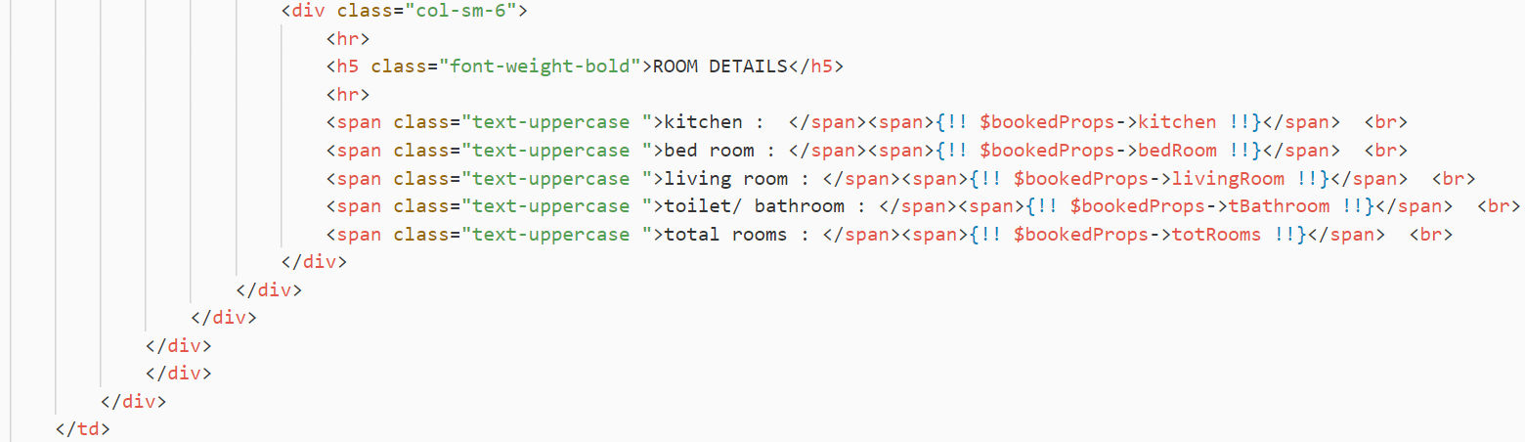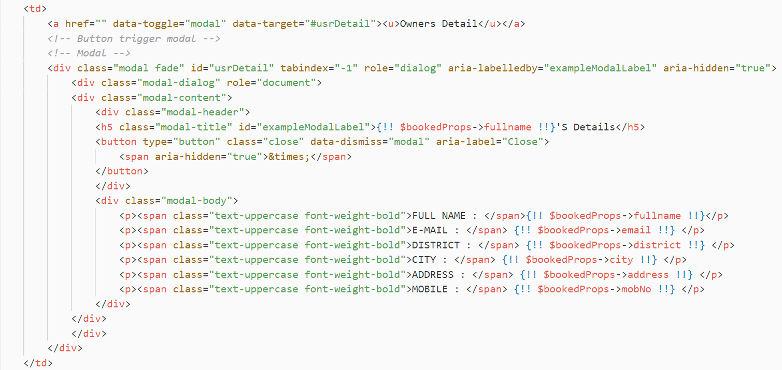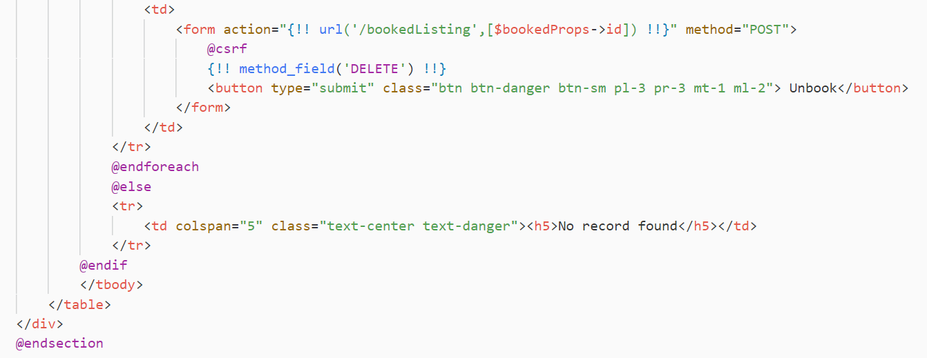

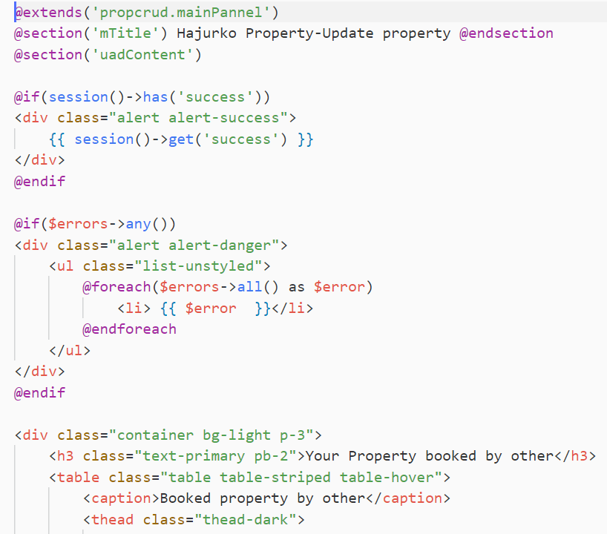

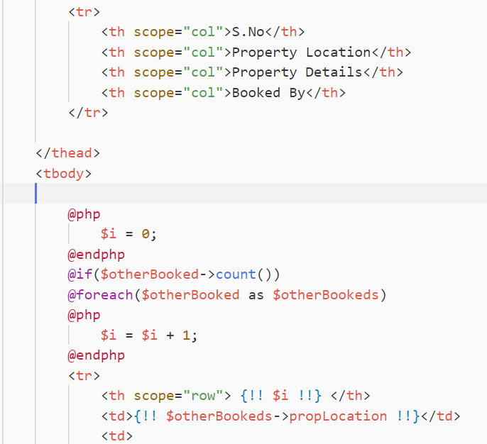

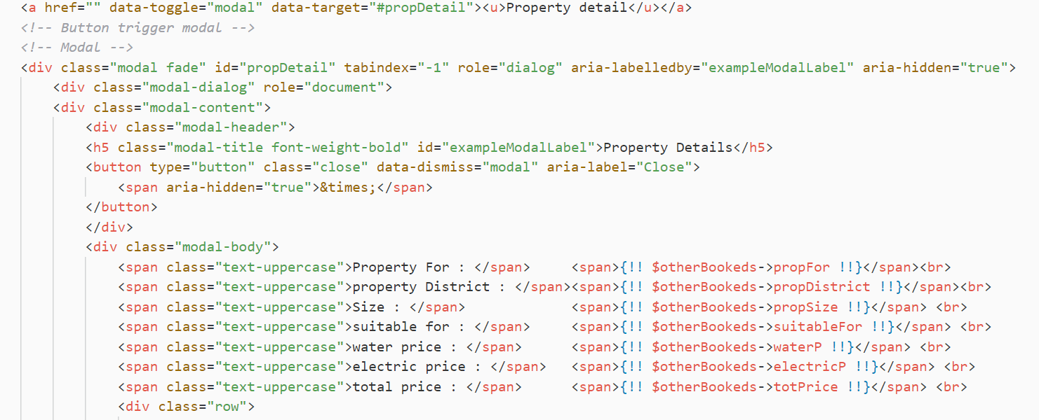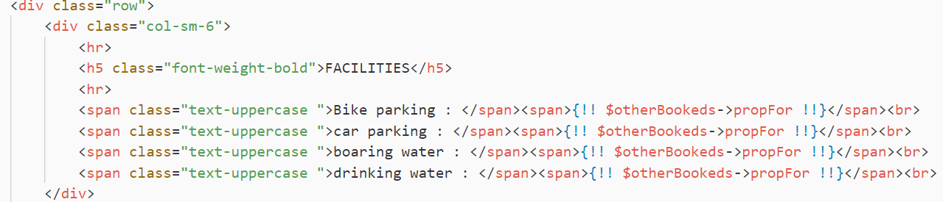

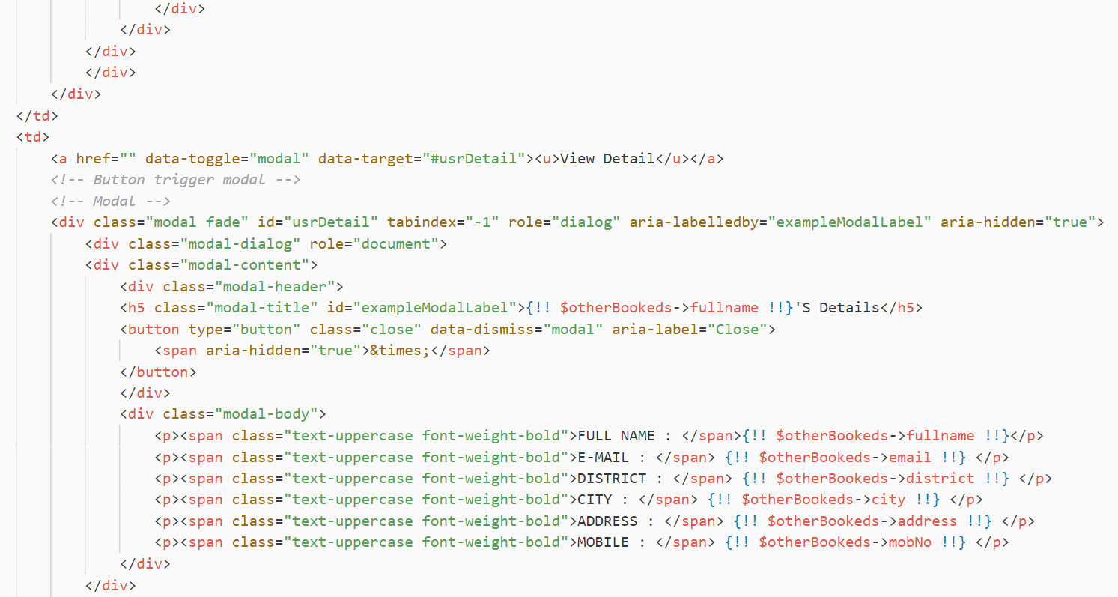

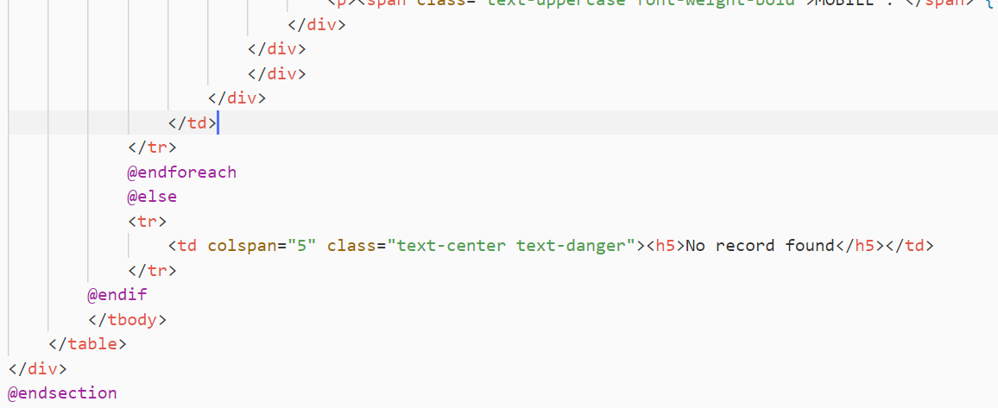

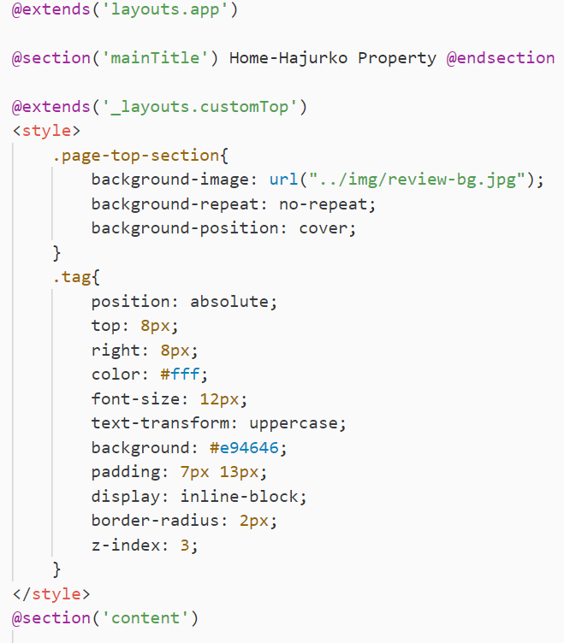

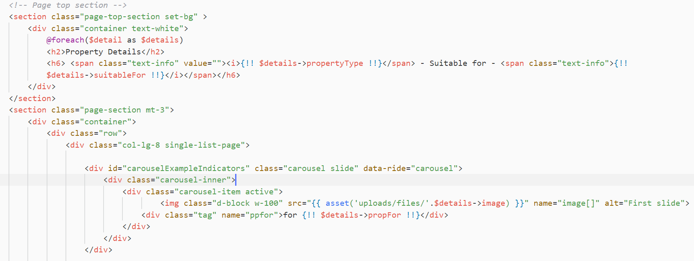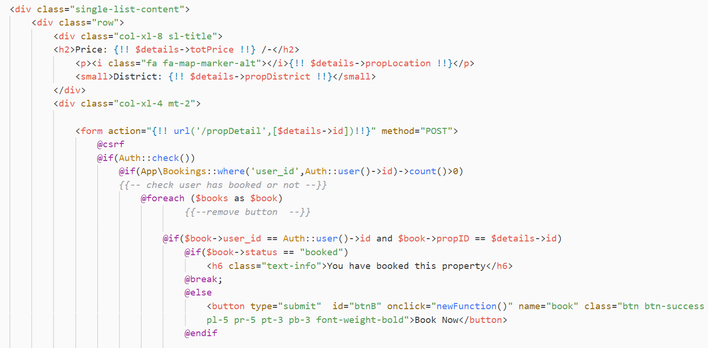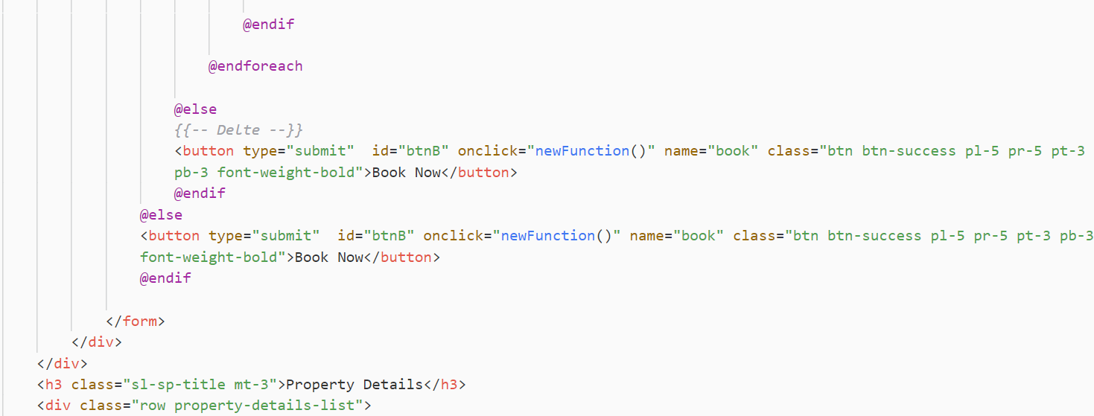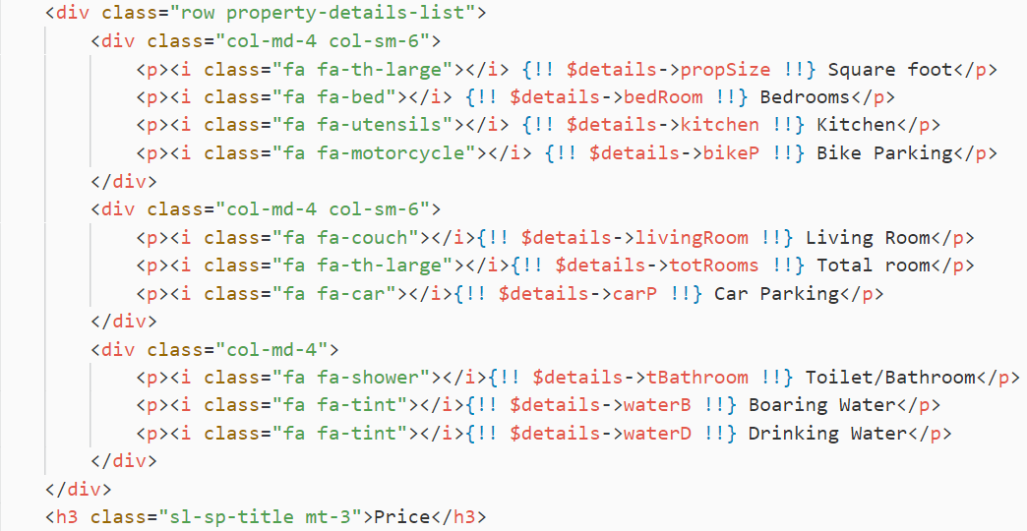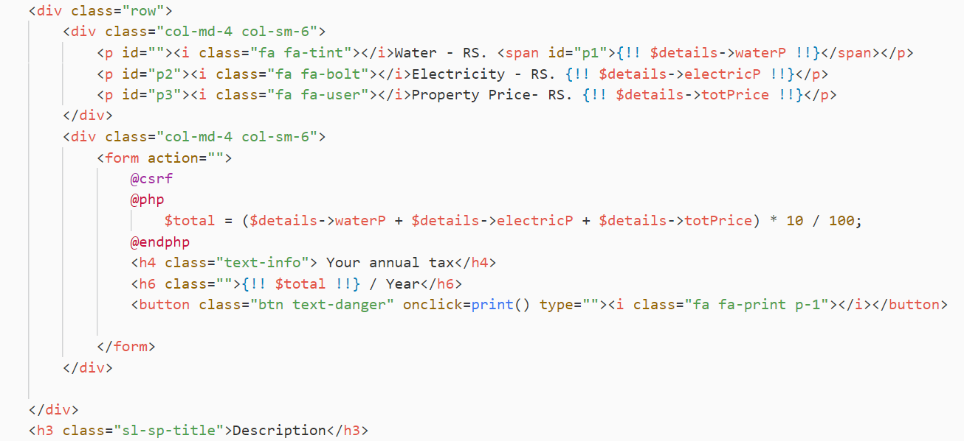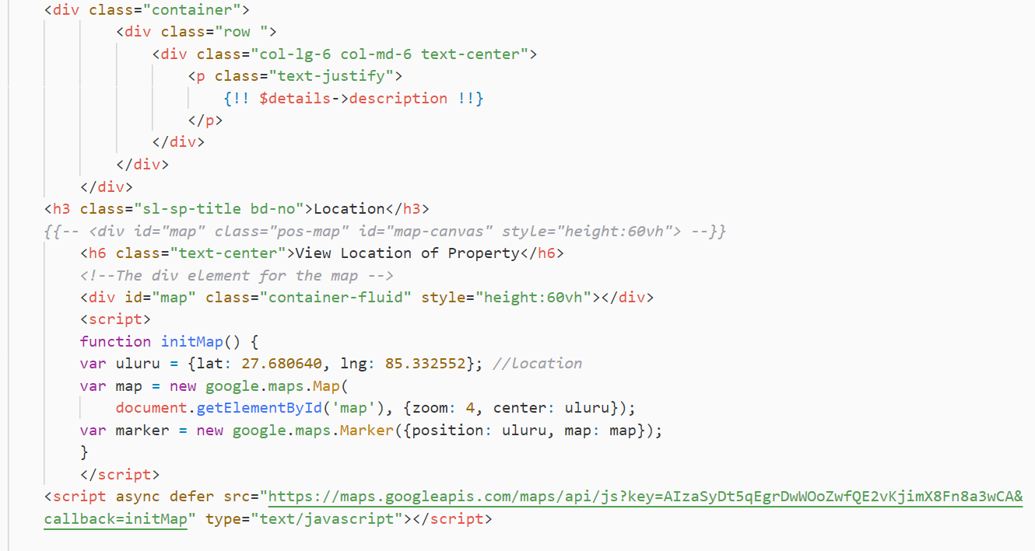

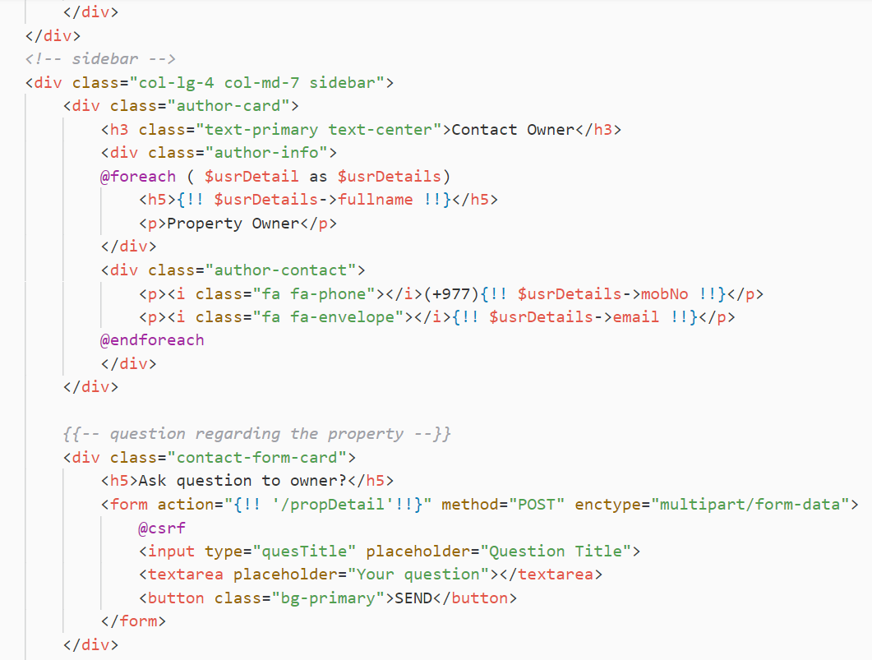

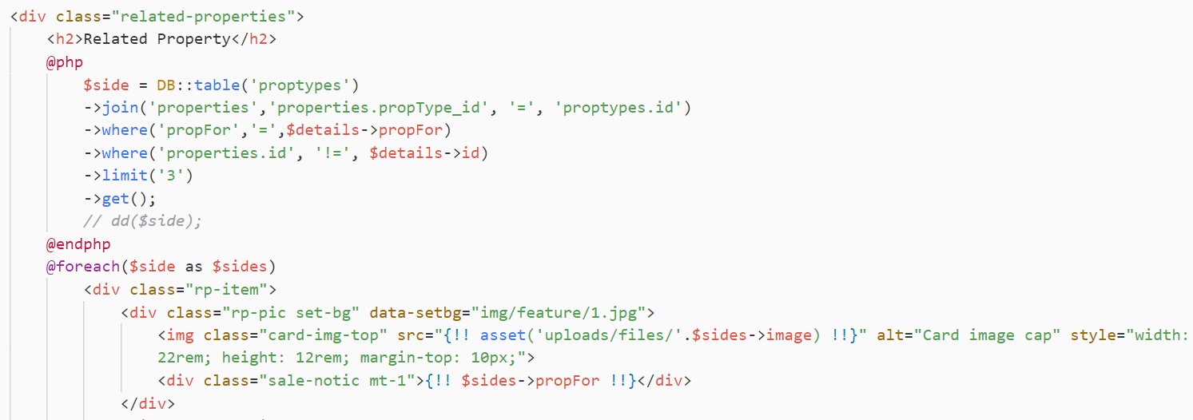

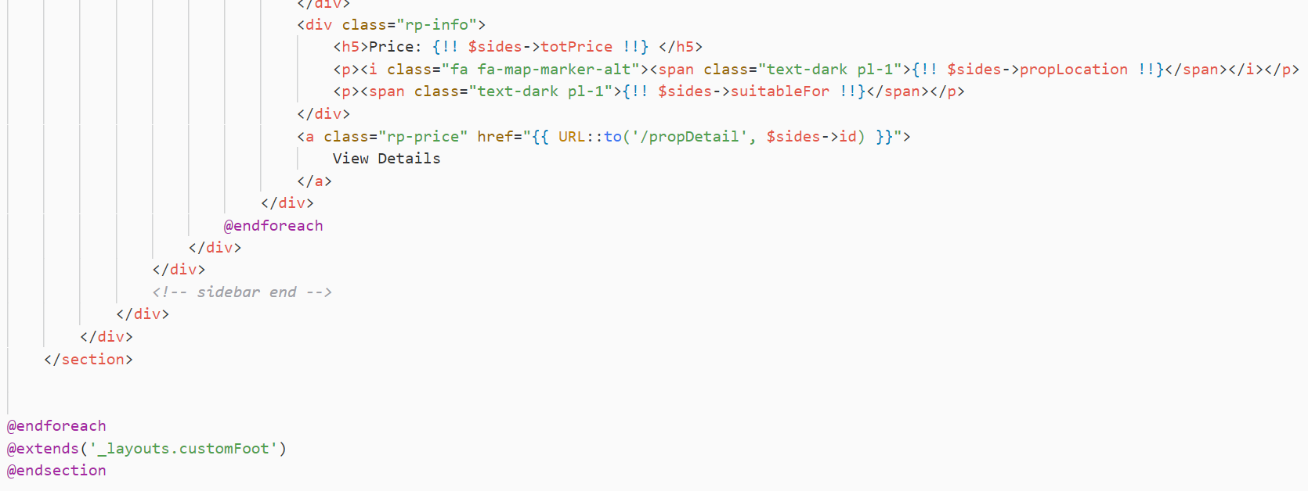

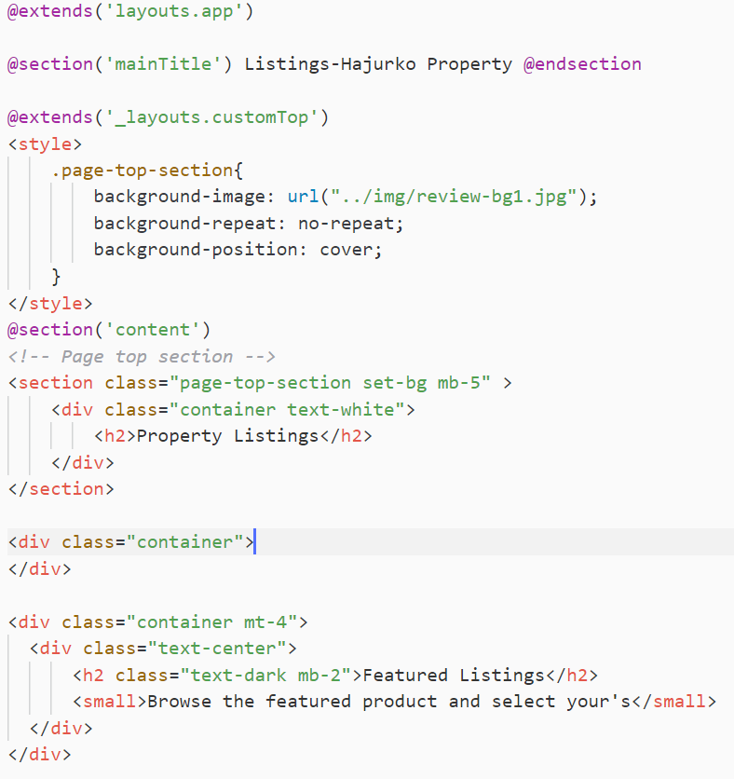

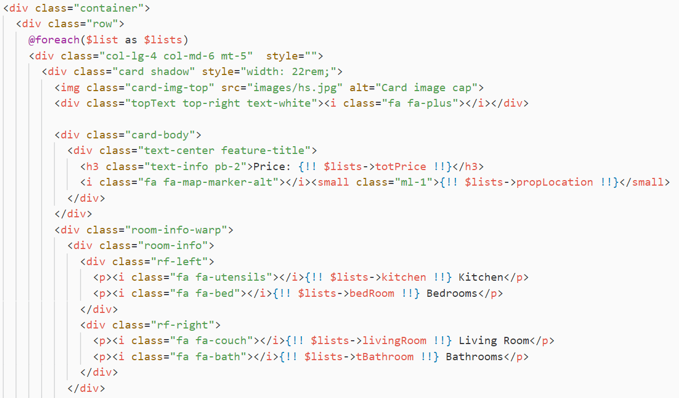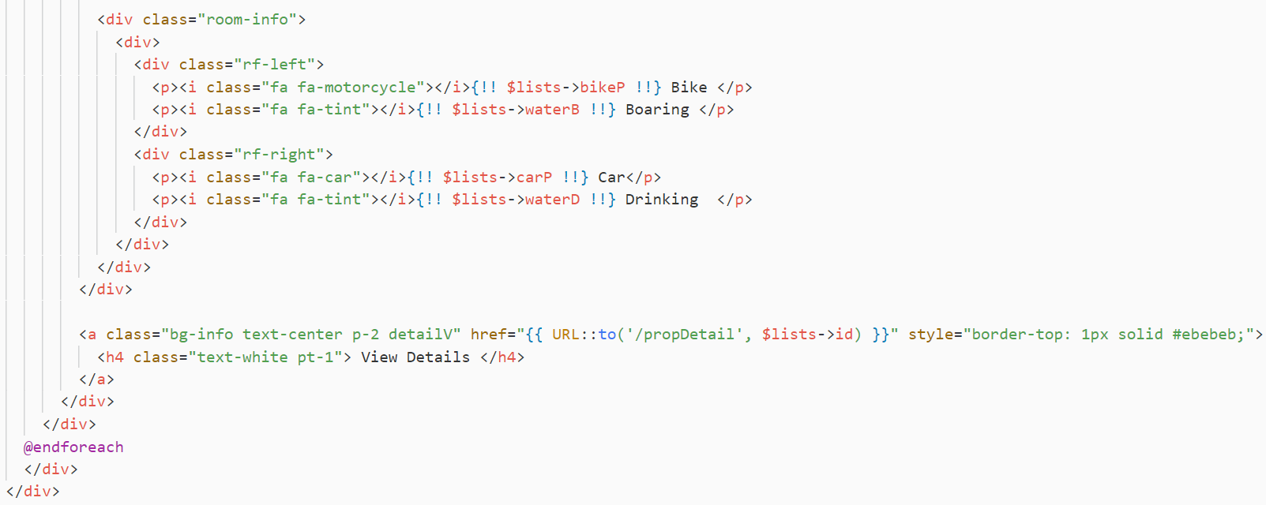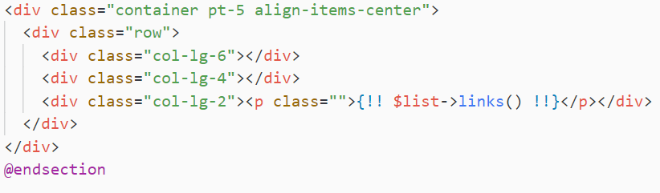

Fig property View

**Search**

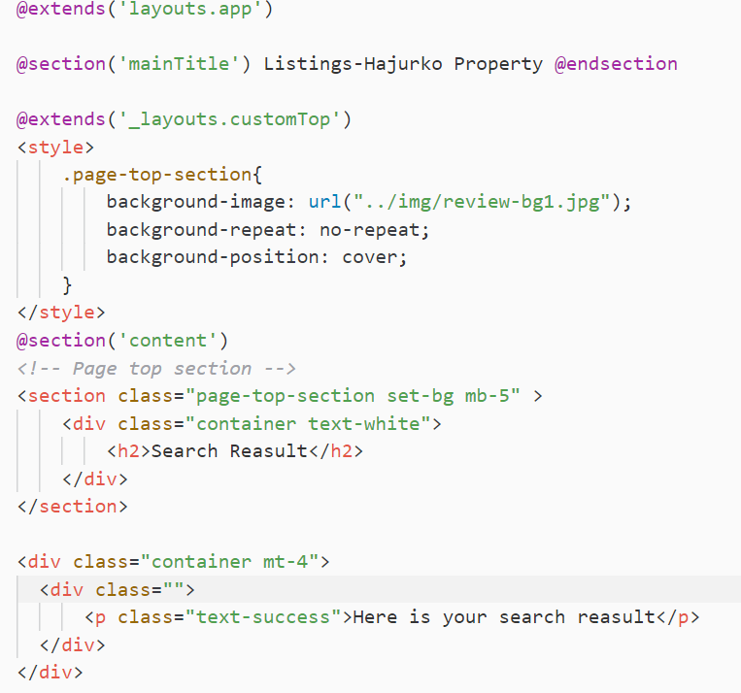

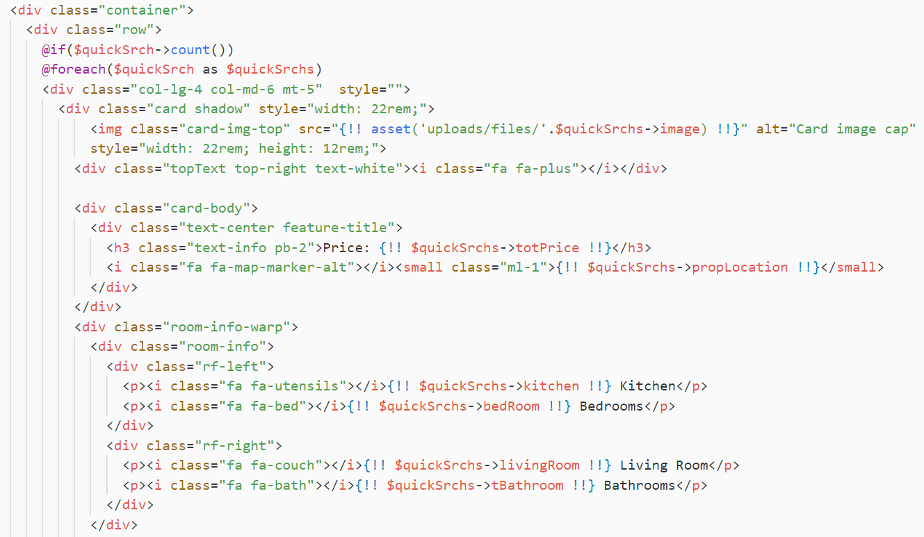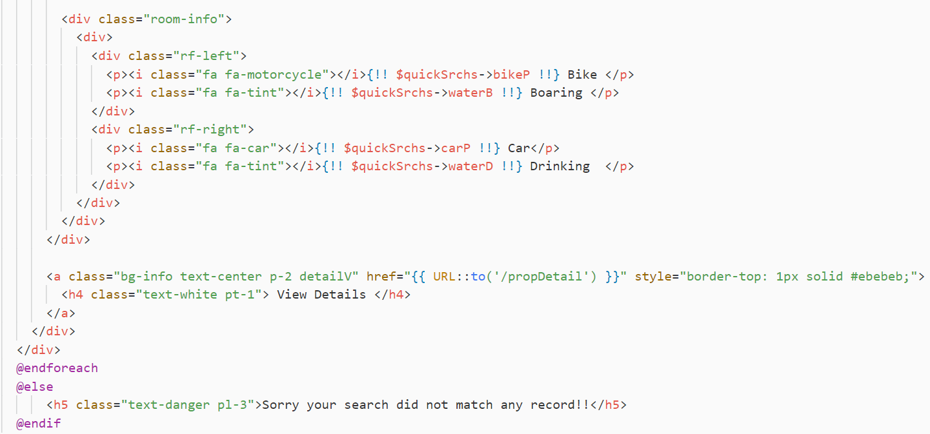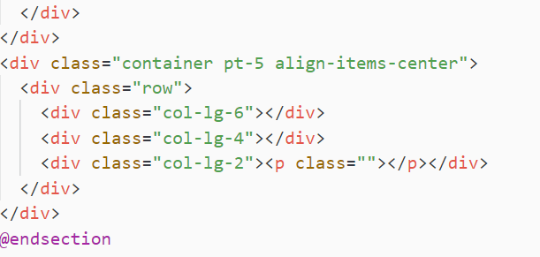

**Controller**

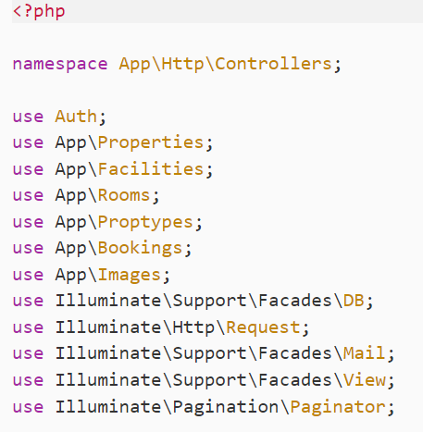

Fig Using different models

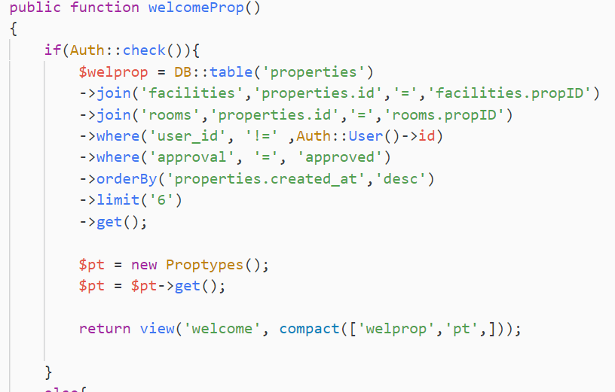

Fig Home page listing load

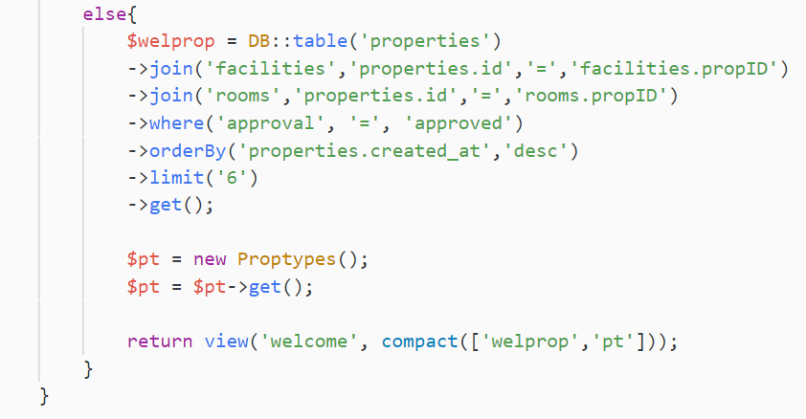

Fig Home page listing load 1

**Admin Controller**

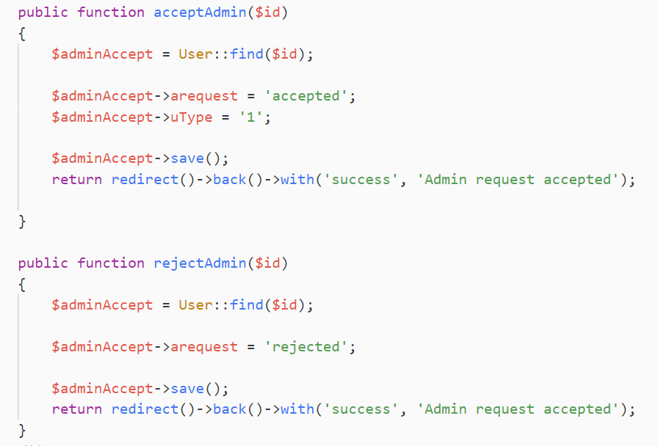

Fig Admin Controller - Accept or reject admin request

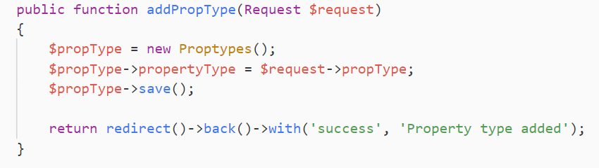

Fig Admin Controller - Add property type

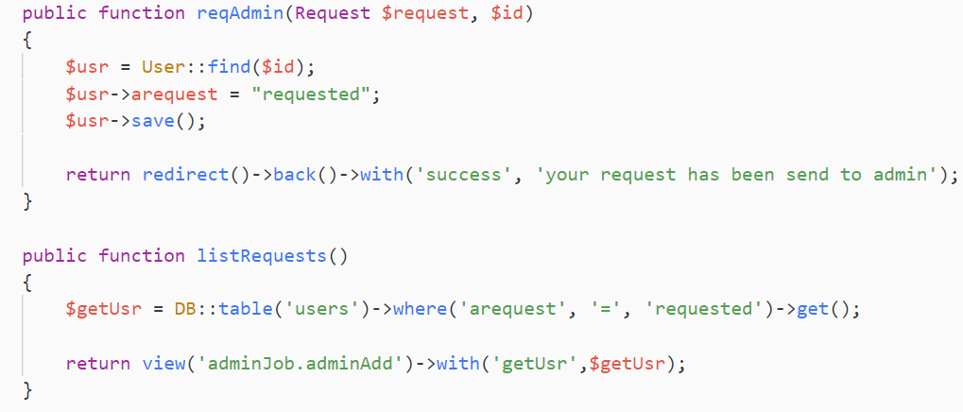

Fig Admin Controller - request and lists

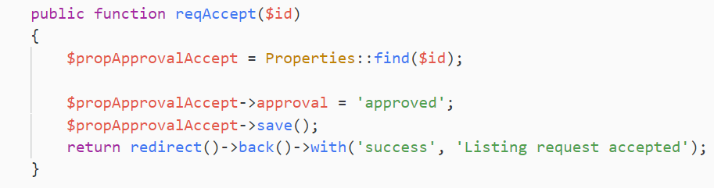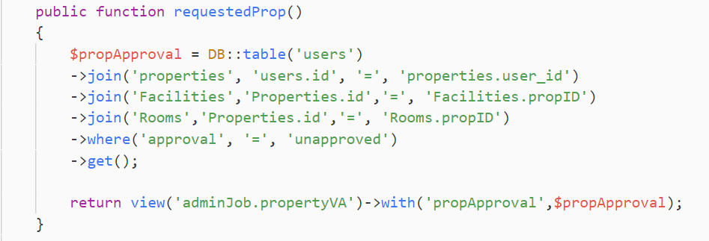

Fig Admin Controller - Accept or reject property request

**Auth Controller**

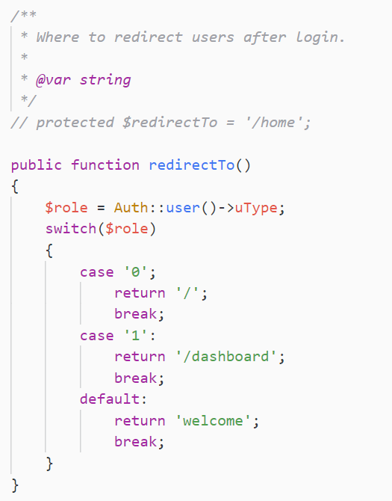

Fig Auth Controller - Admin and normal user

**Register**

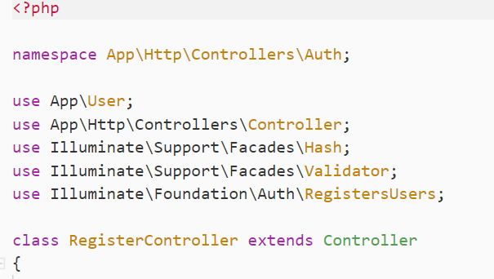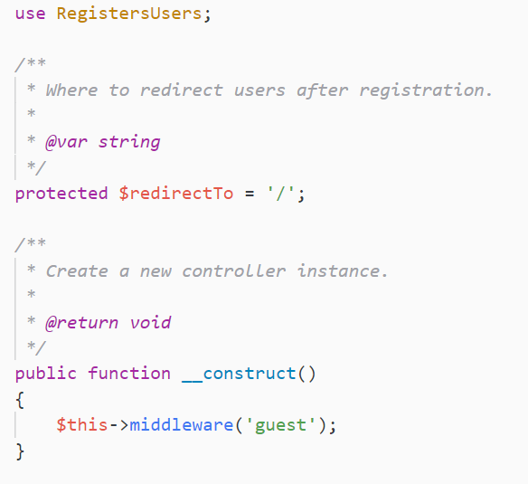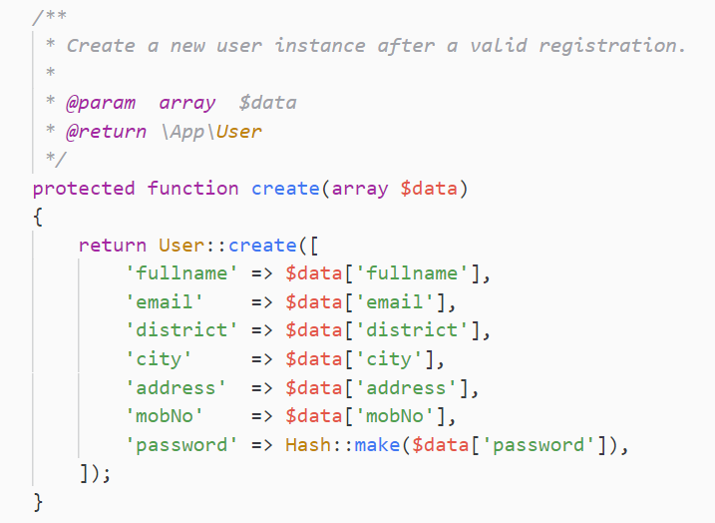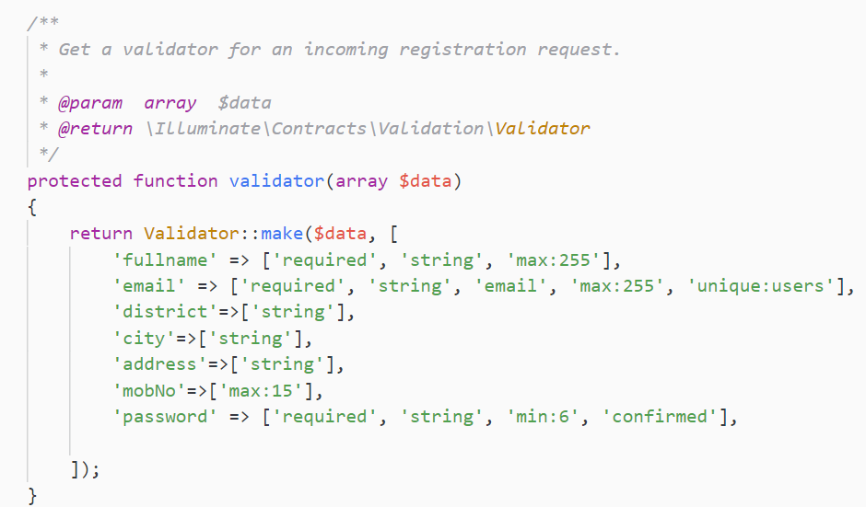

Fig Admin Controller – Register

**Property Controller**

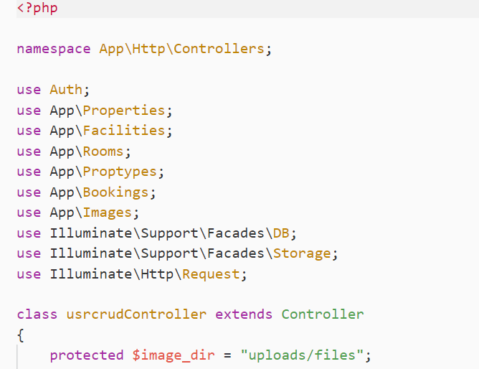

**Add Property**

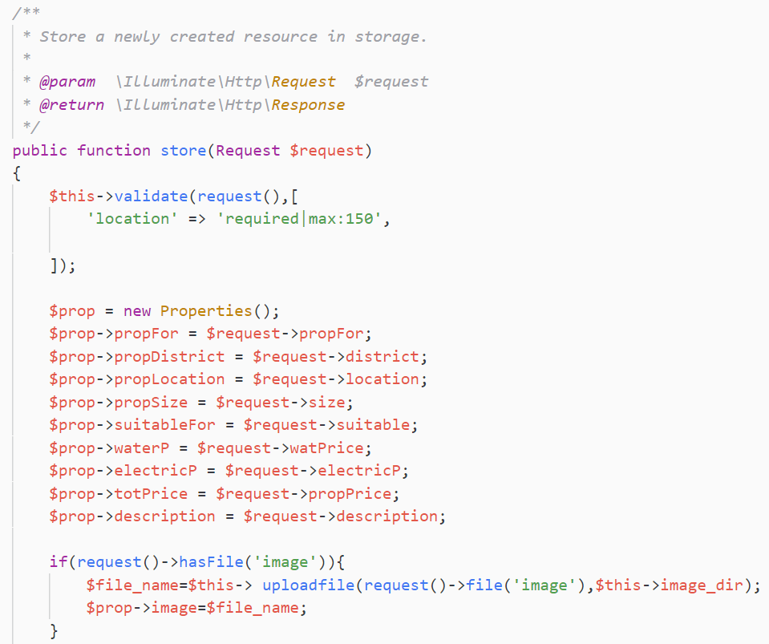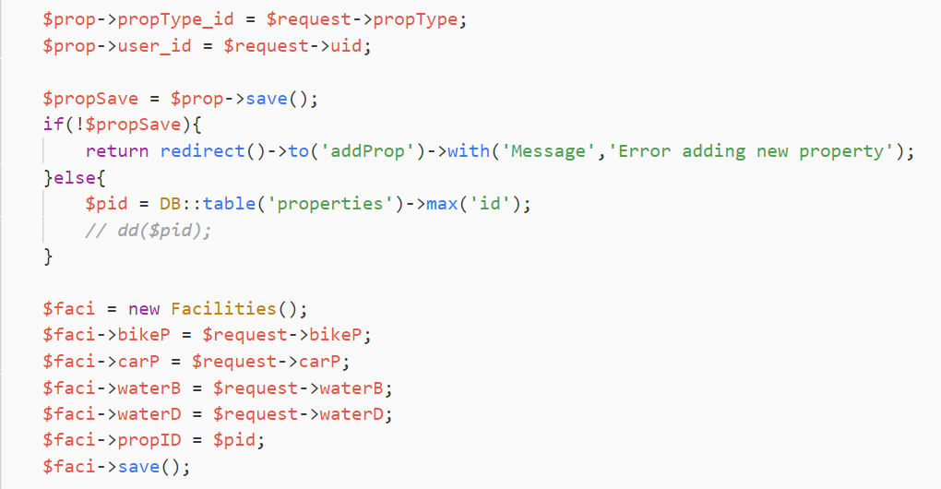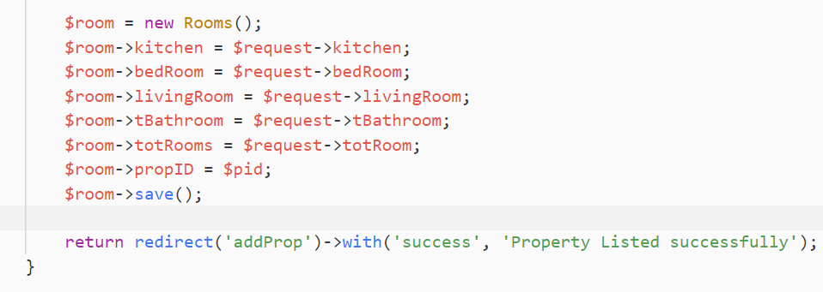

Fig Property Controller - Property Store

**Update Property**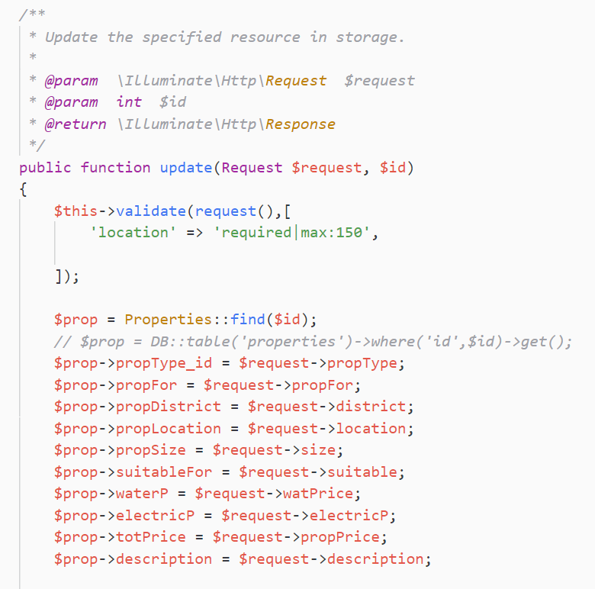

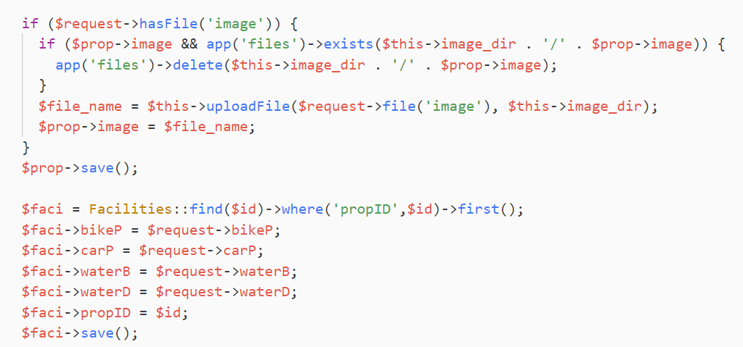

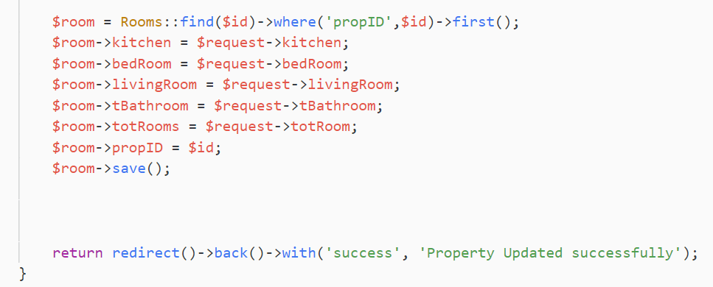

Fig Update Property

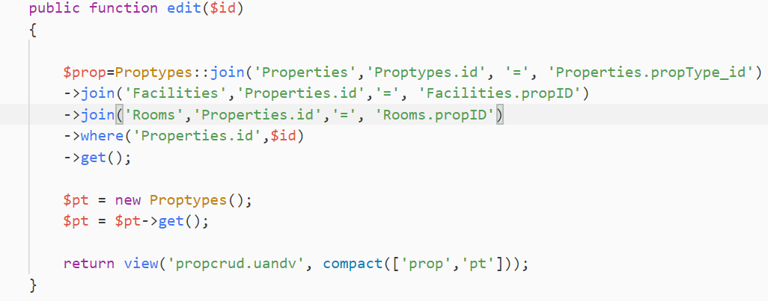

Fig Getting property to edit

**File Upload**

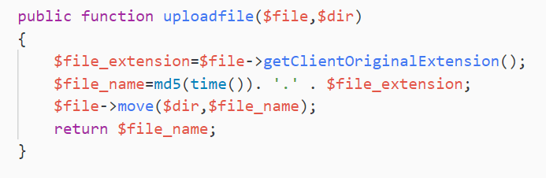

Fig File Upload

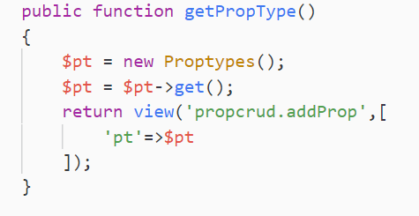

Fig property type

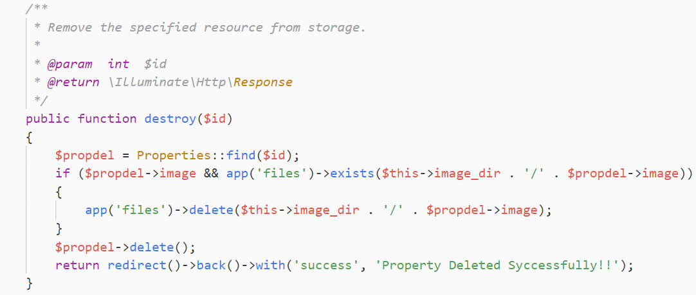

Fig Delete Property

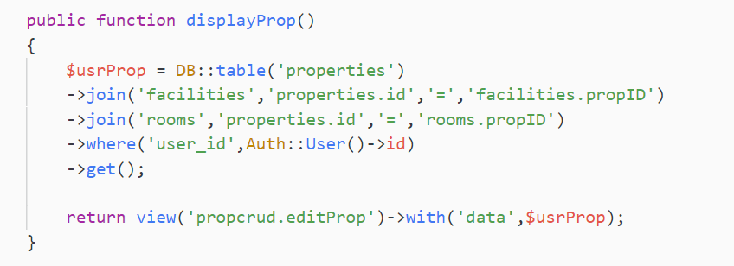

Fig Display Property

**Profile** 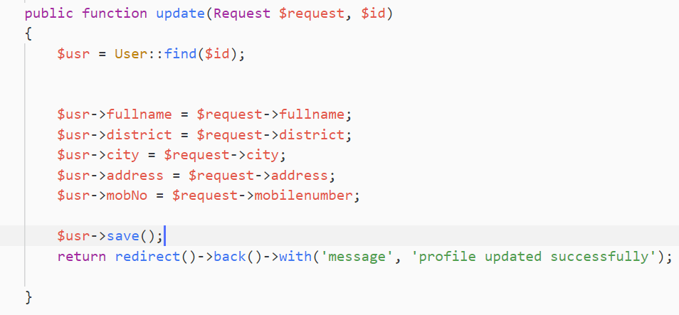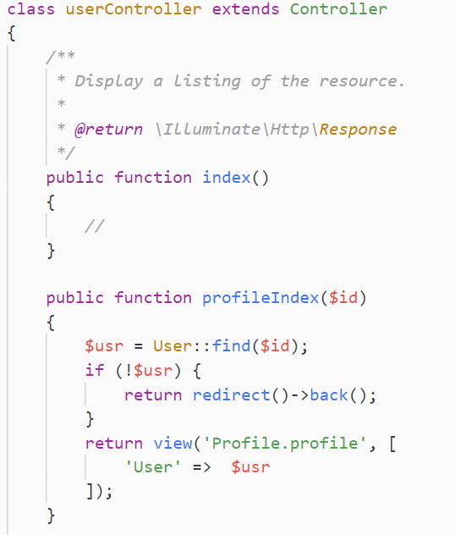

Fig Profile controller

**Search**

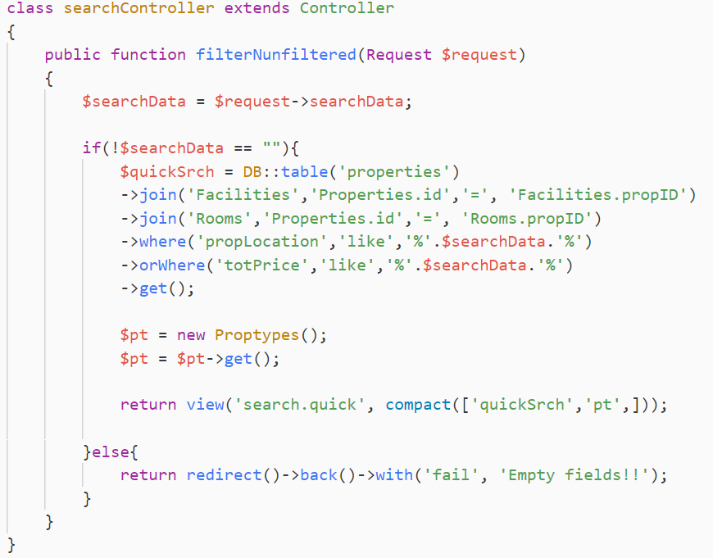

Fig Search Controller

**Property Booking**

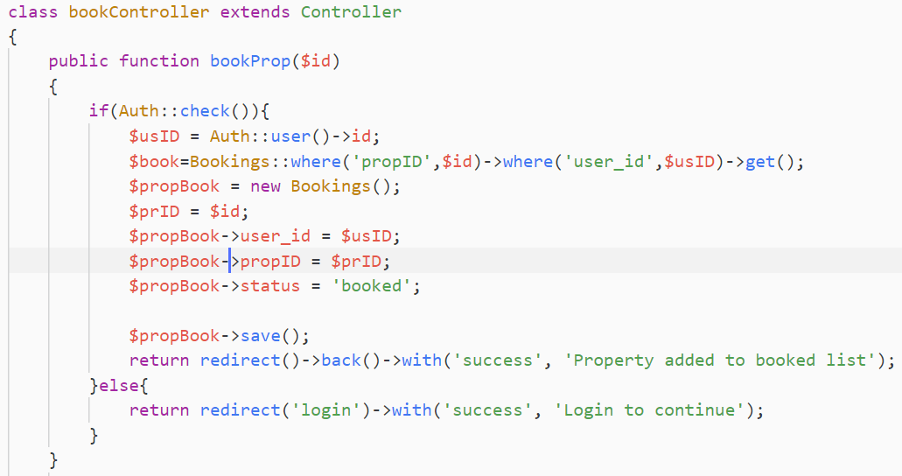

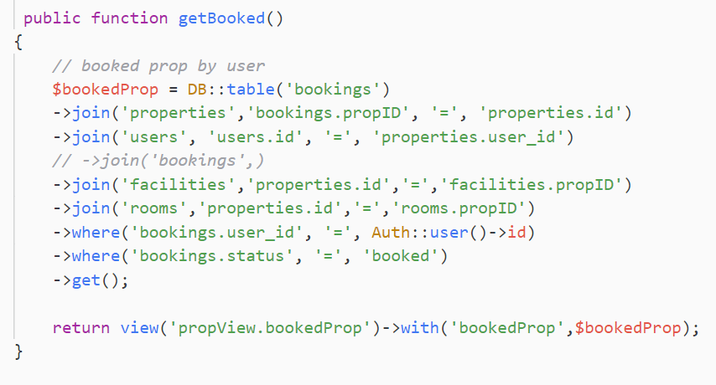

Fig Property Booking

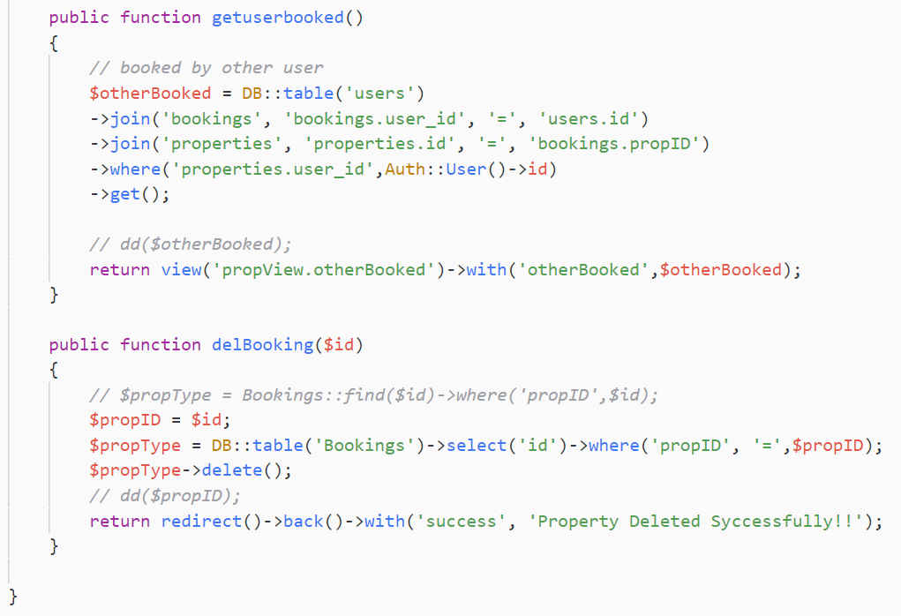

Fig Get booked

**View Property**

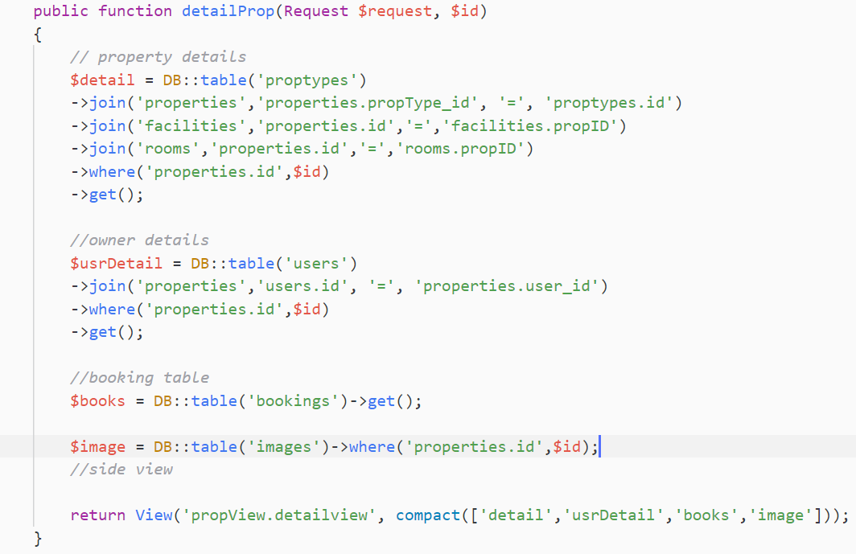

Fig Detail of the property

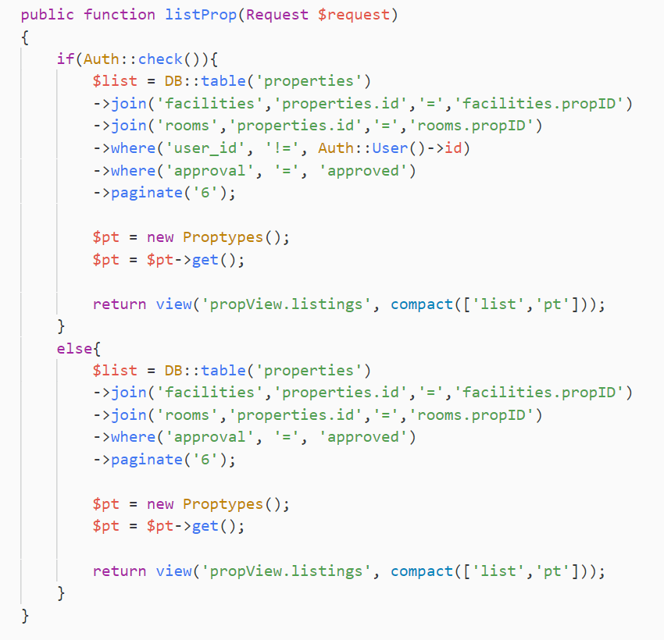

Fig property Listing

**UI Design**

All the design of actual website is shown below

**Home Page**

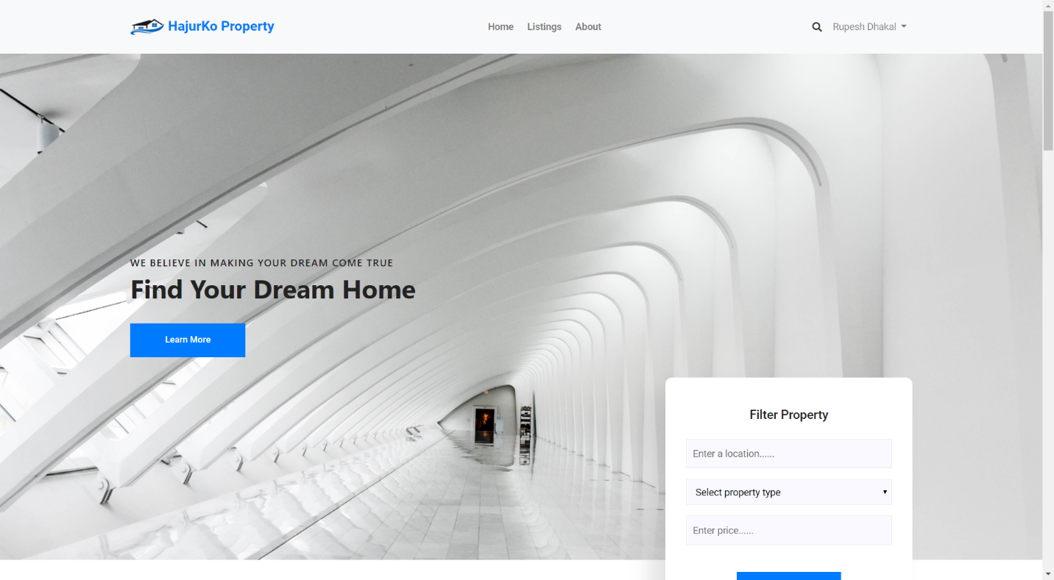

Fig Home page

**Login**

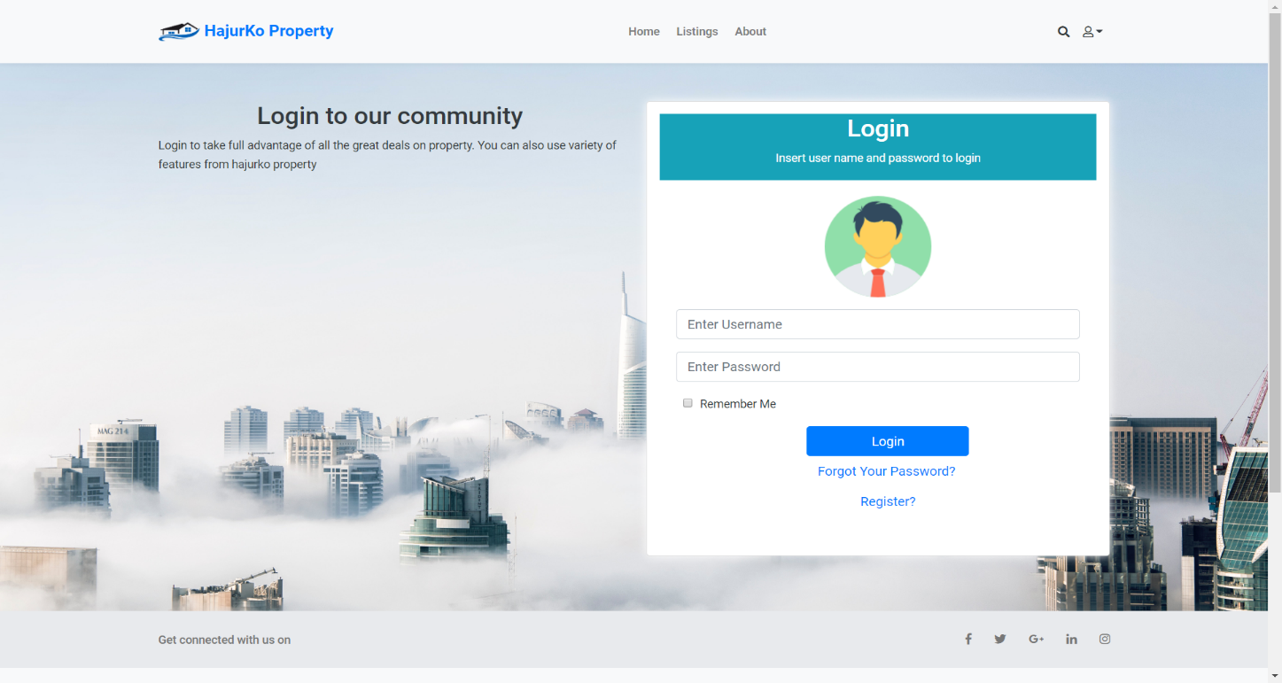

Fig Login

**Register**

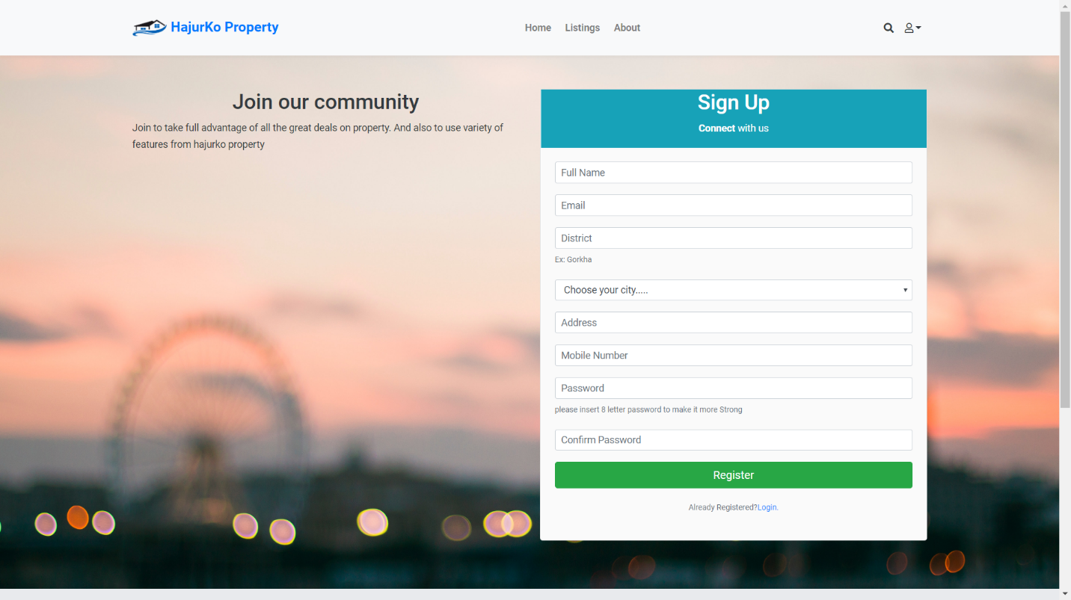

Fig Register

**About page**

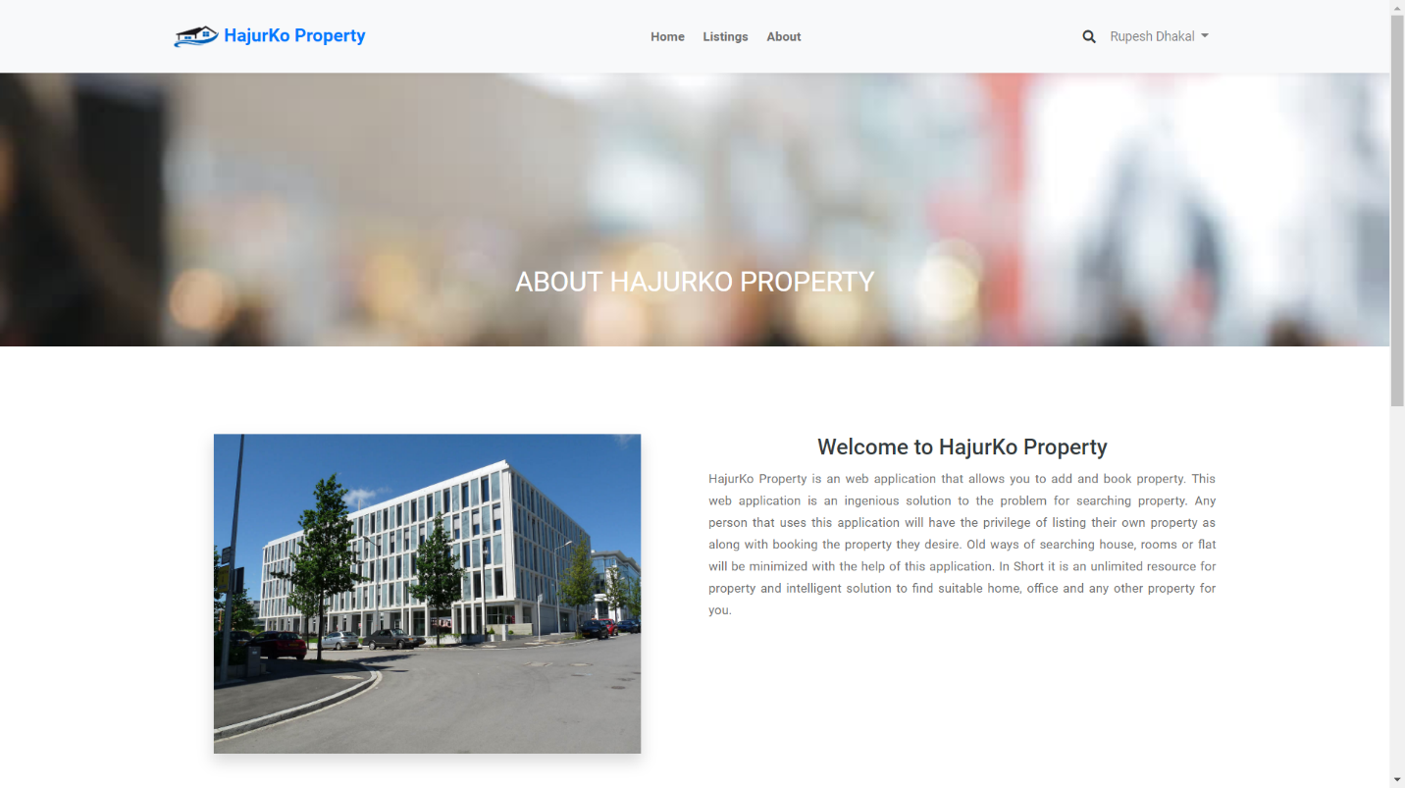

Fig About

**Listing page**

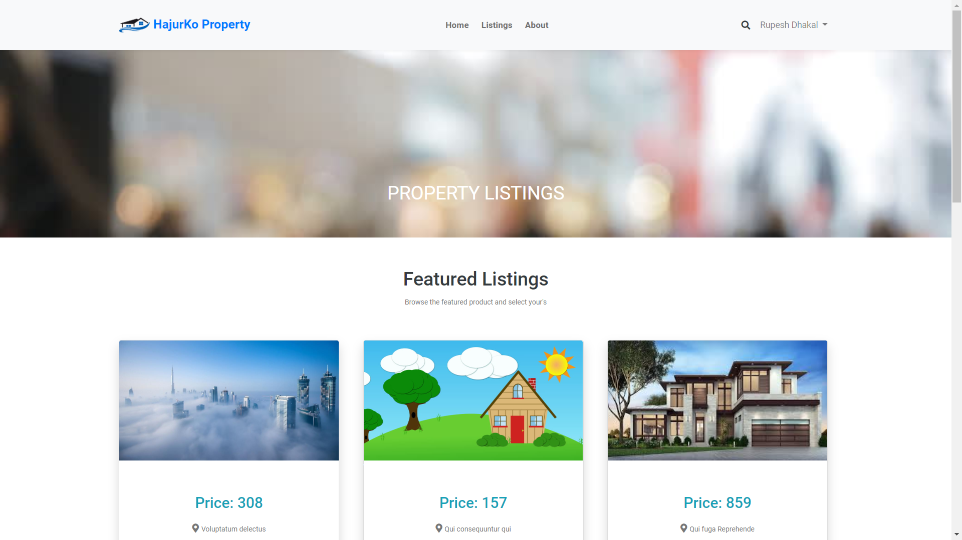

Fig Listing`

**Profile page**

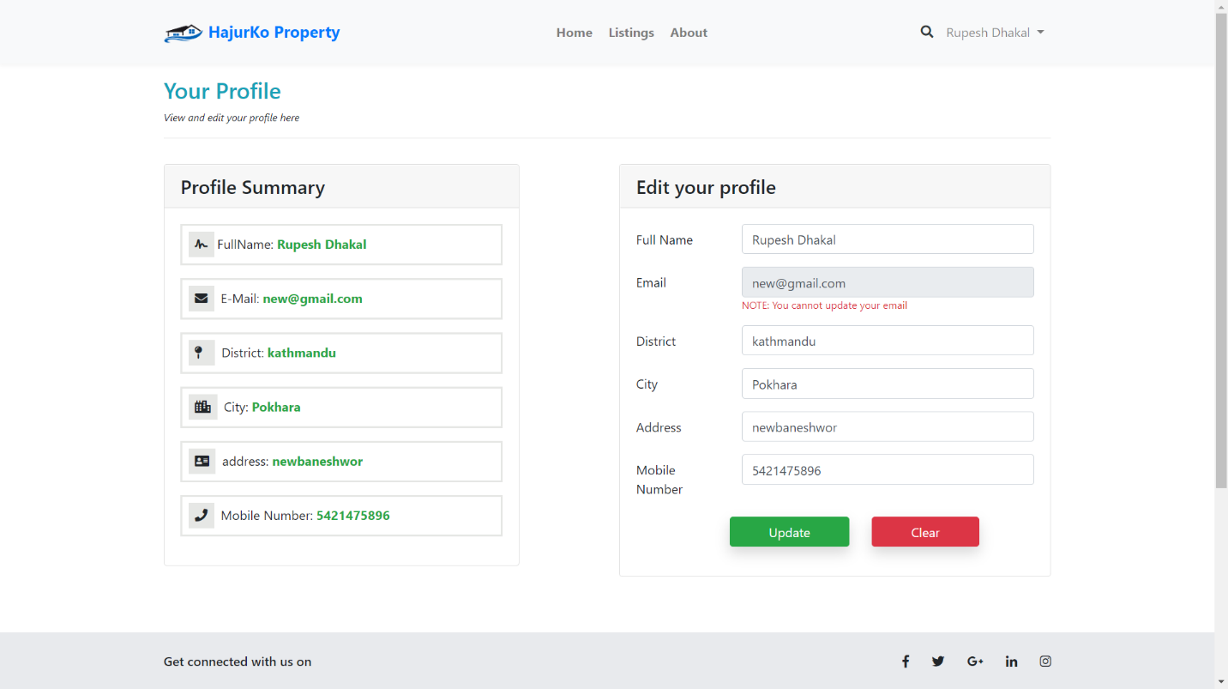

Fig Profile

**Footer**

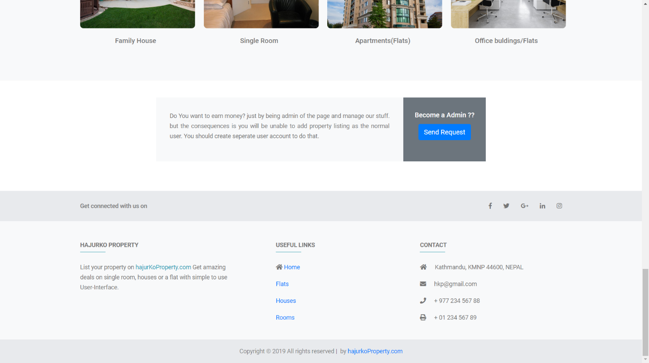

Fig Footer

**Search**

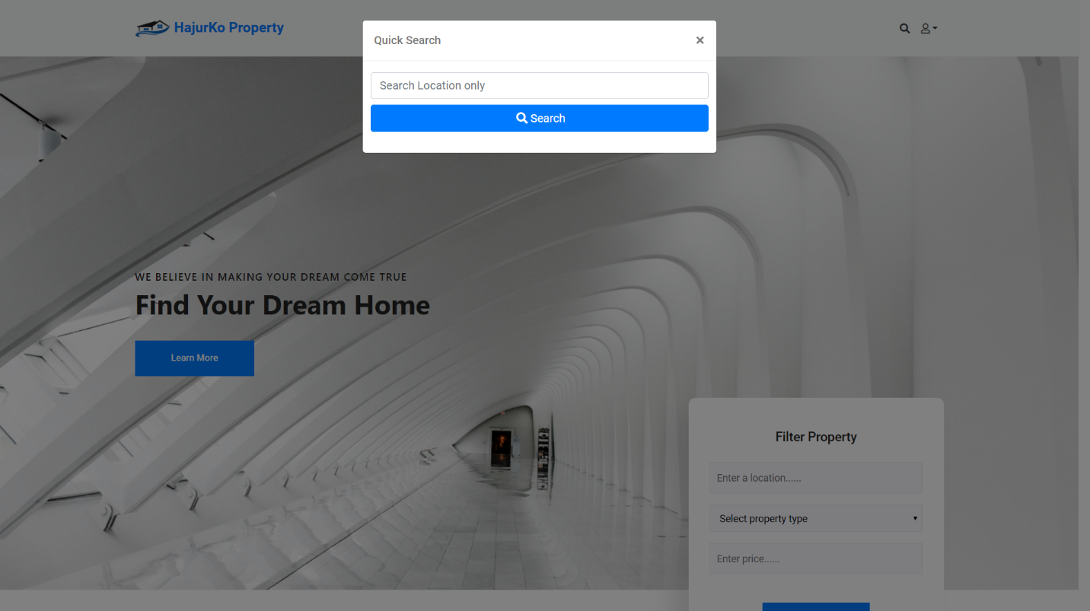

Fig Search

**USER PANNEL**

**Add Property**

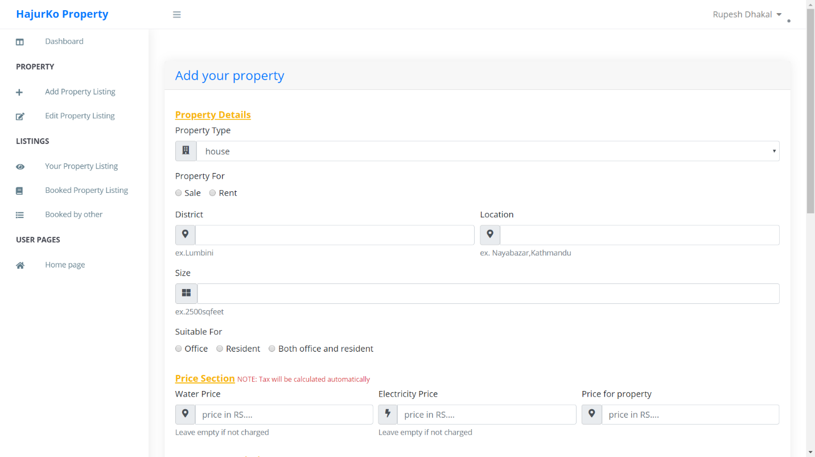

Fig Add Property

**Update**

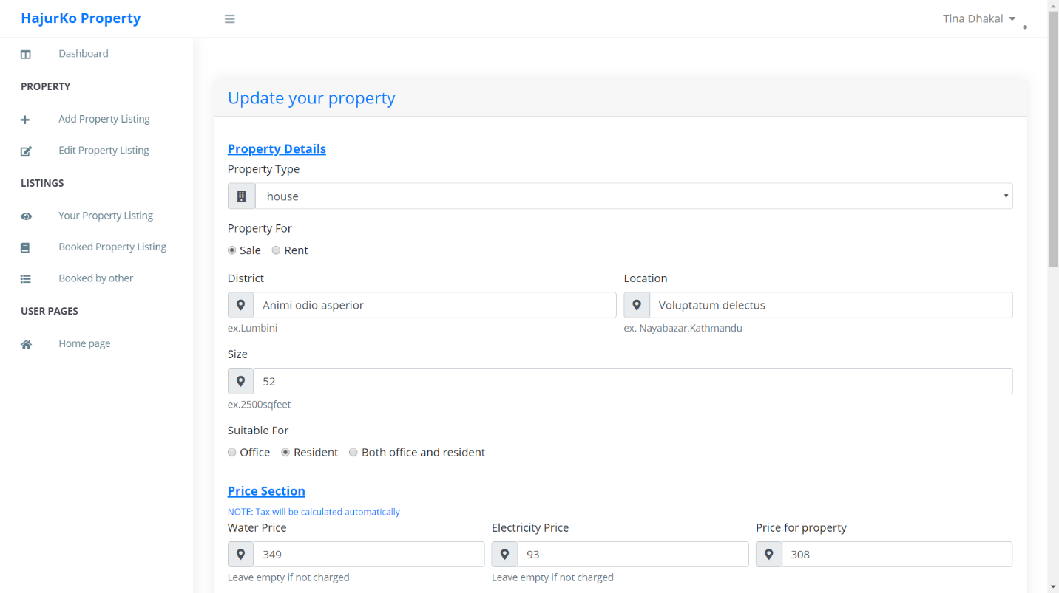

Fig Update Property

**View and Delete**

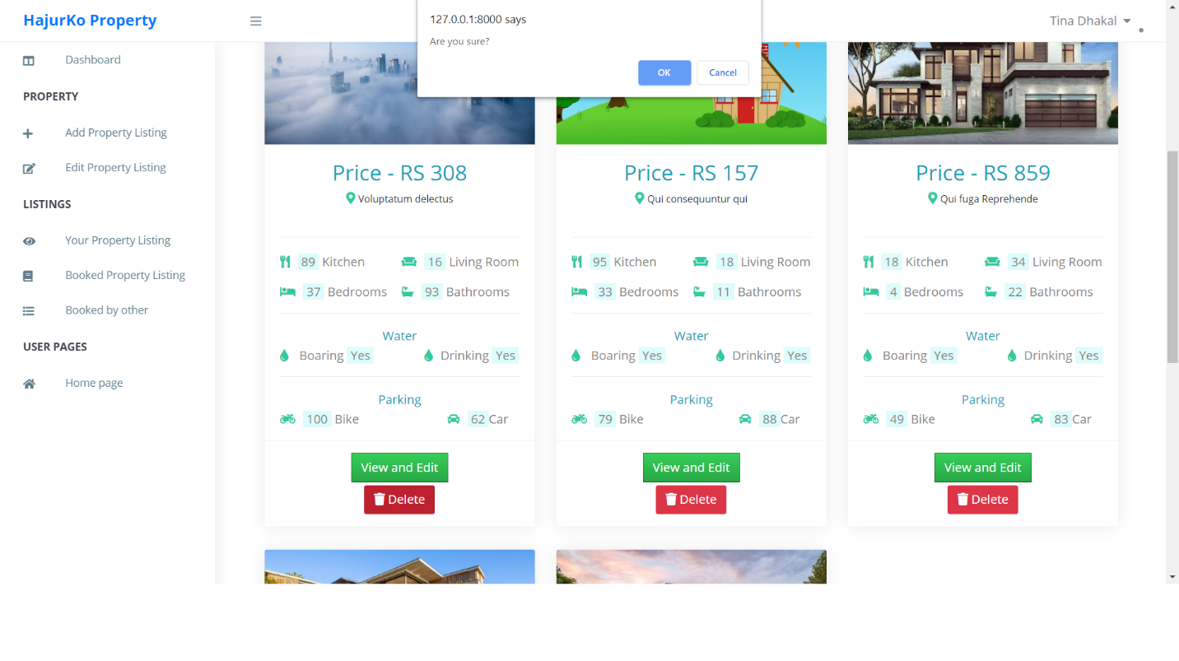

Fig view and Delete

**Booked page**

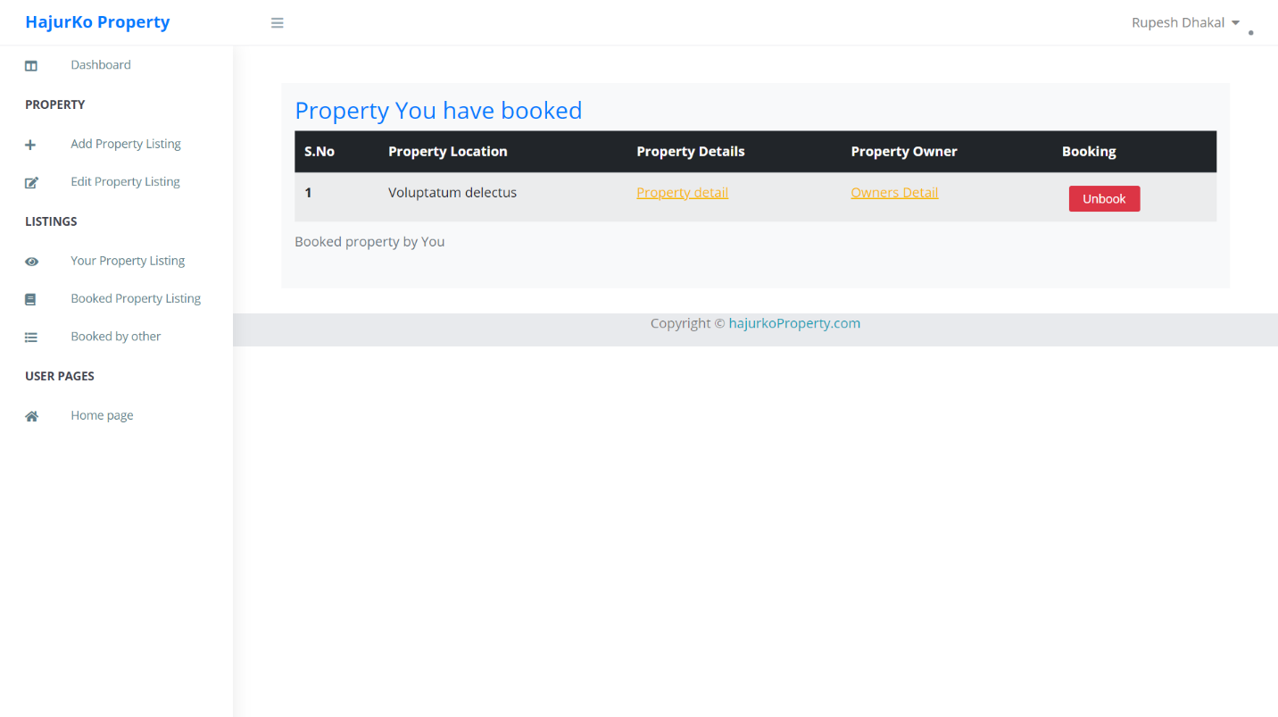

Fig Property booked

**Other user booked property**

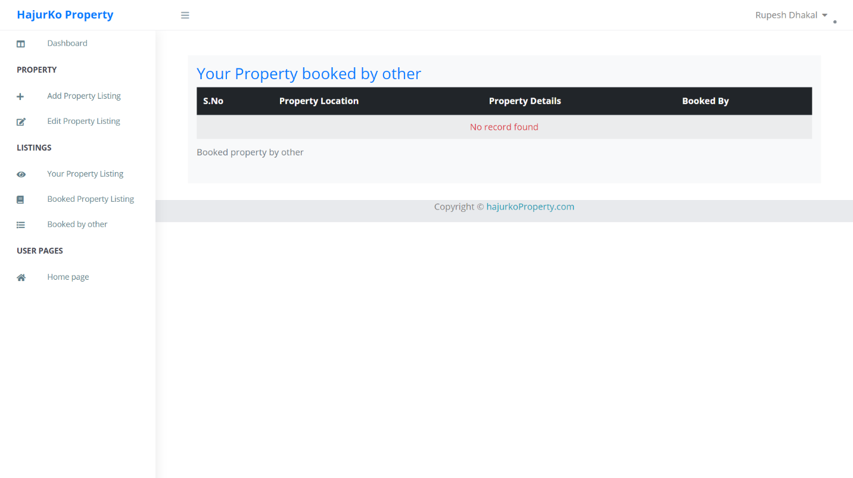

Fig Property booked by

**ADMIN**

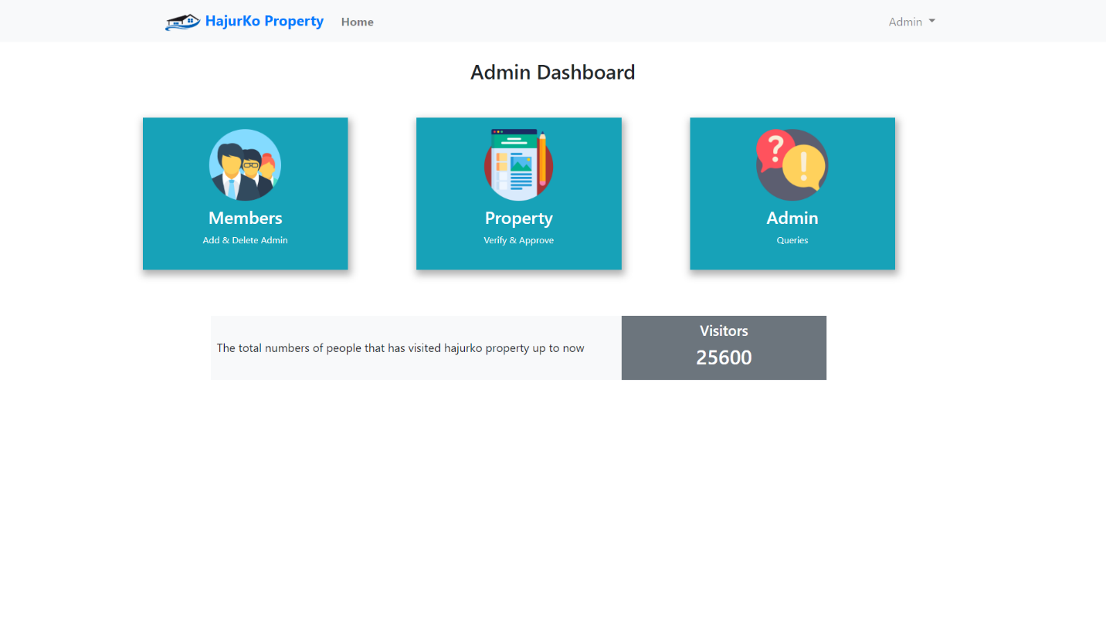

Fig Admin Dashboard

**Admin request**

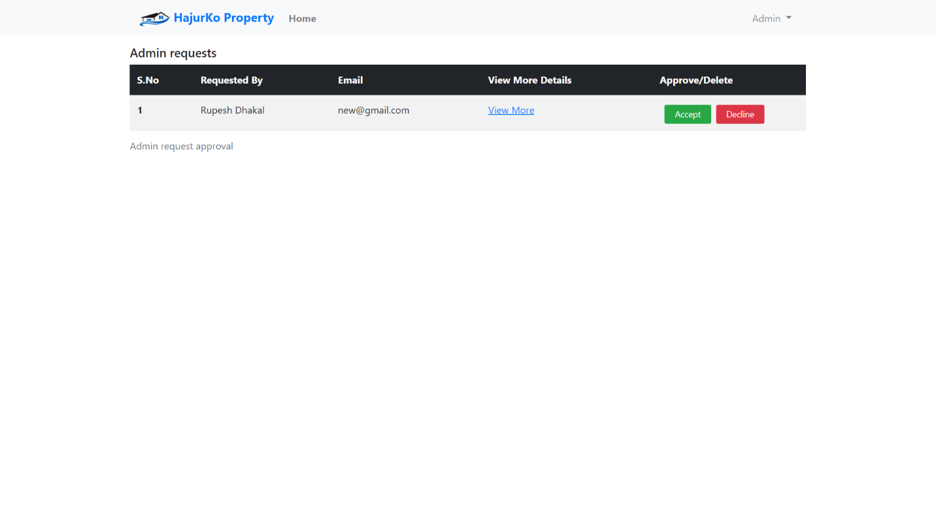

Fig Admin request page

**Property listing request**

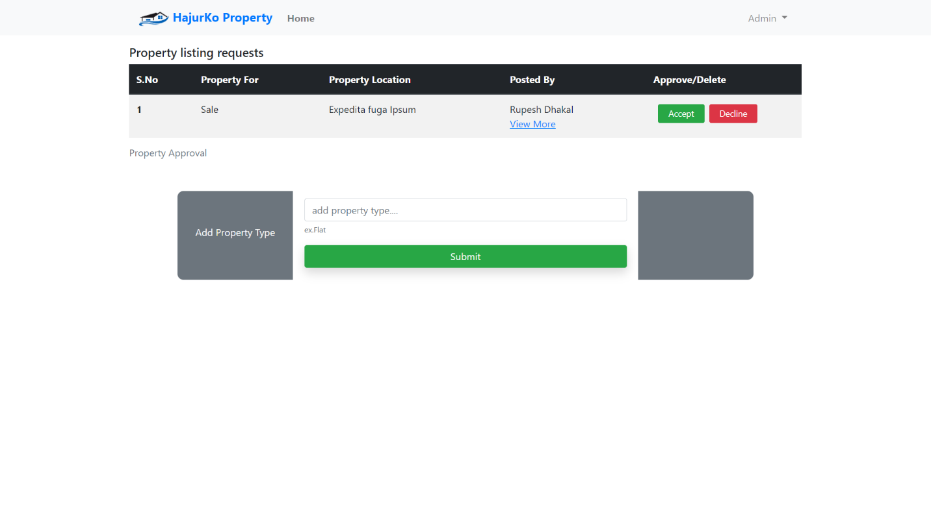

Fig Property listing request

**Detail Property View**

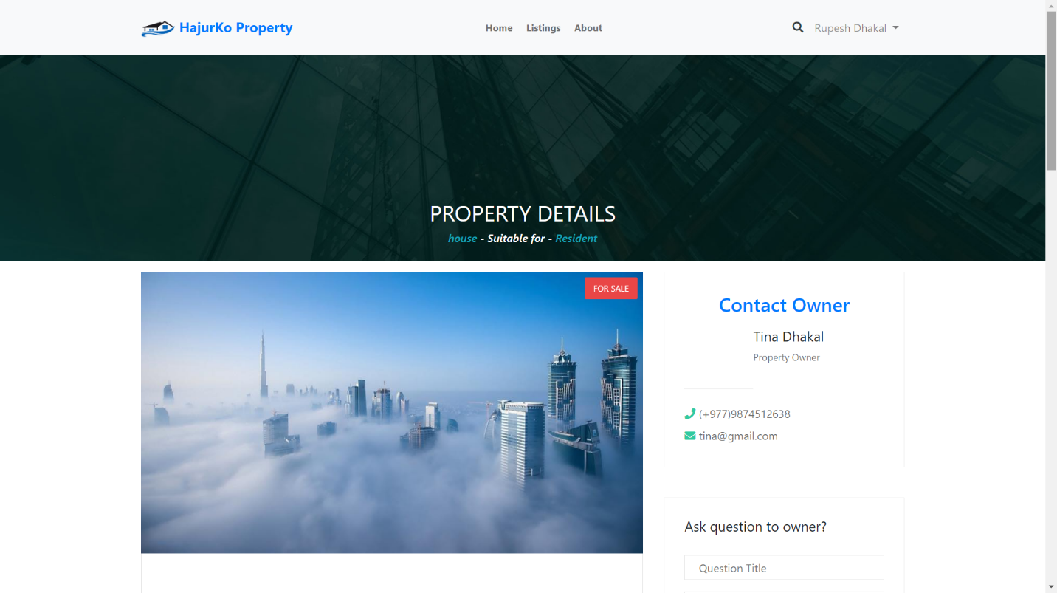

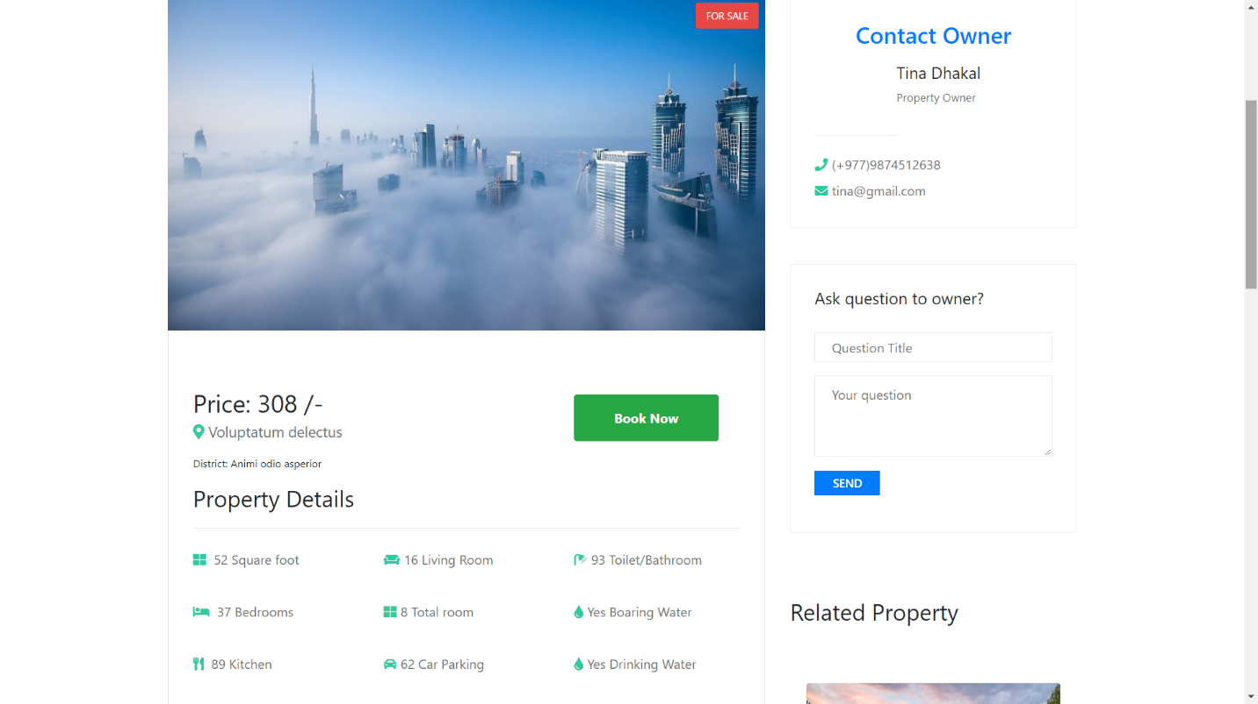

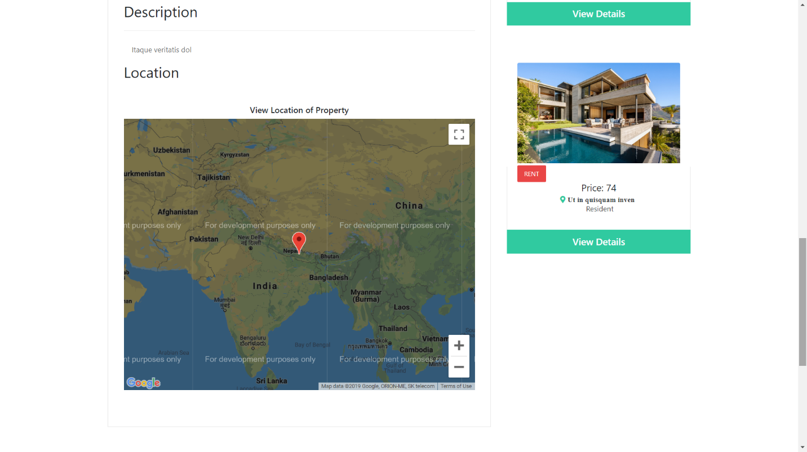

Fig Property detail page